Molecular and Genomic Imaging Center

Specialized Center of Excellence in Genomic Science

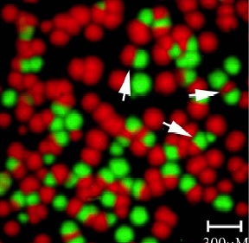
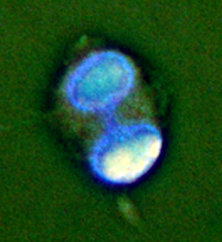
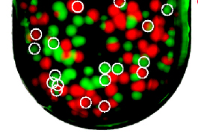
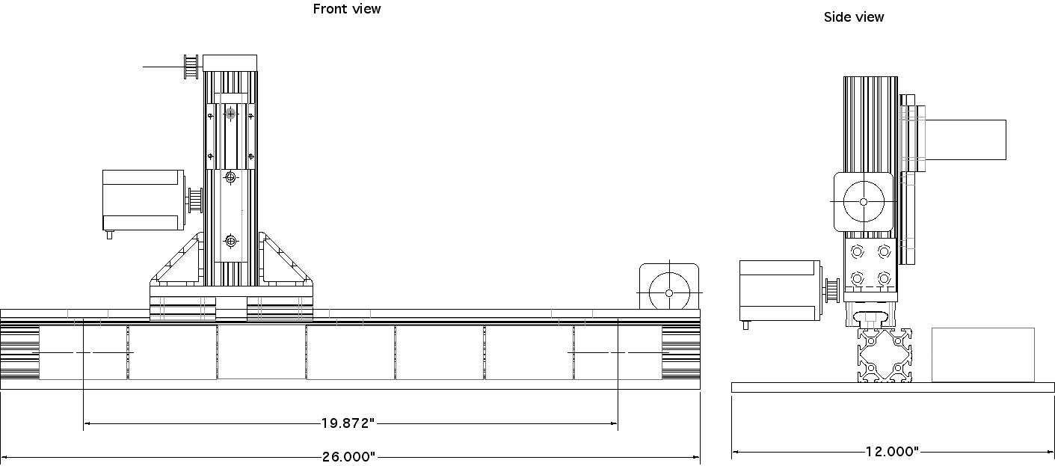
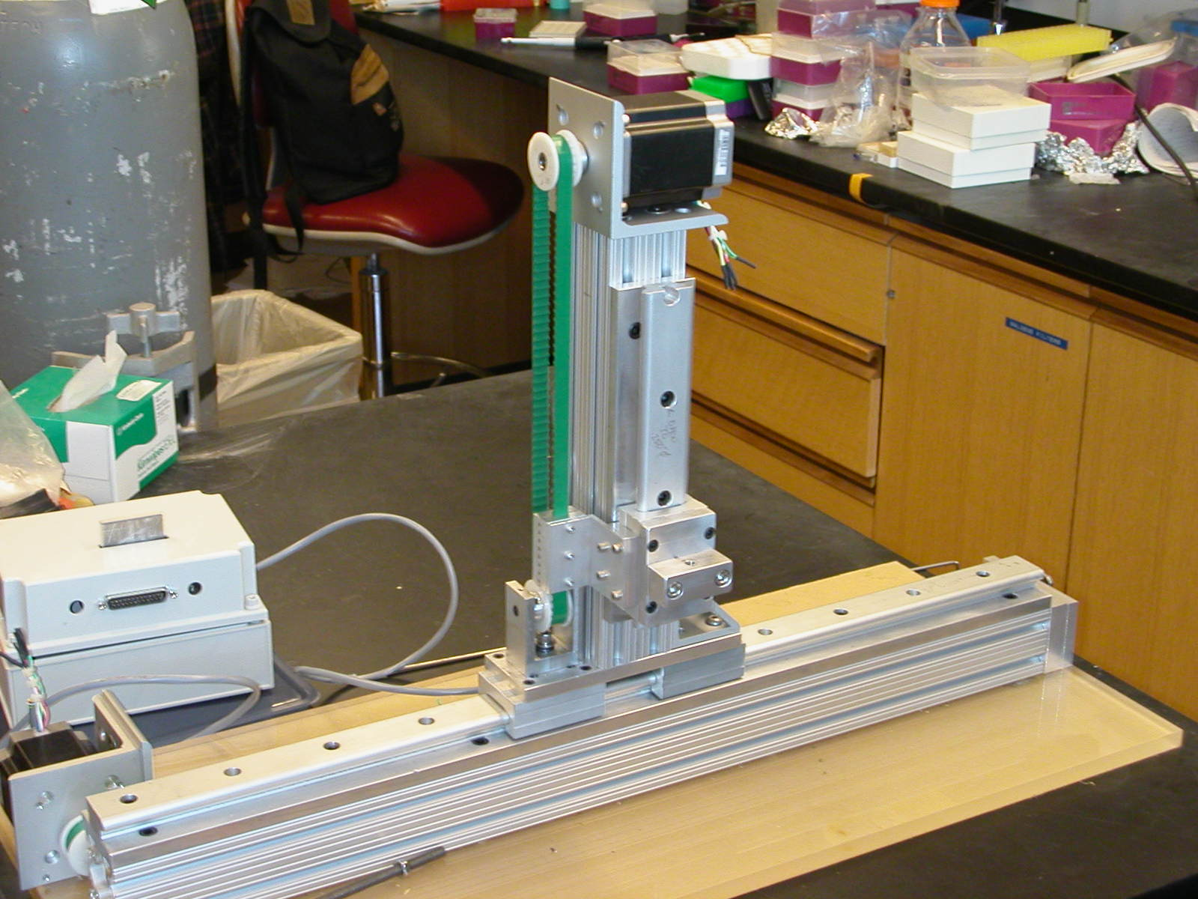
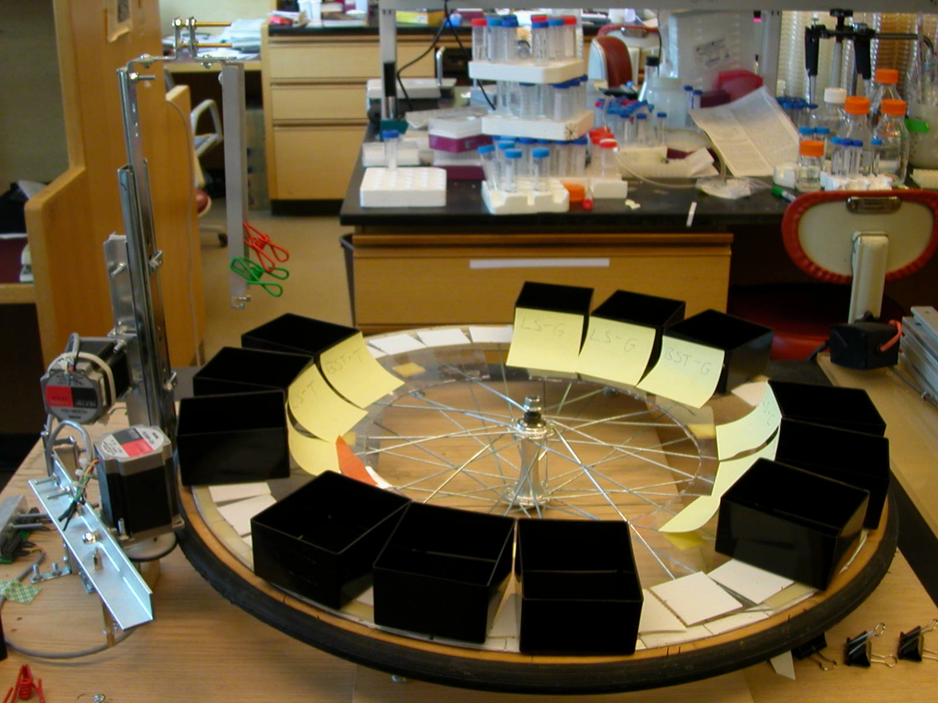




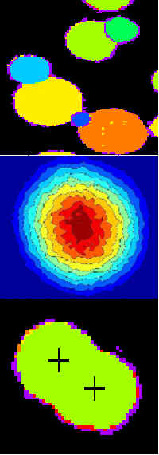
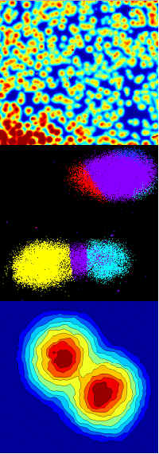
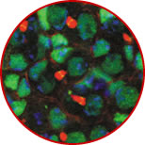
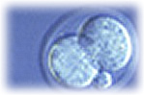
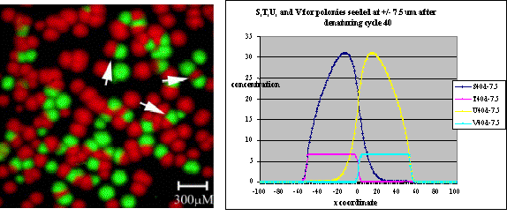
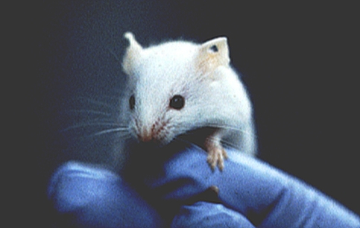
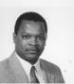
P50 Proposal

June 1, 2003

George Church
David Gottlieb

Robi Mitra
James Sherley

Molecular and Genomic Imaging Center

P50 proposal for a Specialized Center of Excellence in Genomic Science

Note to readers: The CD-ROM version of this document is slightly updated relative to the print version & has hypertext links indicated by underlined characters. Most links should be self-contained within the CD-ROM and not require an Internet connection for viewing. These link sections within the grant text, plus preprints, key papers, spreadsheets, and demonstration-purpose web-tools. You will need Acrobat Reader, Microsoft Excel, and Netscape or Internet Explorer for some of the links. For literature citations we use first author and year, e.g. [Mit03B].

COVER & TABLE OF CONTENTS 60

Budget, Other Support, Personnel
Resources
8a. Specific Aims 62
8b. Background & Significance 66
8c/d. Aim 1: Polonies & fluorescent in situ sequencing (FISSEQ) 74
Aim 2: Quantitating RNA molecules & exon-typing 80
Aim 3: Long sequence connectivity & haplotyping 87
Aim 4: Single cells & in situ profiling 93
Aim 5: Computational methods and systems biology 97
8e. Human Subjects Research 101
ELSI 102
8f. Vertebrate Animals 103
8g. Literature Cited 104
8h. Consortium/Contractual Arrangements 118
8i. Collaborating Laboratories 118
Management & Organization Plan 120
Project Development Schedule (Time Line) & Team Organization 125
Training Plan, Minority Plan 127
Data and Materials Dissemination Plan 133
Related CEGS Applications 134
Letters of Collaboration 135
Subcontract Documents from Collaborating Institutions 148

8a. Specific Aims [to top] [timeline]

We propose here the Molecular and Genomic Imaging Center (MGIC) in response to a biomedical-community-wide need for flexible, cost-effective, high-resolution technology to identify and characterize variation in biological systems at the level of genomes and transcriptomes. We plan to help meet this need by developing the polymerase colony, or polony, technology. Polony technology is realistic, close-at-hand, modular, and versatile. The MGIC will efficiently integrate contributions from technologists and biologists to develop a robust platform for high-throughput nucleic acid analysis.

Technology. Our goal is to simultaneously address a broad spectrum of important challenges in nucleic acid analysis: ultra-low-cost/high-precision (1) DNA sequencing; (2) comprehensive quantitation of mRNA abundances; (3) profiling combinations of alternatively spliced exons within individual mRNA transcripts; (4) direct and unambiguous molecular haplotyping over long genomic distances; (5) determination of DNA sequences and gene expression profiles of single cells and in situ. We believe that all of these objectives can be achieved in a realistic time-frame by developing a unified platform, the polony technology. Two of these goals, direct molecular haplotyping and quantitation of exon combinations within single molecules, have already been developed to the point where data that are highly impractical to obtain by other means can be routinely collected using this technology [Mit03][Zhu03]. Progress towards other goals is at an earlier stage, but we have accomplished proof-of-concept experiments that demonstrate important milestones towards our final objectives. For example, we have acquired short sequencing reads (5 to 8 base-pairs) from a small number of polonies in parallel [Mit03B]. In their current state, the polony technologies offer a balanced risk-portfolio, ranging from protocols in their infancy to immediate deliverables validated through successful proof-of-concept experiments and with which we are ready to begin high-throughput collection of primary biological data. What remains in common is that each is “high payoff”, as success in any one of our technical objectives would in itself represent a substantial contribution to the community.

Biology. A key measure of the value of a biomedical technology is the sum of its direct and indirect contributions to patient care (i.e. diagnostics, prognostics, and therapeutics). Our interests fall along two tracks. The first track is to characterize and understand stem cells. As discussed in this proposal, the high resolution of the polony technology fits well with the needs of the stem cell community. In the long-term, we hope to learn how to manipulate stem cells with an unprecedented degree of precision, a step towards realizing their enormous potential in therapeutics. The second track is to apply measurements of nucleic acids to survey genotypic and phenotypic variation in the human population with the eventual aim of applying the technologies in diagnostics and prognostics. Realizing the “genomics-to-bedside” vision will require nucleic acid technologies that are compatible with clinical considerations, e.g. in terms of acceptable costs, acceptable error rates, etc. Much of the technology proposed here was designed with those considerations in mind.

Synergy. The primary mission of the MGIC is to efficiently integrate a diverse set of technical advances into a robust platform that can be applied to answer specific, critical biological questions that are poorly addressed by existing methods. We are pursuing highly multidisciplinary goals, and feel that this requires a talented, highly multidisciplinary team that (i) works well together and (ii) is capable of communicating across academic and geographic boundaries. The Center must therefore be assembled around specific milestones and effective scientific partnerships. Our intention in forming a CEGS is to solidify the connections and mutual commitments between the biologically inclined technologists and technologically inclined biologists represented on our team. Although realistic and worthwhile, the goals laid out here are too ambitious for any one laboratory or investigator, yet they are tied together in a way that successful execution will be well served by coordination of efforts within the context of a CEGS.

Open Source Biology. Our proposed CEGS will have a strong commitment to making the polony technology accessible to the full biomedical community. We are inspired by GNU and Linux, open-source projects that have proven to be effective models for software development, as well as the success of our own open collaborations (see Management & Organization). We have developed, and will continue to develop, our protocols using off-the-shelf instrumentation and reagents. We have also made up-to-date protocols and software publicly available on our website (see enclosed CD-ROM copy of those web pages). We are committed to exporting the polony technology into as many hands as possible so that it can be rapidly improved and modified in parallel. Our preliminary efforts in this area are bearing fruit, as polony technology has been successfully exported to eleven laboratories (see Collaborators).

Our Team. We have assembled a strong, enthusiastic team to carry out the research plan described in this application. Importantly, many members of our team have productively collaborated in the past. Furthermore, laboratories participating in the proposed MGIC are very experienced in technology development and have demonstrated expertise in a wide variety of fields, including stem cell biology, molecular biology, biochemistry, computational biology, circuit design, microfabrication, instrument development, and image processing. The multidisciplinary nature of our team will not only help us accomplish our research goals, but will also allow us to train a new generation of young scientists who are as comfortable designing a microfabricated fluidics device as they are performing a western blot.

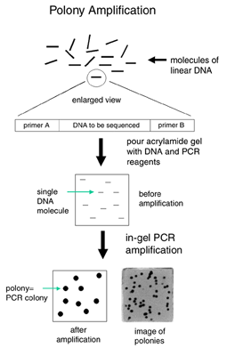
Introduction to Polonies. A polony is a colony of DNA that is amplified from a single nucleic acid molecule within an acrylamide gel, such that diffusion of amplicons is spatially restricted. We begin by diluting a library of DNA molecules into a mixture that contains Polymerase Chain Reaction (PCR) reagents and acrylamide monomer. A thin acrylamide gel (5 to 50 microns thick) is poured on a microscope slide, and amplification is then performed using standard PCR cycling conditions. If one begins with a library of nucleic acids in which a variable region is flanked by constant regions common to all molecules in the library, a single set of primers complementary to the constant regions can be used to universally amplify a diverse library (Figure A-1). Amplification of a dilute mixture of single template molecules leads to the formation of distinct, spherical polonies. Thus, all molecules within a given polony are amplicons of the same single molecule, but molecules in two distinct polonies are amplicons of different single molecules. We have demonstrated that millions of distinguishable polonies, each arising from a distinct single molecule, can be formed and visualized on a single microscope slide [Mit99].
Figure A-1

In our protocols, one of the amplification primers includes an 5’- acrydite-modification [Reh99]. This primer is present when the acrylamide gel is first cast, such that it physically participates in polymerization and is covalently linked to the gel matrix. Consequently, after PCR, the same strand of every double-stranded amplicon is physically linked to the gel. Exposing the gel to denaturing conditions permits efficient removal of the unattached strand. As every copy of the remaining DNA strand is physically attached to the gel matrix, we can perform a variety of biochemical reactions on the full set of amplified polonies in a highly parallel reaction.

The post-amplification protocols most critical to the technologies presented in this proposal involve hybridization of one or more universal or template-specific probes to amplified, denatured polonies. The probes can function as primers for sequencing-by-synthesis using a DNA polymerase and fluorescently-labeled bases (e.g. Cy5-dCTP) [Dub99][Pas96][Pas97]. Moreover, the same denaturation protocol used to remove the free strand of the amplicon can be used to remove extended sequencing primers, so a single slide can be subjected to multiple rounds of interrogation.

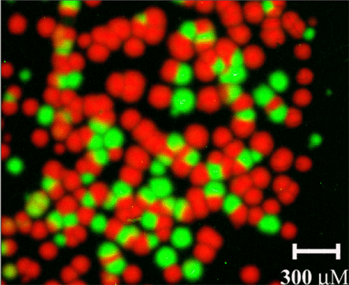
In Figure A-2, genomic DNA from a single human individual was used as a template for a polony PCR reaction targeting a specific 914 base-pair (bp) region. After denaturing amplified polonies (to remove the unattached strand), a single 28 bp probe was hybridized to the gel. The probe was designed such that it was specific for sequence known to be internal to the amplified target, and its 3’ end was immediately adjacent to the position of a known single nucleotide polymorphism (SNP). Application of Klenow fragment (exonuclease-minus), Cy5-dUTP and Cy3-dCTP in the appropriate buffer permitted the probe to act as a sequencing primer for a single-base-extension reaction. Polonies derived from the chromosome bearing an “A” at the complementary position appear as red in the figure (as the polymerase would have extended the primer with Cy5-dUTP), whereas polonies derived from chromosomes bearing a “G” at the complementary position appear as green (as the polymerase would have extended the primer with Cy3-dCTP). The image was acquired with a standard microarray scanner.
Figure A-2

More details on specific applications can be found in our published and submitted work [Mit99][Mit03][Mit03B] [Mer03][Mil03][Zhu03], as well as in the relevant sections of this proposal.

Specific Aims.

(1) Polonies and Fluorescent In Situ Sequencing (FISSEQ). A polony-based sequencing platform has the potential to reduce the cost of DNA sequencing by as many as seven orders of magnitude, such that 220 megabases of DNA could be sequenced for about one dollar. We have accomplished several technical milestones towards this goal, including performing short sequencing reads on a small number of templates. In this aim, we plan to further develop the FISSEQ protocol such that 20 to 500 base-pair reads can be reliably obtained from millions of polonies in a parallel fashion. The ability to readily acquire millions of sequencing reads of this size on a single slide at a low cost will enable numerous biological applications, including de novo sequencing of microbial genomes, resequencing of individual human genomes, pathogen discovery, comprehensive mRNA abundance measurements, high-resolution whole-genome comparative hybridization, etc. Towards this end, we will pursue strategies for improving gel matrix and amplification chemistries, nucleotide chemistry, and robust automation. Towards more immediate clinical and epidemiological applications, we also propose polonies as a platform for the detection of rare somatic and germ-line mutations.

(2) Single Molecule Profiling of the Transcriptome and Alternative Transcriptome. Recent years have seen the development of a number of innovative methodologies for quantifying transcriptomes. Digital tag-counting strategies have a number of important advantages over hybridization-based technologies, but so far, have been substantially less cost-effective and lower throughput, limiting widespread adoption. The first aspect of this aim will be to develop a polony-based method for digital gene expression profiling via highly parallel sequencing and counting of short mRNA-derived tags. We will specifically pursue this strategy in the context of temporal profiling of differentiating murine embryonic stem cells. The second aspect of this aim will address the challenge of quantitating the “alternative transcriptome”. It is estimated that at least 55% of mammalian genes generate transcripts that undergo alternative splicing [Kan01]. A disadvantage common to existing transcriptome-focused technologies is that none is capable of monitoring combinations of alternatively spliced exons, as they occur within individual transcripts [Rob02]. Identifying and quantifying such combinations is an essential prerequisite to any complete “parts list” of mammalian biology. We will scale up protocols developed in successful pilot experiments to assess alternative splicing of Tau and CD44 transcripts in clinical samples. Additionally, we will quantitate exon combinatorics in a large number of genes exhibiting complex alternative splicing.

(3) Haplotyping and Long-Range Sequence Connectivity. Recent studies have suggested that a haplotype-based approach to linkage and association studies may be an effective means of identifying genes underlying complex common diseases [Dou01]. In a number of specific cases, polymorphisms have been shown to interact in cis to cause or modify disease [Dry00][Hoe00][Dav00] [Kim03], i.e. a causative haplotype, rather than a causative polymorphism. For such cases, existing strategies to assess haplotypes are either costly or have error rates that are unacceptable for use in the clinical setting [Niu02]. We have demonstrated that polonies can inexpensively and unambiguously determine the genotypes and haplotypes of two SNPs separated by distances up to 45 kb (and likely much greater) on the same chromosome. In the first aspect of this aim, we will extend our capabilities to phase 3 to 20 SNPs in a single reaction. Also, with the goal of high-throughput haplotyping at the ApoE locus in clinical samples, we will convert this technology to a 96 “gel-well” format. Finally, we will determine haplotype frequencies in pooled genomic DNA of disease and control populations, with the intention of further reducing costs and increasing the throughput of haplotype-focused association studies. The second aspect of this aim will address the issue of long-range sequence connectivity more generally. We will develop novel approaches for establishing sequence connectivity with the polony platform, including mated-pair and jumping-clone strategies. These methods will be used with protocols developed in Aim 1 to de novo sequence the pathogen, Helicobacter pylori.

(4) Characterization of DNA and RNA from Single Cells and In Situ. There are many biological questions for which it would be desirable to measure properties of a single cell, e.g. [Elo02][Fer98]. As polony technology is highly parallel and allows individual nucleic-acid (NA) molecules to retain their locations during amplification, it is well suited to be the basis of high-throughput assays of many individual cells. The main technical issue is the adaptation of existing in situ hybridization (ISH) protocols [Car02] to be compatible with polony generation procedures. In this aim, will develop these protocols and then apply them to several biological problems that will benefit by the parallel analysis of many individual cells. Specifically, we will assay (i) protocadherin gene splice variant distributions in individual mouse Neuro2A cells and in individual differentiating murine embryonic stem (ES) cells, (ii) the population of ds-RNA molecules in murine ES cells, (iii) the distribution of Tau splice variants in human patient samples, and (iv) genes in pathways that control rat adult hepatic stem cell asymmetric kinetics [She02B]. These studies will shed light on the how the diversity of individual neurons in the nervous system is supported at the molecular level in both normal development (protocadherin) and disease (Tau), and on stem cell differentiation. While these experiments will assay many individual cells for only small numbers of NA sequences (“low-plex”) using FISSEQ (Aim 1) and probing techniques we have already developed, we will also work out the more complex techniques needed to assay large numbers (“multi-plex”). Once in hand, we will apply them to identifying single stranded segments of ‘immortal’ DNA strands in adult rat hepatic stem cells [Mer02], and also work towards obtaining expression profiles of many transcripts in these cells.

(5) Computational Methods and Systems Biology. Aims 1-4 are highly dependent on development of computational methods. In addition, the new biological data obtainable by polony methods from comprehensive splice variant analysis, allele expression and haplotyping, and single cell expression and genotyping, opens up new opportunities for systems biology. In this aim we will develop computational tools and methods that will enable users to easily acquire and evaluate polony data, computational models that will help optimize polony technology development, and compelling examples of systems biology using new forms of polony-acquired data. In 5a, we develop a robust, open-source, and user-friendly set of tools for obtaining sequences from the digitally-captured images acquired from polonies, a highly complex and computationally-intensive task. In 5b, we develop tools for assembly of polony sequence reads, whose statistical characteristics are sufficiently different from typical electrophoretically-derived reads to impose unique requirements. In 5c, we develop a mathematical model for polony growth for purposes of optimizing polony technology itself. In 5d, we establish the digital statistical error models required for evaluation of polony-acquired expression level and genotype data. In 5e, we explore examples of systems biology using new kinds of data gathered from polonies, focusing on correlations of comprehensively evaluated splice variants within pathways and with pathway activation levels.
8b. Background and Significance [to top] [timeline]

“I think there is a world market for maybe five computers.” -- Thomas Watson, chairman of IBM (1943)

The resounding success of the Human Genome Project (HGP) clearly illustrates how early investments in developing cost-effective methods of data acquisition can have tremendous payoffs for the biomedical community. Over the course of a decade, through refinement, parallelization, and automation of established sequencing technologies, the HGP motivated a 100-fold reduction of sequencing costs, from 10 dollars per finished base to 10 finished bases per dollar [Col03]. The relevance and utility of sequencing and sequencing centers in the wake of the HGP has been a subject of recent debate. We maintain that the completion of the human genome marks the end-of-the-beginning, rather than the beginning-of-the-end, of the era of sequencing and, more generally, the era of nucleic-acid (NA) technologies. For a wide range of biomedical and bioagricultural goals, a strong need is evolving for low-cost NA technology. The list of realized and potential applications is rich and growing (Figure B-1). NA technology has the potential to significantly and substantially impact health care, both directly by providing diagnostic and prognostic markers for the clinical setting, and indirectly by accelerating the pace of basic and clinical biomedical research.

Figure B-1 Partial List of Applications of Nucleic Acid Technology
- Sequencing of individual human genomes as a component of preventative medicine [Pra02][Pen02].
- In vitro and in situ gene expression profiling across the full range of spatiotemporal variables in the development of a multicellular organism [Rey02].
- Cancer: determination of comprehensive mutation sets for individual clones [Hah02]; loss of heterozygosity analysis [Pau99]; profiling sub-types for diagnosis and prognosis [Gol99][Ram03B].
- Temporal profiling of B- & T-cell receptor diversity, both clinically and in lab antibody selection.
- Identification of known and novel pathogens [Web02]; biowarfare sensors [Ste02].
- Detailed annotation of the human genome via phylogenetic shadowing [Bof03].
- Quantitation of alternative splice variants in transcriptomes of higher eukaryotes [Rob02].
- Definition of epigenetic structures (e.g. chromatin modifications and methylation patterns) [Rob02b].
- Rapid hypothesis testing for genotype-phenotype associations.
- In situ or ex vivo discovery of patterns of cell lineage [Yat01][Dym02].
- Characterization of microbial strains subjected to extensive “directed evolution” [Len03][Coo03].
- Exploration of microbial diversity towards agricultural, environmental, and therapeutic goals [Gil02].
- Annotation of microbial genomes via selectional analysis of tagged insertional mutants [Bad01].
- Aptamer technology for diagnostics and therapeutics [Cer02].
- DNA Computing [Bra02].

Recent trends in proteomics are encouraging [Aeb03], and it is clear that both NA & proteomic technologies are necessary and complementary components of the systems biology mission. However, NA methods are much closer to achieving both high multiplicity and spatiotemporal resolution in multicellular systems. As a consequence of possibilities opened up only by the very structure of the nucleic acid polymer itself, NA methods are also much more well-positioned to utilize single-molecules effectively (e.g. through robust amplification and sequence tags). Moreover, many of the NA methods proposed here do not depend on a huge production effort (as might be the case for “comprehensive” antibody methods) to achieve the generality conducive to a cohesive CEGS community research effort.

Shifting Paradigms in DNA Sequencing (Aims 1a, 1b, 1c). High-throughput technologies succeed by “compacting” signal both spatially and temporally, e.g. through miniaturization or rapid sample processing. Our development of the polony technology reflects a long-standing interest [Chu84][Chu88] in leveraging “shared containers” and post-hoc informatics towards the improvement of assay throughput. Thus, the formation of millions of distinguishable, immobilized, femtoliter-scale polonies from individual DNA or RNA molecules via a single PCR reaction within a single gel (i.e. a “shared container”) supplants the complex robotics required to handle the tens-of-thousands of cloning and PCR reactions that feed conventional high-throughput sequencing. By virtue of its highly parallel nature, polony-based sequencing-by-synthesis has the potential to supplant conventional Sanger sequencing. Our estimates of the cost of polony-based sequencing range from 54 kilobases (conservative) to 220 megabases (optimistic) per dollar, depending on how far we are able to push miniaturization and throughput. Meanwhile, the ability to retain the locations of amplicons derived from individual molecules allows polonies to enable a broad range of other applications, including multiplex genotyping, haplotype phasing, quantitation of RNA expression, single molecule profiling of alternative splice variants, and in situ and single-cell expression and genotype analyses (Aims 2 to 4).

A number of innovative “third-generation” ultra-high-throughput sequencing technologies are now under development, inspired by calls for NA sequencing at a cost of less than $5000 per human genome (a price threshold below which individual patients could conceivably afford "personal sequences") [Jon01][Pra02] [Pen02]. Relative to these efforts, the polony technology has a number of distinguishing features that warrant mention: (i) Nearly all of these technology development efforts are commercially driven (see Figure B-2). We are one of a handful of academic efforts that have made substantial progress in this area. We advocate a system that is as “off-the-shelf” and widely accessible as possible, such that in the not-too-distant future, every lab can be its own sequencing center. (ii) Polonies have a number of important and unique applications aside from high-throughput genomic sequencing, including multiplex genotyping, haplotype phasing, quantitation of RNA expression, quantitation of alternative splice variants, and in situ expression and genotype analysis (Aims 2 to 4). The risk portfolio of the polony technology is therefore balanced, in that the technical risk involved in various goals ranges from high to slight. For two applications in which proof-of-concept experiments have been highly successful, namely long-range molecular haplotyping (Aim 3) and quantitation of alternative splice variants (Aim 2b), the polony technology already represents a significant advance over the state-of-the-art. (iii) Ours is the only technology that has clear potential in the field of “in situ” sequencing (Aim 4), which in itself enables a number of unique and promising applications.

A comparison between polonies and other NA sequencing technologies known to be under development is presented in Figure B-2. The list includes methods based on capillary microfluidics, oligonucleotide arrays, mass-spectrometry, single molecules, and in vitro amplified DNA with multiplex sequencing cycles. While costs of essentially all current methods hover around 10 base-pairs per dollar for useable accuracy levels, the methods exhibit substantial differences in terms of throughput limitations and range of realistic applications. Electrophoretic data (e.g. capillary fluidics) are among the most accurate and proven, but maximal migration takes minutes to hours. Oligonucleotide arrays have a similar bottleneck in that the synthesis chemistry takes hours per array. Mass spectrometry is routinely used for SNPs, but a variant of this method that can compete with electrophoretic sequencing is not clear. “Pure” single molecule methods (e.g. those that lack an amplification step) intrinsically incur signal-to-noise penalties that increase sequencing errors (potentially addressed by higher redundancy requirements, although this incurs an increased cost). Polonies circumvent this problem by amplifying single molecules “in place”, such that amplicons are anchored in a gel that can withstand extensive manipulation. Thus retaining positional information incidentally enables “phasing” of haplotypes, exons, or information collected on nucleotides amplified from single cells.

With this grant, we expect to significantly expand on substantial progress made towards establishing the polony platform as a high-throughput sequencing technology. Furthermore, we will apply the polony technology to enable progress on a number of important biological questions. The methods proposed in Aim 1 (sections a, b, c) will resolve a set of R&D issues critical to widespread application of the polony technology. Most R&D challenges can be defined in terms of “branch-points”. At each branch-point, multiple prospective solutions will be tested. Examples of technology branch-points include polymerase chain reaction (PCR) vs. rolling circle amplification (RCA); redox vs. photochemical vs. no removal of fluorescence between sequencing cycles; randomly distributed vs. arrayed polonies; organic fluorophores vs. nanofluors vs. light-scattering molecules; random vs. directed amplification; and amplification in situ vs. dispersed cells vs. samples captured via laser-capture microdissection (LCM). Detailed discussion of these topics can be found in the aims below.

Figure B-2. Cost & Throughput Comparison of Sequencing Technologies
Note: Many values here are our speculative guesses at where the technologies can reasonably go in 3 years and merely serve to encourage ongoing comparisons and cost modeling. * indicates MGIC investigator involvement.
Method | Liters per BP |  | Read Length |  |  | Error Rate |  | Test Set (bp) | Cost Per Device ($) | raw bp/$, bp/hr
Capillary Fluidics | 1E-06 |  | 600 |  |  | < 0.1% |  | 1E11 | 350K | 100, 80K
ABI, Amersham, GenoMEMS, Caliper*, RTS*
Sequencing by Hybridization | 1E-12 |  | 1 |  |  | <5% |  | 1E9 | 200K | 1K, 1M
Affymetrix*, Perlegen, Xeotron*
Mass Spectrometry | 1E-9 |  | 1 |  |  | <5% |  | 1E9 | 2M | 3, 10K
Sequenom, Bruker*
Unamplified Single Molecule | 1E-23 |  | >>40 |  |  | <10% |  | >80 | 30K - 1000K | 100, 180K
Pore: Agilent*/Harvard; Fluor: US Genomics, Solexa; FRET: VisiGen, Mobious, CalTech*
In vitro Amplification with Multiplex Sequencing
Lynx* | 1E-15 |  | 20 |  |  | <3% | 1E7 |  | 300K | 5K, 1M
Pyrosequencing* | 1E-6 |  | >50 |  |  | <1% | 1E6 |  | 100K | 5K, 100K
MGIC / FISSEQ* | 1E-13 |  | >30? |  |  | <1% | 40 |  | <90K | >1M, 1M?
Other examples: Parallele, 454, Illumina

In terms of significance to the community, progress on most of these technical issues is not relevant only to polonies, and will in and of itself impact a variety of research areas in biology, biochemistry, engineering, etc.

Rare Mutations, Human Disease and the CpG Dinucleotide (Aim 1d). A single clinical picture can arise from a variety of mutations in a variety of genes (genetic heterogeneity). Only a subset of patients with breast cancer have mutations in BRCA1 or BRCA2 [Fra02]; only a subset of patients with obesity have mutations in MC4R [Far03]; and four different genes (ApoE, PS1, PS2, APP) have been clearly linked to familial Alzheimer’s disease [Sel02]. Within a given gene, a wide spectrum of mutations can underlie the disease phenotype. For example, within a set of 1,129 patients with deleterious mutations in BRCA1 or BRCA2, 424 different mutations were observed [Fra02]. Evaluating a candidate gene for causation of a disease exhibiting genetic heterogeneity can require extensive (and consequently expensive) sequencing. For instance, upon resequencing of the MC4R gene in 500 probands with severe childhood obesity, only 5.8% had deleterious mutations. These SNMs may be individually rare (<1% frequencies) but collectively may be more common (or at least more relevant to the burden of human genetic disease) than the set of common (>1% frequency) SNPs.

What is the nature of the mutations underlying monogenic human disease? While the CpG dinucleotide represents only 1.3% of dinucleotides in the human genome, roughly 35% of defined mutations underlying human genetic disease occur at coding CpG positions [Coo88, Vit03]. We rationalize this over-representation at two levels. First, the CpG dinucleotide mutation rate is 10-fold higher than other sequences [Kon03]. Second, CpG occupies positions in the genetic code (e.g. the first two bases of all arginine codons) that increase the odds that a given mutation will be functionally relevant [Vit03]. Our HUMMUS [She02] database defines a set of sequences highly conserved between the human and mouse genomes (e.g. “e-cores”) which cover roughly 10% of either genome. Of the ~28 million CpG dinucleotides in the human genome, 837,001 are unmutated within the set of HUMMUS e-cores. Interestingly, 40% of HUMMUS-conserved CpG’s occur within the coding regions of 15,512 annotated transcripts that we examined. If the final number of mammalian genes is ~30,000 [Wat02], this implies that ~80% of conserved CpGs reside in coding regions.

The relative under-representation of CpGs within any given genomic sequence and the relative over-representation of its mutation in human disease raise the possibility of reducing the cost of testing locus-disease associations by focusing specifically on sequencing CpG dinucleotide positions. In Aim 1d, we discuss how the polony platform might be used for this application.

Parallel and Digital Expression Profiling (Aims 2a, 4). The past decade has witnessed the inception, development, and dissemination of technologies capable of multiplexed profiling of gene expression. Although we anticipate that these are still the early days of the field, there are already numerous examples of important successes made possible through expression profiling. These include the classification of cancer subtypes [Gol99], including definition of an early signature of metastatic potential [Ram03B], discovery of novel transcriptional regulatory networks [Tav99], determination of “toxicity signatures” for rapid screening of drug candidates [War01], and characterization of QTLs underlying variation in gene expression in natural populations [Ste02, Sch03]. Furthermore, we have merely scratched the surface of what could be done with higher throughput and lower cost structures. Laser Capture Microdissection (LCM) of samples can eliminate the confounding effects of cell-type heterogeneity [Sgr99], potentially allowing precise spatiotemporal resolution with respect to anatomical coordinates. Expression profiling under a wide variety of perturbations, ideally with fine time-points, will be critical to efforts to generate integrative models of whole cells [Edw02]. Routine application of diagnostic and prognostic microarrays in the clinical setting is on the horizon as well, but will also require lower costs per sample.

Expression profiling technologies generally fall into one of two categories. Hybridization technologies, such as spotted cDNA arrays and oligonucleotide arrays [Wod97], quantify the relative expression levels between two samples of interest via tens-of-thousands of predefined probes. “Digital” technologies, such as Serial Analysis of Gene Expression (SAGE) [Vel95], Expressed Sequence Tag (EST) sequencing [Ada91], and Massively Parallel Signature Sequencing (MPSS) [Bre00] quantify via counting of short sequence tags derived from individual transcripts. Digital strategies have at least six advantages over hybridization technologies: (a) Absolute, rather than relative, abundance measurements can be made; (b) As a consequence, comparisons between experiments performed at different times or in different laboratories are considerably more justifiable; (c) The magnitude of error in quantitation can be precisely known, whereas multiple microarray experiments are necessary to develop an appropriate error model; (d) A smaller amount of starting material is required, and amplification bias can thus be avoided; (e) Low abundance transcripts can be detected and quantitated simply by sequencing a greater number of tags; (f) Previously unknown transcripts can be discovered through tag sequencing [Che02], whereas microarrays require pre-existing definition of all transcripts being queried.

The first publications on microarrays and SAGE both appeared in 1995 [Vel95, Sch95]. Despite the advantages of a digital approach to transcript quantitation, hybridization technologies have clearly been more widely adopted. The likely explanations involve cost and throughput. Sequencing 25,000 SAGE tags can cost ~$5000 and only provides 0.1x coverage of the estimated ~250,000 transcripts per mammalian cell [Bis74]. MPSS is a more high-throughput digital technology [Bre00, Jon03], but is only available from a single commercial vendor at a high cost per experiment. In contrast, a single Affymetrix array with 30,000 features can be purchased for roughly $400. Throughput is also an issue. A reasonably large number of microarrays can be processed by a single individual in one or a few days, whereas out-sourcing of SAGE library sequencing to a commercial or core facility risks considerable delays. It seems clear that the cost structure and throughput advantages of microarrays arise from its parallel (rather than serial) method of data acquisition, whereas disadvantages arise from an analog (rather than digital) style of quantitation. SAGE, on the other hand, provides a digital representation of transcript abundance (“counts”), but the method of data acquisition, as per its name, is serial.

The goal of Aim 2a is to develop an “off-the-shelf” polony-based system for gene expression profiling that combines the advantages of parallel data acquisition with those of digital quantitation. For reasons essentially identical to those provided above for genomic sequencing, we anticipate that polony-based expression profiling will be orders of magnitude less expensive and more comprehensive than current hybridization and tag-based technologies. Within the context of Aim 2a, we intend to apply it to the temporal analysis of stem cell differentiation. Aim 4 has a related goal, which is to apply the expression profiling platform to stem cells with single cell resolution and direct in situ capabilities. The background and significance of these areas (stem cells, single cell resolution, in situ profiling) is discussed further below.

Single Molecule Profiling of Alternative Splicing (Aim 2b). The regulation of RNA splicing is integral to mammalian biology. The average human gene requires splicing of eight to nine exons into a functional messenger RNA [Lan01], and defects in splicing underlie an estimated 15% of monogenic human disease [Car02]. Alternative splicing provides mammalian cells with a mechanism to diversify the mammalian transcriptome and proteome well beyond the estimated complement of ~30,000 genes [Wat02]. Recent analyses indicate that the fraction of human genes exhibiting alternative splicing is 50% or greater [Kan01]. Adding an additional layer of complexity, the presence of more than one alternatively spliced exon within the same gene can lead to a combinatorial explosion in the number of potentially encoded isoforms [Rob02]. An extreme example can be found in the Drosophila Dscam locus, which can potentially generate an extraordinary 38,016 unique isoforms [Sch00].

Despite its clear importance to mammalian biology, little is known about how this phenomenon is regulated and coordinated through development due to the lack of robust methods to quantify splice variants. There have been a number of attempts to adapt gene profiling technologies to this task [Sho01,Yea02]. We recently submitted a manuscript, “Single Molecule Profiling of Alternative Pre-mRNA Splicing”, in which we describe polony-based digital quantitation of complex alternative splicing in three mammalian genes, Tau, SMN, and CD44 [Zhu03]. Specifically with respect to exon-typing, our approach has two critical advantages over current expression profiling technologies: (i) By performing mini-sequencing and exon-typing on polonies concurrently, we are able to determine the allelic origin of individual transcripts. Single-nucleotide changes can thus be linked to natural and disease-related variability in splicing patterns. (ii) A drawback of expression profiling methods is that none is able to quantify specific combinations of alternatively spliced exons as they occur within individual mRNA transcripts [Rob02]. As polonies can be derived from single transcripts, and can be repeatedly probed for inclusion/exclusion of more than one exon, the technology is readily capable of deciphering the “cis” relationships amongst multiple alternatively spliced exons within the same transcript.

This is an area that is critical to human biology, poorly addressable by other methods, and in which the polony technology offers an “immediate deliverable”. In Aim 2b, we will perform digital quantitation of alternative splicing of Tau and CD44 transcripts in a large series of patient-derived samples. Additionally, we will survey natural and disease-related variability in splicing in a much larger number of genes, with the goal of expanding our understanding of how splicing is regulated and evolves.

Direct Molecular Haplotyping (Aim 3a). The ability to obtain sequence information from multiple locations along a long molecule of DNA enables not only long-range sequence assembly, but also direct molecular haplotyping. Haplotypes are a critical component of the structure of genetic variation in natural populations. By studying candidate genes and performing genome-wide linkage disequilibrium studies, scientists are trying to uncover “causative SNPs” - the SNPs that alter gene function and modify disease risk. Deriving haplotypes clearly increases the efficiency of linkage disequilibrium studies [Dou01]. Surprisingly, a number of recent studies [Dry00, Hoe00] directly implicate specific haplotypes in disease. In these cases, there is not one single SNP that is responsible for altering gene function. Instead, multiple SNPs interact when present in cis to alter the expression or function of a protein [Dav00]. In these cases, one must determine the haplotype to accurately predict disease susceptibility.

The most commonly applied approach to determine the haplotype (or phase) of a set of SNPs is computational inference from unphased data [Hoe00, Ste01, Nie02, Tis00, Haw95]. While this methodology has greatly increased the power of both linkage and candidate gene studies, the error rate falls between 19 and 48 percent, depending on the algorithm used [Niu02]. This error rate presents challenges for the use of this method as a research tool and makes it an unlikely candidate for use in the clinical setting. Recent findings suggest a way to improve the accuracy of haplotype inference. Daly et al. [Dal01] and others [Pat01, Gab02] have shown that SNPs tend to be inherited in larger haplotype blocks than previously thought and that there are relatively few variants of each block. This observation has sparked a public effort to characterize all common haplotypes in the human population [Cou02]. Prior knowledge of common haplotype blocks may make it easier to infer the phase of SNPs that lie within the same haplotype block [Zha02]. However, even with this knowledge, it will be difficult to accurately predict the haplotype of two SNPs that are in different haplotype blocks, as the SNPs might not be in linkage disequilibrium. It is likely that these cases are not rare. The genome contains about 100 kb per gene and the average haplotype block is only 22 kilobases in European and Asian populations and 11 kilobases in Yoruban and African-American populations [Gab02]. If haplotypes are to be used in the clinic as a prognostic marker, a cost-effective, direct molecular haplotyping technology that can phase SNPs separated by at least 50 to 100 kilobases is necessary.

Current methods for the experimental determination of haplotypes have limitations. Allele specific PCR [Mic96] and single molecule PCR [Rua90] require optimization and cannot routinely determine the phase of SNPs separated by more than 10 to 15 kb. Atomic force microscopy [Woo00] is a promising alternative, but it requires expensive equipment not commonly found in a molecular biology laboratory, and it is unclear how easily this technology can be scaled. Methods in which chromosomal fragments are cloned into BACs or in which somatic cell hybrids [Dou01, Pat01] are made, are useful for studies in which a large number of SNPs must be phased but are not cost effective for the phasing of a small number of SNPs on a large number of samples [Dou01], as would be necessary for a clinical diagnostic. In recently published work [Mit03], we demonstrated that polonies can be used for cost-effective and direct molecular haplotyping of SNPs separated by distances of 45 kb or greater.

In Aim 3a, we present a plan to improve polony haplotyping and scale this technology to perform a haplotype analysis of the ApoE locus in DNA obtained from patients with Alzheimer’s disease and matched controls. The ε4 allele of the ApoE gene has been identified as a major risk factor for late onset Alzheimer’s disease [Cha94][May93][Poi93]. However, the presence of the ApoE ε4 allele does not guarantee disease, prompting some to suggest that additional genetic loci may alter the risk of developing Alzheimer’s disease [Lam97]. Here we test the hypothesis that common polymorphisms (or combinations of polymorphisms) in ApoE regulatory regions influence expression of the ε4 allele of ApoE and thereby affect disease progression. We will test this hypothesis by determining the direct molecular haplotypes of all known common polymorphisms in the ApoE proximal and distal control regions in 200 Alzheimer patients and matched controls. We will correlate haplotypes with variable manifestations of disease. Furthermore, we will use digital genotyping [Mit03] [Vog99] to precisely measure the individual expression levels of each ApoE allele. Thus, for every patient we will measure not only the total ApoE expression, but also the relative expression levels of each allele of ApoE, allowing us to directly analyze the effect of a given promoter haplotype on the “in cis” copy of the ApoE gene.

Sequence Connectivity (Aim 3b). Polony sequencing is a highly parallel process. In our best-case scenario, up to 133 million sequencing reactions will be performed simultaneously in a single gel. However, it is likely that each reaction will produce shorter read-lengths than what is achieved by today’s sequencing instruments. For example, a single run of the ABI 3700 generates ~800 bases for each of 96 sequencing reactions. In contrast, we estimate that with current gel chemistry, polony sequencing will achieve read-lengths of ~200 bases before extended primers become “dephased” (see Aim 1 and [Mit03B]). For the resequencing of genomes in non-repeat regions, this read-length should be quite sufficient as generally a 200 base-pair read is unambiguously unique. But what about sequencing and assembling a genome de novo? De novo sequencing remains clinically relevant; roughly three years passed between the first AIDS cases in 1981 and the sequencing of the HIV genome. The SARS virus, in contrast, was discovered and sequenced a mere 31 days after the World Health Organization issued a global health alert. Despite its clear categorization as a coronavirus, the SARS genome was sufficiently novel that it had to be assembled de novo. Fortunately SARS has a relatively small genome (~30 kb), so existing technologies were sufficient for rapid sequencing. Nevertheless, the example illustrates the importance of flexibility—any new sequencing method should be applicable to both characterized and uncharacterized nucleic acids. In Aim 3b, we develop methods to establish long-range sequence connectivity between multiple polony sequencing reads. As a milestone towards our longer-term goal of de novo sequencing of vertebrate genomes, we will use these methods to sequence and assemble the H37 strain of Helicobacter pylori genome.

Two sequencing strategies are widely used for gathering assembly information. In the “clone-by-clone” approach [e.g. Hus01], adopted by the HGP, one first constructs a “tiling” of a given genome by finding a minimal set of overlapping BAC clones, and then determines the sequence of each BAC within the set via shotgun sequencing. In contrast, the “whole-genome-shotgun” (WGS) approach sequences pairs of reads from random sub-clones of the entire genome and performs assembly en masse. Polony sequencing is compatible with either approach. However, If the polony technology is fully realized, the cost of creating and characterizing a minimum tiling set of BACs will be significantly greater than the cost of sequencing billions of base-pairs. We therefore favor the WGS strategy as more cost-effective.

Critical factors for successful WGS sequencing are (1) fold-coverage, (2) error-rate, (3) read-length, (4) sequence connectivity – obtaining two or more sequencing reads derived from a single DNA fragment of known size, and (5) the size and complexity of the genome. These factors are interconnected. Small genomes with few repeated sequences can be assembled without establishing long-range connectivity, even if the sequencing reads are short; however, high sequence coverage is needed. For example, a 1 MB genome (roughly the size of Mycoplasma pneumoniae) can be assembled with a likelihood of 99.9% with 37-fold sequence coverage, assuming 40 bp read lengths (for details of calculation see latter worksheets of cost analysis; [Roa95]). As we move to larger genomes, even higher sequence coverage is required for assembly. The problem becomes much more difficult if a genome contains long repeated regions (e.g. mammalian genomes). In these cases, establishing long-range connectivity of sequence reads is critical to the assembly process, as sequence contigs can be ordered using the additional constraints provided by this connectivity [Mye00]. In Aim 1, we describe how we plan to increase the read-length and reduce the cost of polony sequencing. Success will allow us to resequence new individuals of species with already-assembled genomes (large or small). However, long-range connectivity methods developed in Aim 3b will be critical if we wish to push the polony technology to a level such that genomes can be routinely de novo sequenced. In general terms, we plan to establish this connectivity by obtaining multiple sequencing reads at various locations from the same single molecule of DNA. Our initial efforts at de novo sequencing will be focused on obtaining the genomic sequence of the H37 strain of Helicobacter pylori. This represents an ideal choice because two other strains of H.pylori have already been sequenced [Alm99][Tom97], allowing us to validate our assembly protocols by comparing the three genomes. But because H.pylori is one of the most genetically variable bacteria in which even isolates taken from the same patient can show remarkable genetic diversity [Isr01], the sequence information that we collect from H37 will still provide new and valuable information about H. pylori and could shed light on some of the mechanisms underlying its genetic diversity.

Single Cells and in situ Profiling (Aim 4). The ability to assay genomic loci or transcripts in single cells in a high-throughput manner would contribute greatly to our understanding of biological systems, freeing analysis from assumptions regarding cell population heterogeneity and enabling cellular diversity to be systematically explored at the molecular level. The ability to genotype many individual cells would be informative about cell clonality, tumor structure and tumorigenesis. Similarly, profiling gene expression from individual cells would present a highly parallel view of intra- and inter-cellular gene regulatory networks, and thereby illuminate development, differentiation, and disease progression. Current approaches in single-cell research can be generally divided into two categories: One strategy is to extract and amplify the contents of a single cell using PCR or RT-PCR, and analyze it by blotting and probing or by application to a microarray [Ebe92][Ebe01] [Chi03][Tie03]. This has the advantage of allowing many transcripts to be analyzed at one time (multiplex), but permits only one individual cell to be examined at a time. The other approach involves in-situ hybridization, especially FISH, or RT in situ PCR. This has the converse advantage of allowing multiple cells to be examined at once, but only a few transcripts to be analyzed at once (low-plex).

The use of polonies should enable improvements because they permit locations—of cells, and of loci and transcripts—to be preserved during amplification, while at the same time supporting sensitive quantitation of loci or transcripts via FISSEQ (Aim 1) or probing. In this Aim we work towards realizing these improvements and applying them to biological problems that would benefit from them: Nervous systems are characterized by specific connections between a vast repertoire of different neuronal cell types. This diversity, presumably supported by differential gene expression, endows each neuron with a distinct position, pattern of connectivity, and set of electrophysiological properties. We will analyze the splice variant profile of protocadherin genes, whose large number of potential isoforms is suspected of involvement in this diversity, in sets of individual neurons [WuQ99, WuQ00]. Similarly, we will apply the splice variant analysis of the Tau protein, studied in neuron populations in Aim 2b, to individual neurons, thereby gaining insight into the diversity of Tau expression in clinical samples. Stem cells: Polonies have particular potential to elucidate stem cells because their differentiation behavior can be highly individual even when populations of them are exposed to common inducers, suggesting high sensitivity to microenvironment or a major stochastic component. Using polonies, we will analyze the presence of functional dsRNA complexes in individual mouse embryonic stem cells that may be indicative of antisense regulation. We will also study asymmetric cell kinetics in adult stem cells, the process by which stem cells divide into daughters, one of which remains a stem cell that will divide indefinitely, while the other differentiates into progeny that eventually become senescent. We will study the p53-IMPDH pathway in individual adult stem cells, implicated in control of asymmetric kinetics ([She02]), and also the molecular architecture of chromosomes in individual adult stem cells, which supports the co-segregation of a set of original ‘immortal’ DNA strands in stem cell daughters, behavior that has been understood as a protection against accumulation of mutations and oncogenesis [Mer02][Cai75].

The analysis of immortal DNA strands in adult stem cells is a multiplex application of polonies and will drive the development of the techniques required to enable many transcripts and loci to be analyzed simultaneously (Aim 4b). The other projects above (Aim 4a) are amenable as low-plex applications of polonies and thus can begin before multi-plex techniques are developed.

Computational Methods and Systems Biology (Aim 5). The two tracks of Aim 5 are to develop the computational infrastructure that will enable polony technology to become established and widely used, and to demonstrate the contributions to systems biology that are possible with the new kinds and levels of biological data that polonies enable. We consider these in turn.

For a new high-throughput technology to become productive and accepted, (i) the computational steps required to acquire numerical data must be laid out and implemented in software, (ii) methods for statistically evaluating these numerical data must be developed, and (iii) software implementing important data applications must be made available. Continued progress, interest, and acceptance are stimulated by (iv) making these computational resources open-source and easily available. These conditions are well illustrated by the recent history of microarrays, which has several parallels with polonies. As with the introduction of microarrays [Der97], initial studies using polonies [Mit99][Mit03][Mit03B][Mer03][Mil03][Zhu03], have employed preliminary computational tools but have identified directions for further refinement and development. In Aim 5 we mean to make progress in these directions to the point where users can easily adopt the technology. For polonies, a key direction for computational development is sequencing. In Aim 5a we develop the software needed to easily and reliably convert image data into sequence reads, and in Aim 5b we adapt assembly algorithms to enable them to use polony-derived reads. Statistical models are developed in Aim 5d. A mathematical model of polony growth (Aim 5c) will guide our exploration of several branch points in polony technology (Aim 1).

The second track of Aim 5 aims to demonstrate important biological results from new kinds and levels of data that polonies will enable. Much recent progress in systems biology has involved the integration of different forms of high-throughput data (e.g. mRNA expression and protein-protein interaction data [Ide02][Stef02] [MGI03]). Though polony technology may be developed into a low cost assay for genome sequencing and mRNA expression data that may be obtained by other means, we focus here on the novel kinds of data that can be obtained with them (e.g. comprehensive splice variant analysis, allelic expression levels, long range haplotypes, single cell expression and genotyping). While many directions for systems analysis of these data may be pursued, we will initially characterize correlations between splice variants within pathways and with pathway activation levels, an analysis that can be readily performed using data gathered in Aim 2. However, we anticipate performing similar pathway analyses with single-cell data obtained from stem cells (Aim 4), and to correlate long-range haplotypes with allelic expression (Aim 3). Details may be found in Aim 5e.
8c/d. Preliminary Studies / Research Design & Methods

8c/d. Aim 1: Polonies & In Situ Sequencing [to top] [timeline]

Overview. In previous work, we demonstrated amplification of polonies and investigated parameters that affect their growth and size [Mit99]. We achieved reductions in polony size such that as many as 5 million distinguishable polonies could be amplified on a single microscope slide, and developed a chemistry such that one strand of every DNA molecule within each amplified polony is covalently attached to the acrylamide matrix [Mit99]. Recently, we have focused our efforts on developing a protocol for highly parallel polony sequencing via sequential single base extensions [Figures 1-1 and 1-2; Mit03B]. We refer to this method as “Fluorescent In Situ Sequencing” (FISSEQ). FISSEQ has the potential to reduce the cost of DNA sequencing by 7 orders of magnitude (to 220 megabases per dollar). We have accomplished several technical milestones towards this goal. We have designed, synthesized, and tested sets of novel fluorescent nucleotides with two types of cleavable linkers. Using these nucleotides, we have demonstrated 5 to 8 base-pair reads on a small number of amplified polonies [Mit03B]. Quantitation of the specificity and extension efficiency of our sequencing protocol leads to the prediction that reads of at least 200 base-pairs should be possible without making significant changes to the chemistry. The objective of Aim 1 is to further develop the sequencing protocol such that 20 to 500 base-pair reads can be reliably obtained from millions of polonies in a parallel fashion.

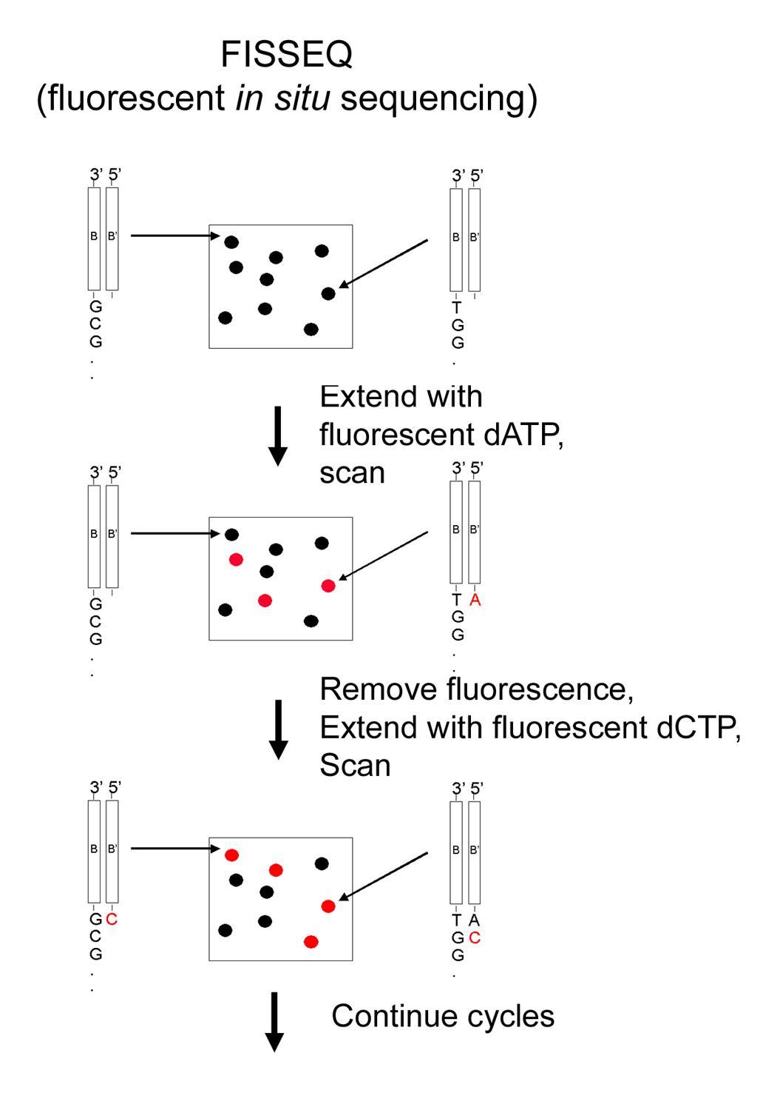
Figures 1-1 and 1-2. Figure 1-1 (on the left) is a diagrammatic representation of the FISSEQ “sequencing-by-synthesis” protocol. Polonies are denatured, and a sequencing primer is annealed to the gel-anchored strand. Polonies are sequenced by serial additions of a single fluorescent nucleotide. After scanning a given slide to determine the subset of polonies that were extended, the fluorescent dye is removed via cleavage of a chemical group linking the dye and the base. The cycle is then repeated. Bases are added in a predefined order (e.g. C..A..G.. T..C..A..G..T..) and the sequence of any given polony is computationally reconstructed from the pattern of base additions. Figure 1-2 (below) presents four cycles of FISSEQ extension on polonies amplified from a small set of templates. The sequencing primer is Cy3-labeled (green), and the fluorescent bases are Cy5-labeled (red). Polonies that have incorporated the added base on a given extension step appear orange, whereas those that have not appear green. The sequence of one of the included templates is shown below the images, and the corresponding polony is labeled with an arrow in each image. The order of base addition was [C..A..G..T..]. Orange polonies display different Cy5 intensities due to sequence context effects on dye fluorescence. Figures are adapted from [Mit03B].

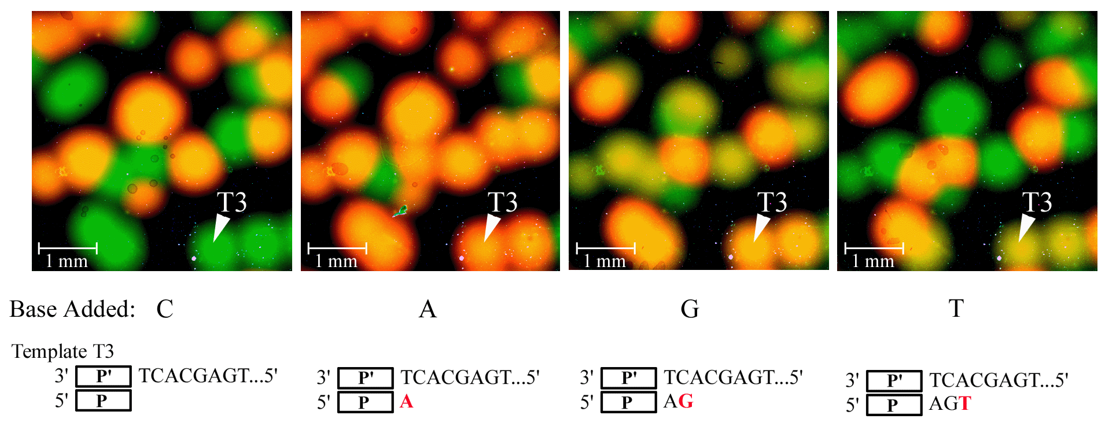

Cost analysis is crucial in genomics R&D. This is especially so when a technology is still formative and a small change in priorities can have a large impact. We have developed an initial set of cost models with over 8 adjustable parameters and protocol branch points. A range from $3M down to $54 per human diploid genome sequence is obtained depending on these parameters. A hyperlinked spreadsheet helps us to make explicit the cost dependencies and to explore a fuller set of scenarios. In the management section we give estimated milestones for exploring each of the major points of impact.

Aim 1a. FISSEQ Protocol Development. The key priorities for further protocol development are (i) FISSEQ accuracy, (ii) FISSEQ read-length, (iii) template library construction, and (iv) polony density. Accuracy is a function of nucleotide and polymerase chemistry (discussed in section 1c of this Aim) as well as the level of sophistication of computational algorithms (discussed in Aim 5). Read-lengths as long as 100 have been described for a related sequencing-by-synthesis method, Pyrosequencing [Gha02]. Two reasons to expect that FISSEQ might have longer read-lengths are that (a) our reaction can go closer to completion since we wash between cycles, and (b) FISSEQ does not contend with dilution-related issues that remain for Pyrosequencing [Gha02]. One of the factors limiting the number of FISSEQ cycles in the past has been physical stress on the gel. We have reduced this dramatically with new polymers (e.g. DATD) and gentler handling of gels via automation (discussed in section 1b of this Aim). Regarding template library construction, we have made in vitro libraries in the past [as per Sin97] and note that in situations where starting material is in excess, this is a mature field. Techniques for polony amplification from small amounts of starting material (e.g. single cells) will be developed in Aim 4.

Polony density can be increased by a higher acrylamide concentration, fewer PCR cycles, and/or increasing template length. We have previously demonstrated that polonies as small as 6 uM (radius) can be amplified and clearly visualized [Mit99]. Three factors have limited us from pushing FISSEQ to maximal polony densities. First, with the original gel chemistry, single base extensions were inefficient on templates over ~100 bp. Inclusion of DATD as an additional cross-linking reagent [Hah87] appears to circumvent this problem, possibly by altering the pore-size or electrostatics within the gel. Second, increased acrylamide concentration comes at the cost of decreased gel stability. To work past this, we are currently exploring the use of commercial gel-strengthening agents. Third, our current imaging systems have a resolution limit of 5 uM per pixel. We are therefore exploring alternatives that will allow more “pixels-per-polony” as we move to higher densities. With our current protocols, we can readily visualize single-base-extensions on ~2.4 kilobase amplification products (43 PCR cycles) in a 12% acrylamide gel that contains DATD. In such gels, the radii of polonies are approximately 75 to 100 microns [image]. At this size and density, ~100,000 distinguishable polonies could be amplified if the full slide area was used. This is still three orders of magnitude below our ultimate goal of 133 million polonies per slide, but also three orders of magnitude above “milestone” experiments presented in Mit03B, demonstrating progress that we have made since submission of the first FISSEQ manuscript.

Isothermal Amplification. In the long term, isothermal formation of polonies may be desirable either to reduce the cost associated with thermal cycling (see scenario #3 in our cost model), to preserve heat labile structures, or to selectively amplify single-stranded-nucleic acids. Isothermal amplification with Φ29 polymerase using random hexamers as primers can begin with either single or double-stranded genomic DNA [Dea02]. We will explore compatibility of these protocols with the polony platform.

Aim 1b. Instrumentation. As each gel must be both scanned and exposed to a variety of solutions as part of each FISSEQ cycle (e.g. cleavage of fluorescent label, alkylation of free sulfhydryl group, single-base-extension reaction), instrumentation is critical to low costs and high throughput. In our current system, sample flow is as follows: a multi-well plate of samples → clean-hood manual pipetting of acrylamide mix onto slides → a 32-slide-PCR machine → a 24-slide dipping device → a 20-slide-auto-loading-scanner. The slides then cycle between the scanning instrument and the dipping device (which performs both removal-of-fluorescence and single-base-extension steps by dipping a slide rack through a series of reactive solutions). Our primary goals are (i) to integrate this further, such that the integrated elements are shareable and easily manufactured,

Figure 1-3. Preliminary Progress in Instrumentation. A prototype dipping device (left panel) was constructed from $500 of hardware. It dips a 24-slide rack through 17 separate solutions and is computer-controlled. This inspired the design (center panel) of a compact, linear, more easily manufactured version, constructed (right panel) by Jim Horn (HMS Machine Shop).

and (ii) to assess and improve resolution, signal-to-noise ratio, and cost-effectiveness via upgrades of individual components. Integration of our fluidics and scanning systems can potentially be done in two ways. One path is to make the slide racks for the dipping instrument and the scanner compatible (or identical), such that the manual portion of the cycling protocol can be reduced to moving a slide rack between these two stations. The second path is a simple flow cell configuration [e.g. Bra03] in which the amplification, cycling and scanning can be done in a sealed immobile chamber within a single instrument. The latter approach will only be developed during Year 2 if our cost model changes. The former slide-rack-based approach seems to have both short and long-term advantages in that (i) a large number of slides can be processed simultaneously without tying up expensive scanning devices and (ii) the setup for thousands of samples in parallel seems simpler than the “plumber’s nightmare” of thousands of flow cells. We will test a variety of automated microscopes and microarray scanners as they become available commercially. This is a rapidly changing and highly competitive field, which hopefully will hasten commoditization, low prices, and high quality. In particular, we will assess CCD versus PMT-based scanners, assessing scanning-time versus signal-to-noise optimization, dynamic range, and ease-of-integration. As much as possible we will perform initial evaluations in collaboration with the manufacturing companies, delaying purchase of any given device until convinced of a mission-critical improvement that we need to assess in-house. A list of candidate instrumentation with costs is provided in the Budget section.

Aim 1c. Nucleotide & Polymerase Chemistry. “Sequencing by synthesis” (SBS) methods generally work by sequential addition of non-terminator nucleotides. An issue for SBS methods anticipated since the beginning [Mel89][Met94][Ron98] is how to determine the number of incorporations at tandem mononucleotide repeats (such as AAA). We anticipate at least 4 major pathways for handling this: (i) "collapsing" runs of bases to use sequence as tags (e.g. GAAAC would yield a tag of GAC), (ii) inferring the number of dNTP incorporations from signal magnitude [Ron98][Gha02], (iii) preventing multiple incorporations with reversible dNTP terminators [Met94], and (iv) single molecules allow asynchronous incorporation and detection of each dNTP in a repeat [Bra03]. The first three methods are relevant to the polony platform and are discussed here.

We have been working on method (i) and anticipate that it should be at least as informative as 21 bp SAGE tags [Sah02] and capable of detecting mutations and polymorphisms as long as they do not affect mononucleotide runs. Gene expression profiling via method (i) is discussed at length in Aim 2a. An extension of method (i) is method (ii), wherein we will explore relative signal quantitation as a means of inferring the length of a given mononucleotide run. In Pyrosequencing, the ability to distinguish runs of 9 and 10 with reasonable confidence intervals by this approach has been shown [Ron98][Gha02]. FISSEQ has an advantage over Pyrosequencing in that the reaction is allowed to go to completion rather than having a race between the destruction of the dNTPs and the completion of each cycle. However FISSEQ (as developed so far) has the disadvantage that fluorophores can interact during incorporation and/or detection [e.g. Bra03]. We will explore (and integrate, if valuable) 3 approaches to method (ii): (a) using mixtures of labeled and unlabeled bases; (b) using allylamine-modified bases and allowing partial chemical labeling as a separate step after nucleotide incorporation, (c) using two fluors to allow fluorescent resonance energy transfer (FRET). In all methods, software will be developed to search and exploit sequence-specific patterns that might include context-effects of bases adjacent to the mononucleotide runs.

In method (iii), we will extend work on reversibly terminating nucleotides. The idea here is to develop a set of nucleotides with a chemical moiety attached to the 3’-hydroxyl, such that one (and only one) nucleotide can incorporate in a given extension reaction, even in the context of a tandem mononucleotide repeat. In a subsequent step of the protocol, the protecting group is chemically or enzymatically removed, leaving a 3’-hydroxyl that can serve as substrate for the next extension reaction. An advantage of this approach is that it opens the possibility of four-color sequencing. In this system, each of the four nucleotides is labeled with a different fluorescent dye (each with a unique excitation wave-length). However, all dyes are attached to their respective base with the same cleavable linker, and all nucleotides are reversibly terminated with the same protecting group. The full set of four nucleotides can be added in each cycle, and all polonies will extend by a single base. Data on incorporation of each base can be collected by scanning the slide at each cycle on four channels, and removal of the dyes and protecting groups can be performed in single steps as well.

Critical to preventing “dephasing” of templates within a given polony in method (iii) are that (a) removal of the terminating moiety must be highly efficient, and (b) the chemical moiety must not significantly interfere with the efficient incorporation of the modified nucleotide by the polymerase. It should be noted that previous attempts at using reversible terminators have been reported and were of limited utility [Met94][Wel99][Wel99B][Che94] [Hia99][Bal01] [Kwi01]. Part of the problem was a desire to have the terminating moiety include a fluorescent group (such that both the 3’ blocking group and the fluor could be removed in a single chemical or enzymatic reaction). As a consequence of this choice, bulkiness of the protecting group could lead to steric clashes with most polymerases.

As we have already developed several working methods for efficiently cleavable fluors on the bases rather than the 3’-OH [Mit03b], we are free to decouple these aspects of nucleotide modification. We will survey small 3’-OH protecting groups and their functionality with various polymerases. Synthesis of modified nucleotides will be performed by consultants or via custom synthesis by commercial vendors, whereas testing of nucleotides will be performed within the Center. We will systematically study incorporation efficiency, deprotection efficiency, sequence context effects, etc. “Winners” will be labeled with SS cleavable fluors [Mit03b] and characterized in the context of the full FISSEQ protocol. The ability to use photo-deprotectable groups are especially interesting because of possible spin-off technologies for "writing" with template-independent polymerases and patterned light sources [Sin99]. In collaboration with a proposed consultant, Jerzy Olejnik, we have already shown the utility of photo-cleavage with our fluor-release system [Mit03b]. The first two photo-labile groups tested as reversible terminators will be the NPPOC and nitrobenzyl groups [Pir01] [Mit03b]. We have already obtained an NPPOC-modified nucleotide from another proposed consultant, Michael Pirrung, and are currently evaluating it in the context of our system.

To optimize incorporation rates of modified nucleotides, we will also conduct global mutagenesis and directed mutagenesis (the latter based on published 3D structures) of the most promising polymerases. Mutant forms of polymerases have been developed by Tabor and others for irreversible dideoxy-terminators, yielding a 1000-fold improvement in utilization of the modified nucleotides (Figure 1-4) [Tab95]. We anticipate collaborating in this area with Stan Tabor and Tom Ellenberger's groups at Harvard Medical School. It will be important to test polymerases for residual 3’→5’ exonuclease activity, as well as to carefully ensure that undesired chemical or enzymatic release of 3’ blocking groups can be excluded. For example, when present as 3’ blocking groups on nucleotides, normally stable protecting groups such as thioureas and acetals are rapidly removed by polymerases [Marek Kwiatkowski, personal communication].

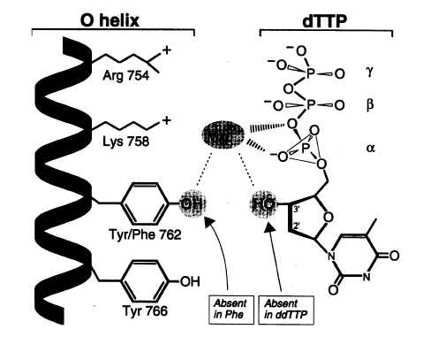Figure 1-4. Residues homologous to Phe762 and Tyr766 are close to the 3' OH of the incorporating nucleotide and have been shown to influence incorporation of chain-terminating analogs by up to 8000-fold. Adapted from [Tab95].

Fluor Removal Chemistry. Our current system uses Cy5-SS-dNTPs [Mit03b]. To remove the fluorescent Cy5 group after each extension, we treat with beta-mercaptoethanol, but this leaves a free sulfhydryl group. To cap this potentially reactive group, we then treat with an alkylating agent, iodoacetamide. It is likely that this protocol, which leaves incorporated nucleotides minimally modified prior to the subsequent extension step (i.e. we do not use mere dye-photobleaching agents which would leave large substituents on the bases) has been helpful to our progress-to-date. We have been actively testing alternative compounds to increase the efficiencies of these steps. In preliminary results, we have demonstrated moderate success with alternative reducing agents, including MESNA and TCEP, as well as alternative alkylating agents such as malemides. We will continue to test new reduction and alkylation chemistries in the context of the FISSEQ protocol as it evolves.

Alternatives to Fluorescence. Fluorescence is a superb starting technology for polony-based sequencing. However, fluorescence has disadvantages, including dark states and bleaching, requirements for expensive lasers (> $10K), and lasers and optics where less than 1E-19 of the input electrical power arrives at CCD or PMT detection devices. In contrast, photon-scattering nanoparticles (typically 40 nm clusters of gold or silver atoms) can utilize white light and/or simple LED sources. These particles have been shown to be 10 times more sensitive than fluorophores in comparably optimized assays [Ygu01]. We will explore the utility of these particles using commercially available nanoparticle-labeled anti-biotin antibodies. Specifically, we will incorporate biotinylated dNTPs into polonies, and attempt to detect incorporation via reversible binding of the nanoparticle-labeled antibodies. In an ideal scenario, inexpensive (~$50) microscopic digitization devices might provide high signal-to-noise ratios. An alternative approach that we are considering (still fluorescence, but offering advantages over conventional dyes of narrow emission spectra and bleach resistance) would make use of Q-dot fluorescent labeling reagents [Lac00].

Aim 1d. Detection of Rare Mutations. Aims 1a, 1b, and 1c discuss technical advances necessary to develop the polony platform into a high-throughput sequencing method. Towards shorter-term clinical and epidemiological applications, we propose polonies as an inexpensive, high-throughput platform for the detection of rare mutations, in evaluating hypothesized locus-disease associations in the context of genetic heterogeneity. The polony technology, in its immediately deliverable form, is capable of rapidly and cost-effectively screening a pool of DNA derived from thousands of individuals for mutations at a specific genomic position. A unique advantage of polonies over other genotyping technologies is that over the numerical range of individuals normally genotyped within any given study (e.g. n=1 .. n=50,000), the cost is fixed, as all genotypes can be obtained on a single slide. This is possible by simply pooling or arraying genomic DNA within a single gel. By genotyping-in-parallel (via standard amplification and single-base-extension over the position of interest), we are already capable of detecting mutations at frequencies as low as 1 in 100,000 (Figure 1-5).

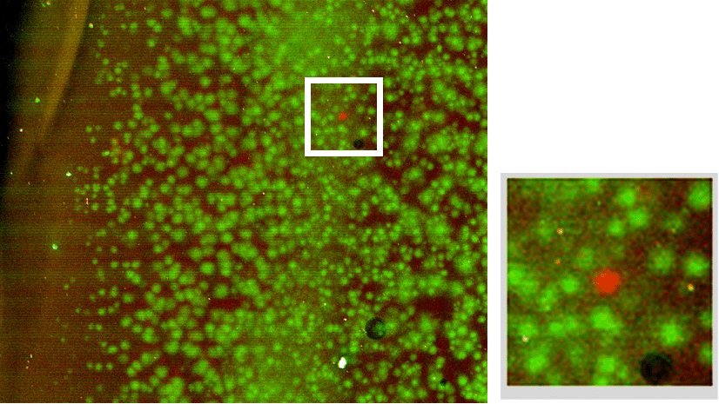
Figure 1-5. Detection of rare mutations on the polony platform. Nucleic acid bearing a point mutation was spiked into un-mutated nucleic acid template at a ratio of 1:100,000. The single red polony amidst a sea of green polonies exemplifies detection of the mutant nucleic acid with an excellent signal-to-noise ratio (adapted from unpublished data).

Through collaborations with David Hunter and Eric Lander, the Center will have access to in excess of 80,000 human DNA samples, each anonymously associated with data on the health of the individual from which it was collected (i.e. phenotype). As discussed in the Background & Significance, conserved CpG dinucleotides in protein-coding regions represent a particularly interesting class of nucleotides with respect to their over-representation in the set of mutations underlying monogenic human disease. We propose an inexpensive, high-throughput approach to performing genotype-phenotype association studies by mini-sequencing of all conserved, protein-coding CpG dinucleotides within a given gene of interest.

We are in the process of planning proof-of-principle experiments that will primarily involve cases of known locus-disease associations where the relevant phenotype is sufficiently represented in our panel of human DNA samples. To test a hypothesized locus-disease association (e.g. MC4R and severe childhood obesity), we propose the following general approach: (1) Generate sub-pools of genomic DNA (i.e. both a “test pool” and a “control pool”) from the master-panel on the basis of specific clinical criteria. The pooled genomic DNA will be used as template for polony amplification and mini-sequencing. (2) On any given slide, amplify polonies from a target region within the gene of interest using the pooled genomic DNA as template. (3) On any given slide, sequentially query conserved, coding CpGs for any and all mutations present in an individual within the pool (i.e. via FISSEQ of 2-base-pair sequencing reads, using a set of sequencing primers adjacent to CpG positions). If samples are pooled and the number of polonies exceeds the number of individuals represented in the pool by an order-of-magnitude, detection of a single individual with a mutation in any given CpG dinucleotide should be unambiguous. (4) Gene-trait associations suggested via the discovery of mutations specific to the “test pool” of genomic DNA can be followed up by confirmation via dideoxy- sequencing.

The advantages of the outlined approach are that it would be significantly less expensive than conventional dideoxy-sequencing of all exons from all genomic DNA samples of all individuals in test and control sets. A disadvantage is that by focusing on CpG positions, one risks missing rare associations (e.g. if only a few individuals in the test-pool had mutations in the hypothesized disease-associated gene due to genetic heterogeneity, and those mutations happened to not involve CpG dinucleotides). An additional disadvantage is that in the above methodology, pooled DNA is randomly scattered within a gel, such that the origin (i.e. the patient source) of a given strand of DNA is lost. In another method, standard arraying technology can be used to spot template genomic DNA from individual patients to defined coordinates on the slide prior to polony amplification. We have already combined arraying and polony amplification in the context of single-cell work (Aim 4).

8c/d. Aim 2. Quantitating RNA Molecules & Exon Typing [to top] [timeline]

Overview. The second aim of the MGIC is to develop applications of the polony platform in the field of gene expression profiling. As discussed in Section B, polony profiling of the transcriptome will represent a significant advance over state-of-the-art technologies in the field, in terms of cost-structure, throughput, precision, and coverage. In Aim 2a, we will develop methods for highly parallel, digital analysis of gene expression. Specifically, we will apply a variant of the FISSEQ protocol to generate “condensed sequence tags”, such that a polony can be unambiguously matched to the transcript from which it was derived. A second, more limited method relies on quantitation via pools of gene-specific sequencing primers. Biologically, we will focus on expression profiling of murine ES cells undergoing neural differentiation. We have chosen basic experimental issues not addressed by established profiling technology and thus will provide information the field needs to go forward. Our priorities are to first get data within easy reach of the technique and then push towards more ambitious goals. In Aim 2b, we will focus on quantitation of alternatively spliced exons and the combinations in which they occur within individual transcripts. Clinically, we will focus on (1) dysregulation of Tau alternative splicing in neurodegenerative disease and (2) altered patterns of CD44 alternative splicing in tumorigenesis. We will also profile alternative splicing across a large number of human genes to explore the extent of natural variation in splicing as well as to survey the dependencies of mammalian exon combinatorics. Profiling of alternative splicing will serve as an established application on which we can pilot our abilities to scale the polony technology to high-throughput sample processing.

Aim 2a. Polony Expression Profiling of ES Cells Undergoing Neural Differentiation. We first consider technical challenges to polony expression profiling and then discuss the actual biology that we will pursue with these protocols.

Condensed Read FISSEQ. Digital quantitation must be achieved by identifying, in parallel, the transcript that gave rise to each polony. In the first method, we will apply FISSEQ to identify polonies derived from cDNA. After amplification, we will denature the unanchored strand of amplicons and hybridize a universal sequencing primer, targeted immediately adjacent to unique cDNA sequence. We will then sequence short “tags” (40 base-pairs on average) that can be used to unambiguously identify the origin of a given polony. This protocol will essentially be identical to the FISSEQ schematic for multi-base sequencing-by-synthesis [Mit03B]. Strategies for advancing on our preliminary success in FISSEQ are discussed in detail in Aim 1. To avoid excessive dependence of Aim 2a goals on the successful accomplishment of Aim 1, we have designed an approach to “compressed tag” sequencing that is quite compatible with well-tested nucleotide chemistries and our current systems of automation and image acquisition. Advances towards Aim 1 goals will be incorporated into Aim 2a protocols as they occur.

This application of FISSEQ avoids one of the major technical hurdles that remains for genomic sequencing. Specifically, it is possible to proceed without solving the problem of how to sequence homopolymers (e.g. two or more adjacent occurrences of the same base), a challenge that is universal to sequencing-by-synthesis methods (discussed in detail in Aim 1). Applying current FISSEQ protocols and our well-tested set of Cy5-SS-dNTPs will lead to the generation of “compressed sequence tags” (CST), in which stretches of the same base appear as a single addition of that base. For example, the sequence “AAAGGCTT” would read in serial single-base-extensions with non-terminating nucleotides as “AGCT”. However, if a given CST is of sufficient length, it can be unambiguously matched to a unique origin within a given transcriptome or genome.

We evaluated what length of sequencing read would be necessary before a given CST could be assigned to a unique location in a given genome. In other words, what read-length of CSTs is necessary to make this approach practical? In computational simulations, we find that read-lengths beyond the 25 to 30 base-pair range are sufficient to unambiguously identify the origin of nearly all CSTs, and read-lengths beyond this provide diminishing returns (Figure 2-1). Given that we have already demonstrated read-lengths in the 5 to 8 base-pair range with labeled nucleotides, and up to 26 single-base-additions with unlabeled nucleotides [Mit03B], we feel that a target mean read-length of 40 is a reasonably limited extension over what we have already accomplished, and therefore technically feasible in the short term.

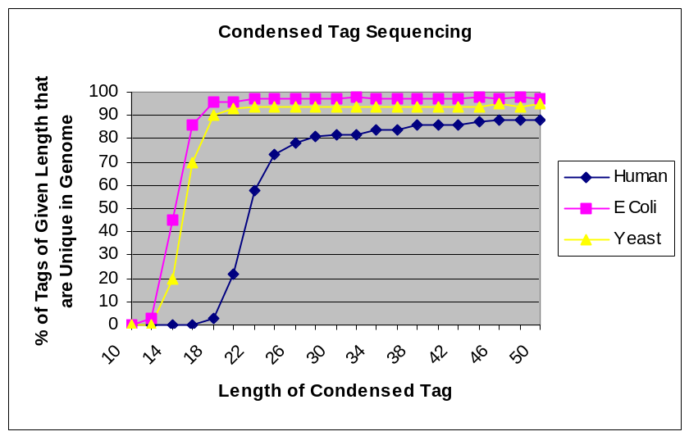
Figure 2-1. Condensed Tag Sequencing. We performed a Monte Carlo simulation of FISSEQ-generated condensed sequence tags (CSTs) of various lengths from randomly selected starting points of a given genome sequence. We then calculated the fraction of CSTs of a given length that occur once and only once within that genome. The results of this analysis are depicted in the plot. For example, if a condensed sequence tag of length 30 was obtained from a polony derived from human cDNA, our analysis indicates that there would be a 82% chance that it could have only been derived from one and only one location in the human genome. The curve for the humans is a conservative estimate of what could be done, as the effective size of the human transcriptome is substantially smaller than the human genome. The leveling off of the curve for the human genome well below 100% is due to the relatively large fraction of repetitive elements and segmental duplications.

As discussed in Aim 1, FISSEQ proceeds by sequential base additions in a predefined order (e.g. T..C..A..G..T..C..A..G..”). Each base addition is referred to as a “quarter-cycle” and each cycle of adding four bases (e.g. “T..C..A..G..”) as a full-cycle. We will perform 20 full-cycles per slide. Simulations and analytical solutions in a random sequence model indicate that this number of cycles will yield CSTs with read-lengths of 40 ± 3.

Raw images generated by each sequential base addition will be processed by algorithms developed in Aim 5 that provide integration and advancement over our current sets of polony analysis software [Mit03][Mit03B] [Zhu03]. “Signatures” (i.e. the pattern of images in which a given polony indicates extension with a given series of nucleotides) will be determined and converted to CSTs. The tag sequences can then be matched against databases of annotated transcripts. Tags that do not match known transcripts can be slated for further validation as exons of previously unannotated genes [Che02] or novel splice variants of known genes.

Polony Identification with Pooled Probes. In a second method, we will explore an alternative to FISSEQ-based identification of polonies. Specifically, polonies will be identified by hybridization of single or pooled gene-specific probes to an amplified gel. This approach is attractive for a number of reasons. (i) In our experience, hybridization to polonies with relatively short gene-specific probes (e.g. ~25 bp) is a highly specific reaction, generally yielding signal-to-noise ratios of 50:1 or greater. (ii) Probes do not necessarily need to be synthesized with a covalently attached fluorescent label (as this can be quite costly). Instead, the label can be added to all probes after hybridization, via an in situ single-base-extension reaction [Zhu03]. (iii) A gel can undergo repeated cycles of probe hybridization (with a denaturation step between cycles to remove previously hybridized probes). We have successfully passed through at least 10 serial rounds of probe hybridization, single-base-extension, and denaturation of extended probe, without significant damage to the gel matrix. (iv) The approach will be useful for confirming results obtained by the first method.

An obvious drawback of this approach is that the serial application of gene-specific probes limits throughput. A ‘data compression’ scheme will therefore be tested. We will synthesize probes specific to a set of genes (one per gene). Pools of probes will be designed and generated, such that although each probe is present in one or more pools, the specific combination of pools in which a given probe is present is unique. Gels of amplified polonies derived from cDNAs will undergo repeated cycles of hybridization with probe-pools, labeling via single-base-extension, and denaturation. Our software can readily identify the specific combination (i.e. “signature”) of probe pools with which each polony underwent successful hybridization/extension. The signature of each polony can then be matched to the gene-specific probe used in the same combination of pools. The maximal number of such combinations that can be encoded with a set of N pools is 2^N (e.g. 20 pools to encode ~1 million probes), but by using only a fraction of the full set of possible combinations the risk of errors can be greatly reduced (i.e. an error-correction code). A potential caveat is that we have little experience with how many probes can be reasonably pooled before we begin to see inter-probe interference or significant non-specific signal.

Neural Differentiation of ES Cells. Stem cells are widely recognized as having enormous potential in the areas of basic and medical research [Bri03][Got02]. Because ES cells have the potential to develop into all cell types of the body it should be possible, in principle, to guide their differentiation in culture along a particular lineage resulting in terminally differentiated cells of a desired type [Bai95][Fra95][Str95][Got02]. Significant steps in this direction have been taken in the case of the neural lineage using murine ES cells. One protocol, developed within our group, is illustrated in Figure 2-2.

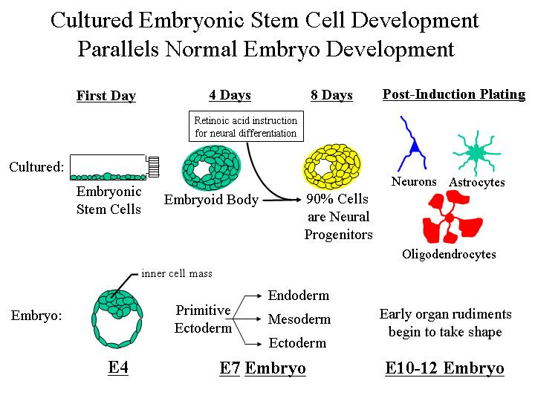
Figure 2-2. Undifferentiated, totipotent, murine ES cells are first cultured as aggregates, also known as embryoid bodies (EBs), in the absence of the cytokine LIF which promotes self-renewal of ES cells. By about 4 days, EBs contain a mixture of stem cells including those for blood and lymphoid lineages, mesenchymal stem cells (which can differentiate into cartilage, bone, fat and smooth muscle) and neural stem cells. Culture of EBs for an additional 4 days in the presence of retinoic acid (RA), results in conversion of about 80% of the cells into neural stem cells. Plating these stem cells on an adhesive surface promotes terminal differentiation of neurons (glutaminergic, GABAergic and glycinergic), astrocytes and oligodendrocytes. A variant protocol with sonic hedgehog (shh) promotes motor neuron differentiation.

Despite much progress in the in vitro manipulation of ES cells, a major challenge remains. To date the focus of research has been on the development of specific neural stem cells and terminally differentiated cells. A logical follow-on goal is to model not just cells but actual nervous tissue. In the normal developing nervous system each anatomical region is identified by a positional code defined by expressed regulatory genes including transcription factors and cell surface signaling ligands and receptors [Shi02]. The spinal cord and hindbrain express a large number of Hox genes, but these genes are not expressed anterior to the hindbrain. Anterior divisions selectively express genes such as engrailed (midbrain) or Bf-1 (forebrain). As a first step towards modeling the spinal cord we are studying expression of Hox genes. Hox genes are arrayed in the genome in 4 paralogous groups, each of which is a contiguous set of about 12 genes. Orthologous genes are highly similar but have slightly different expression patterns. We are currently asking the first order question “Are these Hox genes expressed in the ES cell system?” Our preliminary data show that they are and we conclude that by studying the expression of these region-specific genes we can reduce the problem of modeling a tissue to a manageable proportion. The high-resolution expression analysis afforded by the polony platform will be crucial in unraveling this problem.

Preliminary inquiries focused on the question of whether region-specific genes are expressed in ES cell-derived neural cells. In summary, we found via non-quantitative RT-PCR that ES cell-derived neural cells express 9 Hox genes from the B and D paralogous groups as well as midbrain and forebrain markers. This finding affords a starting place for analyzing how regional fate choices are controlled. In initial experiments, we will focus on mRNA isolated from small populations (several hundred cells) from each of five time-points of in vitro ES cell differentiation. We will generate cDNA via reverse transcription, generating sequences complementary to universal primers via oligo dT priming and 5’ polyA added by terminal transferase. Alternatively, we will use commercial kits to generate common primer sequences flanking cDNAs.

Methodologically, we anticipate two approaches, corresponding to the two methods for polony expression profiling described above. In the first method, we will apply gene-specific probes (either singly or via the pooled method described above) to precisely quantitate the absolute abundances of a core set of positional genes. Our first experiments will focus on nine Hox genes, engrailed 1 and 2, and Bf-1. We will then seek to expand to a set of several hundred known genes. The stem cell field has already identified about 100 genes that are relevant to the developmental pathway and more are rapidly being discovered [Tie03].

In the second method, as techniques developed for FISSEQ-based expression profiling are advanced, we will perform quantitation of the full transcriptome of these differentiating cells. Knowledge and quantitation of the full transcriptome of individual cells will have a great impact on the field. The next frontier in stem cell biology is to understand and model how multiple networks of genes operate within stem cells to determine important biological steps. Our best guess is that hundreds of genes, many unannotated due to the early stage at which they are expressed, are involved in this process and only knowledge of the full transcriptome will reveal the important patterns. We anticipate that this effort may proceed rapidly and we hope to contribute to the annotation and precise quantitation of transcripts that are relevant to guiding stem cell differentiation.

Future Directions. An exciting aspect of developing polony expression profiling around this set of questions is that it provides a direct launching point for connecting progress in Aim 2 with that of Aim 4. Data based on analysis of pooled cells suffers a fundamental limitation and cannot answer a set of first-order questions: (i) Are all members or specific subsets of members of a paralogous group expressed in single cells? (ii) Are all or specific subsets of Hox genes expressed in individual cells; (iii) Do cells that express posterior markers also express anterior ones or have they already made a binary fate choice? Answers to these and other basic questions require single cell and/or in situ level analyses such that expression profiles can be correlated with anatomical and temporal variables. As the method is proven, we will push towards single cell resolution (e.g. each gel amplifies template derived from a single cell; “unicellular multiplex”). In later years, we will seek to incorporate methods developed in Aim 4 for multicellular, multiplex quantitation on a single slide. We hope to characterize and learn how to manipulate differentiating ES cells with an unprecedented degree of precision.

Aim 2b. Single Molecule Profiling of Alternative Pre-mRNA Splicing. The paradox of how mammalian complexity emerges from a mere 30,000 genes [Wat02] can be explained in part by extensive alternative splicing of the transcriptome. As discussed in the Background & Significance section, the community is in need of a multiplexed technology capable of quantitating isoforms of the greater than 55% of mammalian genes that likely undergo alternative splicing [Kan01]. Importantly, our method is readily capable of not only quantitating alternative splicing, but also deciphering the complex cis combinations in which multiple alternatively spliced exons occur within single transcripts. In work recently submitted for publication [Zhu03], we demonstrate successful quantitation of alternative splicing within three mammalian genes. We do not consider these to be merely proof-of-concept experiments, as we are actively pursuing profiling of clinically-isolated samples for two of these three genes.

Our technical approach is as follows. Specific primers directed at constant exons of a defined target gene are used to amplify single transcripts of that gene from a complex cDNA sample. Denaturation of the unanchored strand is followed by hybridization of a labeled exon-specific probe. Alternatively, we can hybridize an unlabeled probe and perform in situ labeling via a single-base-extension reaction. Repeated cycles of denaturation, hybridization, single-base-extension and imaging, can be used to query the presence or absence of multiple alternatively spliced exons in the same amplified gel. The “signature” of each polony across the set of acquired images defines the combination of alternatively spliced exons that are present in the single cDNA molecule from which that polony was derived.

Figure 2-3 presents polony profiling of alternative splicing within human Tau transcripts in cDNA derived from human brain. The Tau gene product has clearly been implicated in a number of neurodegenerative diseases, including Alzheimer’s disease, Pick’s disease, Chromosome 17-linked frontotemporal dementia and parkinsonism, cortico-basal degeneration, and progressive supranuclear palsy [Lee01]. We would like to pursue the question of whether splicing of Tau is dysregulated within neurodegenerative plaques of Alzheimer’s patients. Brad Hyman’s group, which has expertise in both neuroanatomical pathology and laser-capture-microdissection (LCM) is providing clinical samples to Jun Zhu (Church Lab) who is collecting data in this area. Progress on this goal will be informed by technical aspects of Aim 4, in which we are generating protocols to handle RNA derived from a few or single cells.

Figure 2-4 presents the monitoring of combinatorial patterns of exon inclusion in individual murine CD44 transcripts. CD44 has ten alternatively spliced exons, and can therefore potentially encode 1024 (2^10) isoforms. The question of whether variant exons of CD44 can serve as prognostic cancer markers has been the subject of long controversy in the literature [Pon03]. We profiled over 9000 individual murine CD44 transcripts, identifying 69 unique sets of exon combinations (15 of which could account for 95% of observed
isoforms). Furthermore, we were able to capture highly significant changes in the relative expression of specific CD44 isoforms upon stable expression of an active form of MEK1 in a tumorigenesis cell-line model.

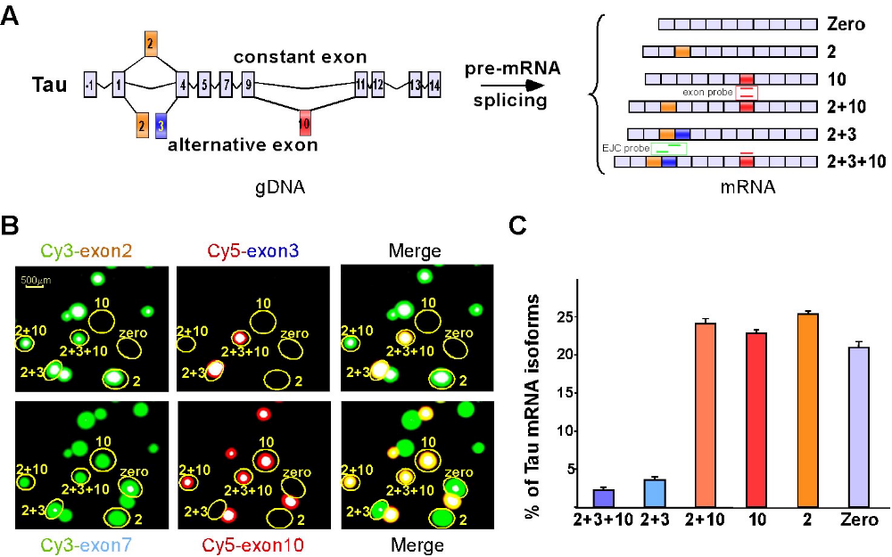

Figure 2-3. Polony Profiling of Splicing at the Tau Locus (A) Scheme of brain-specific Tau alternative splicing. Constant exons are shown in light blue, whereas alternative-spliced exons, exon 2, 3 and 10, are shown in orange, blue and red respectively. All six possible alternative splicing isoforms are indicated. Examples of an exon probe and exon-exon junction probe (EJC probe) are shown as red and green, neither of which will hybridize to a unique mRNA species. (B) Individual and merged images were obtained by hybridizing exon 2, 3, 7 or 10 specific fluorescence (Cy3- or Cy5-) labeled probes to the same gel. Six different Tau alternative splicing isoforms were identified as indicated. The white center shown in some of the polonies is due to signal saturation. (C) Quantification of Tau alternative splicing based on triplex experiments (total polony number n= 723). Adapted from Fig 1 of [Zhu03].
These exciting results support the possibility that specific combinations of variable exons, as well as comprehensive splicing profiles, may prove to be more robust and specific prognostic markers than any single exon. We are actively pursuing this hypothesis by scaling up the throughput of our CD44 assay. We are working with a collaborator (Matthew Meyerson’s group at the Dana Farber Cancer Institute) to obtain access to clinically-derived specimens for this task.

Finally, we focused on the survival motor neuron (SMN) genes, which are present as two nearly identical, paralogous copies in the human genome. This experiment combined exon profiling with mini-sequencing of a single nucleotide change. We were able to amplify transcripts derived from both the SMN1 and SMN2 loci and quantify alternative splicing. However, we could also distinguish SMN1 and SMN2-derived polonies from one another by mini-sequencing over a transcribed polymorphism that distinguishes the two genes (Figure 2 of [Zhu03]). By the same method, we are capable of precisely quantifying polonies derived from the maternal vs. paternal allele of a single-copy gene, if a transcribed SNP is present (e.g. Figure 3 of [Mit03]).

Target Selection. We envision digital polony profiling as a quantitative, multiplexed platform to study spatiotemporal regulation of alternative splicing and to correlate diversity in splicing with genetic variability, developmental stages, and disease states. It also represents an “immediate-deliverable”, and will therefore serve as a model application for our efforts to scale up the sample-throughput of the Center. To summarize, we will focus on four classes of targets: (i) Quantitating Tau alternative splicing in LCM-dissected neuro-degenerative plaques. (ii) Quantitating CD44 alternative splicing in biopsy specimens of cancer patients. (iii) Exploring natural and “paralogous” variation in alternative splicing. (iv) Quantitating exon combinatorics in a large set of genes.

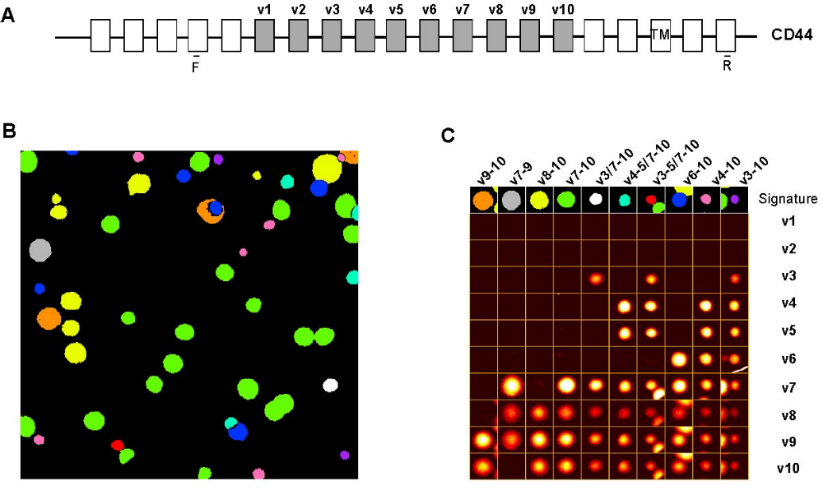

Figure 2-4. Polony Profiling of Splicing at the CD44 locus (A) Schematic of murine CD44 locus. Alternatively spliced exons, v1 through v10, are shown in grey. Positions of amplification primers used here (F and R) are as indicated. (B) Images specific to the detection of each of the 10 individual alternative exons were aligned at single pixel resolution (10 micron) and processed to detect polonies and determine exon composition signatures. Pseudocolors are assigned to unique mRNA isoforms with specific compositions of variable exons. orange= v9-10; grey = v7-9; yellow = v8-10; green = v7-10; white = v3/7-10; light blue = v4-5/7-10; red = v3-5/7-10; dark blue = v6-10; pink = v4-10; purple = v3-10. (C) Distinct polonies shown in (B) with corresponding regions from each background-subtracted signal image. Note that four of the profiles each contain a portion a second, adjacent polony in the image: v9-10 (+ v8-10), v3-5/7-10 (+ v7-10), v6-10 (+ v8-10), and v3-10 (+ v7-10). Adapted from Fig 3 of [Zhu03].

The first and second goals involve scaling a single assay to process a large number of RNA samples, and the biological motivation for each is described above. The third and fourth target classes involve performing a large number of assays on a limited number of samples. Between these goals, we anticipate profiling splicing in a total ~500 distinct genes as an initial goal. Our motivation for these particular classes of targets is described in more detail here.

Although humans may be genetically 99.9% identical to one another, recent studies have found significant amounts of variation in transcription between normal individuals [Yan02][Yan02b][Cow02][Che03][Sch03]. By mini-sequencing of transcribed polymorphisms in amplicons of a specific transcript, we have demonstrated that polonies provide an accurate means of quantitating allelic ratios (e.g. transcription off the paternal vs. maternal chromosome) (Figure 3 of [Mit03]). Other technologies may be more high-throughput in the number of genes that can be scanned for transcriptional variation, but no other is well-suited to study variation between individuals in patterns of alternative splicing. An analogous task is to study how patterns of alternative splicing evolve, an intriguing task given how little is known about the regulation of alternative splicing. An actively accessible fossil of evolution is present in recent gene duplications (such as SMN). At least 1739 genes have closely related paralogs in the human genome (i.e. ranging from 95% to 99.9% identity). By simultaneously monitoring the splicing patterns and genomic source of transcripts of these genes (using the same methodology as with the SMN locus), we will effectively study how patterns of both transcription and alternative splicing diverge in the period of evolutionary time immediately following a gene duplication.

The polony technology is also unique in its ability to query patterns of exon inclusion / exclusion within single transcripts. We have identified 1363 genes (~60% of the human alternative splicing database [Mod01]) that contain more than one alternative splice site [Gu02]. Some of these genes contain as many as 17 alternative splice sites. Our goal is to quantitate the combinations that occur and the extent to which patterns of combinations are spatiotemporally regulated or exhibit splicing “dependencies” such as those that were observed for CD44 [Zhu03].

Prioritization will be given to targets on these lists that have relevance to human disease or represent the highly complex scenarios. We are curious to see if a mammalian equivalent of Drosophila dscam can be found (in terms of the number of potentially encoded isoforms, as the mammalian homolog of dscam is not alternatively spliced).

Development of High Throughput Work-Flow. From a technical perspective, the protocols for Aim 2b goals have been largely worked out. The challenge will therefore be on how to scale our efforts to generate primary biological data. Methods for inter-lab transfer of biological samples, as well as raw and processed data, will have to be implemented. Informatics personnel will have to establish lines of communication to other groups to provide solid support in target-selection, primer-design, and data processing. Automation will have to be integrated. For gene-focused goals (CD44 and Tau, initially), the work-flow must begin and end with the disease-focused researchers, who are ultimately in the best position to interpret the biological relevance of the data. For survey data (target classes (3) and (4) in the above list), the task of data interpretation will remain with the informatics group. We are excited to have this area as an “immediately-deliverable” goal because it puts us in a position to set up a sample processing program that other technologies can be substituted in to as they come online. These tasks are related to Aim 3a, which will also involve scaling of an “immediate-deliverable” (direct molecular haplotyping at the ApoE locus).

8c/d. Aim 3. Long Range Sequence Connectivity & Haplotyping [to top] [timeline]

Overview. The third aim of the MGIC is to enable (i) direct molecular haplotyping and (ii) de novo sequencing, by establishing methods to obtain multiple sequencing reads at various locations from the same single molecule of DNA. We have already made progress in developing the polony haplotyping technology [Mit03]. In Aim 3a, we propose technical improvements to the protocol, and plan to use polony haplotyping to study the relationship between genetic variations in regulatory regions of ApoE and progression of Alzheimer's disease. In Aim 3b, we discuss technical advances that will likely be necessary to achieve high throughput de novo sequencing with the FISSEQ polony platform.

Aim 3a. Direct Molecular Haplotyping. In the polony haplotyping approach (Figure 3-1), we use a small amount of patient DNA polymerized into an acrylamide gel containing all of the reagents necessary for PCR. Two pairs of locus-specific PCR primers are included, each pair capable of amplifying a short region containing one of the SNPs of interest (i.e. with both targets on the same chromosome but separated by a substantial distance). Because the concentration of patient DNA is so low, the chromosomes are well separated from each other on the surface of the slide. We then perform an in gel PCR reaction to simultaneously amplify two loci from a single DNA molecule. Because the acrylamide matrix restricts the diffusion of amplification products, double-stranded DNA accumulates around the chromosome, forming two overlapping polonies - each amplified from a different region on the same molecule of DNA. Acrydite-modification of one member of each pair of locus-specific primers ensures that one strand of each amplified polony is attached to the acrylamide matrix [Reh99]. As described earlier in this proposal, this allows us to remove the unattached strand from all polonies by heating and washing the slide, leaving single-stranded templates for subsequent single base extension (SBE) reactions [Dub99][Pas96][Pas97]. Serial SBE reactions (using sequencing primers internal to the PCR products and adjacent to the SNP positions) essentially allows us to phase the SNPs by identifying the genotypes that occur at overlapping positions (Figure 3-1). We have successfully applied this strategy over a range of genomic distances (8 to 45 kb) [Mit03]. For SNPs that are 1-4 kilobases apart, another feasible strategy is to use a single pair of primers to amplify all SNPs in a single amplicon and then genotype the SNPs by repeated SBEs.

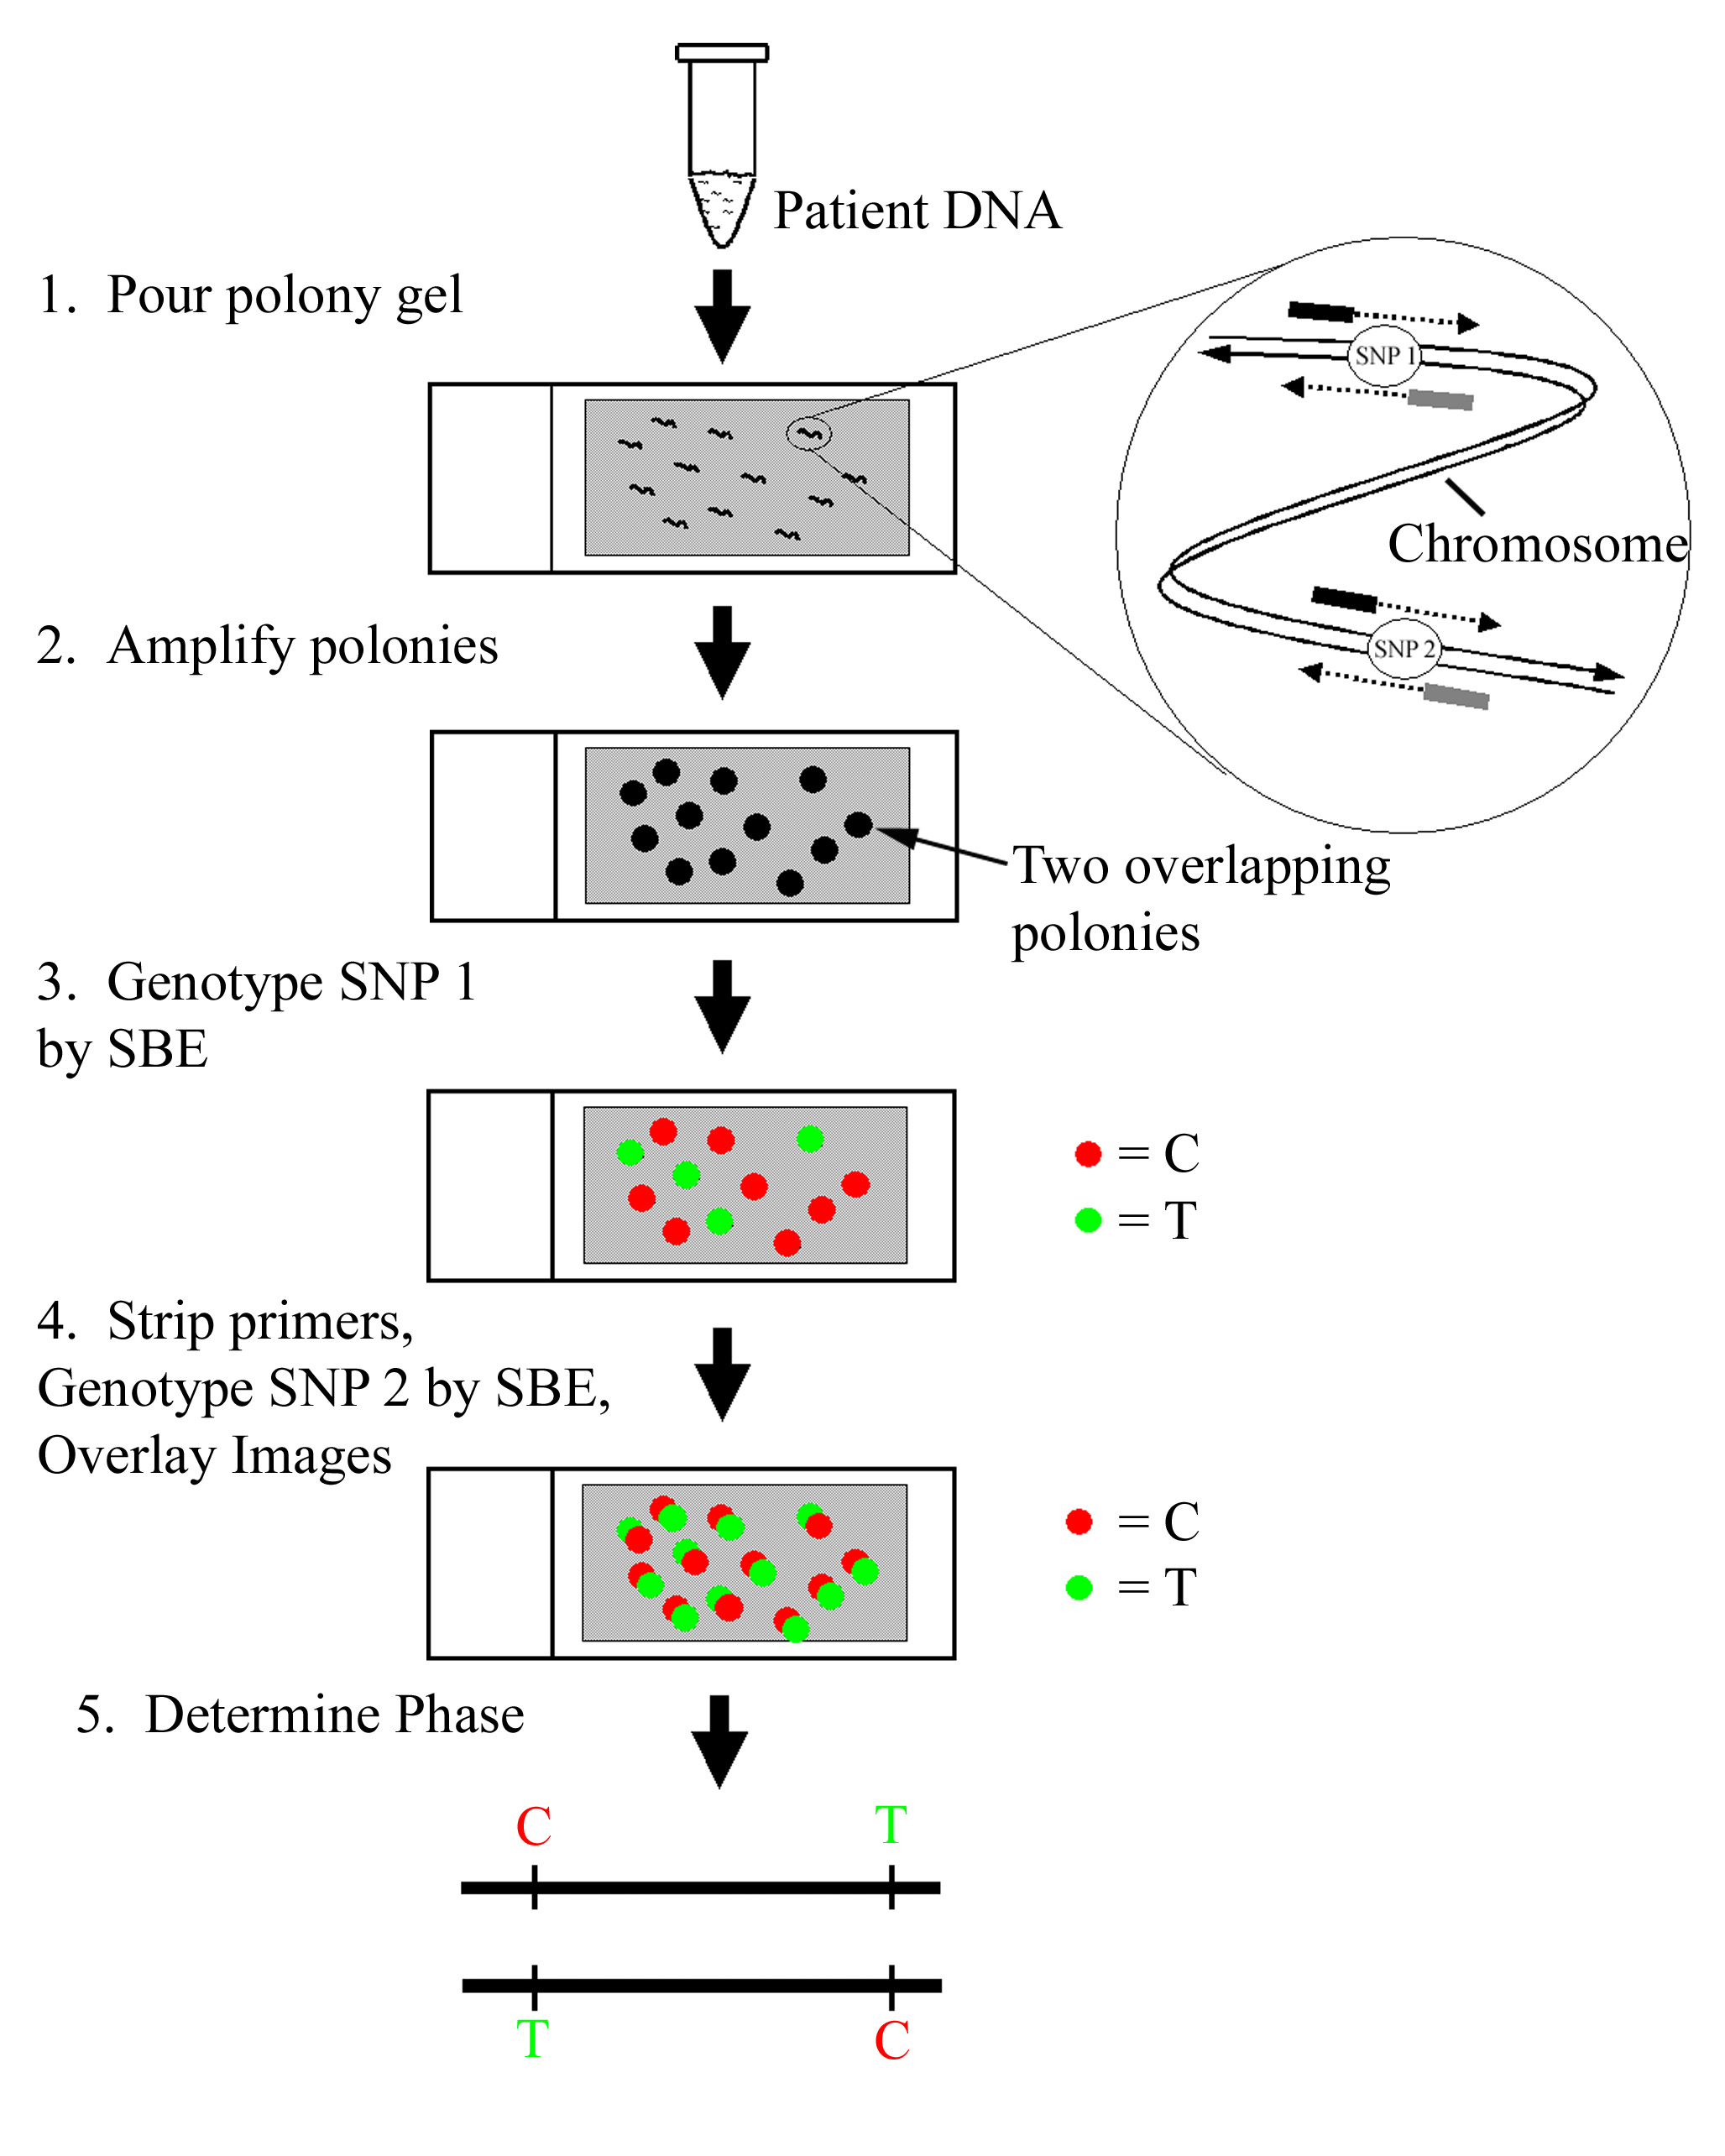
Figure 3-1. Polony Haplotyping.

1) Polymerize dilute sample of patient DNA into a polyacrylamide gel on a glass microscope slide.

2) Amplify single chromosomes by PCR with two
primer pairs flanking the SNPs of interest (inset).

3) Genotype the first SNP by performing an SBE reaction with a location-specific sequencing primer, and scan the slide using a laser scanner.

4) Denature the slide, then genotype the second SNP by performing a second SBE reaction (using a different location-specific sequencing primer), and scan the slide as above.

5) Computationally merge the images to detect overlapping polonies. The haplotype is determined directly from the overlapping polonies. Figure adapted from [Mit03]

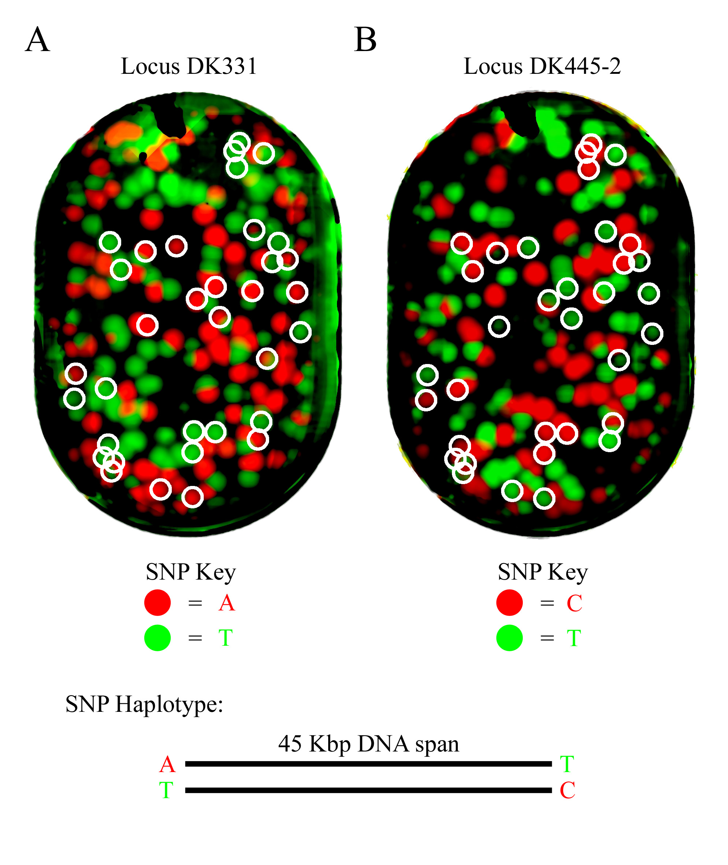
Figure 3-2. Polony Haplotyping at CFTR Locus. To test whether we could use the polony technology to correctly determine both the genotype and haplotype from patient samples, we examined two SNPs that are 45 kilobases apart on chromosome 7. These SNPs, DK331 and DK445-2, have been previously characterized [D. Keen, D.E. Housman personal communication], and their phase is known because they are in strong linkage disequilibrium with one another.

We amplified and genotyped SNPs DK331 and DK445-2 by SBE. 153 polonies were genotyped at the DK331 locus (5A) and 175 polonies were genotyped at the DK445-2 locus (5B). We identified 34 overlapping polonies (circled in the figure) in an informatically-merged scan, 32 of which indicated that the A variant at SNP DK 331 is in cis (i.e. on the same chromosome) with the T variant of SNP DK445-2 (LOD = 20.3). The SNPs were separated by a genomic distance of 45kb. More details are available in [Mit03]

Automation of Polony Haplotyping and Pooled Strategies. We will first convert the polony haplotyping protocol into a 96-well format. Currently, each genotyping or haplotyping experiment is performed on a single microscope slide. This means that at best, one can perform 10 to 25 reactions in a day. However, adapting this technology to glass-bottomed 96-well plates would enable us to utilize commercially available fluidics platforms (e.g. BioMek). To image the polonies in each well, we will use the Tecan LS series imaging system, which is compatible with the proposed 96-well plate format. These modifications should greatly increase the throughput, enabling thousands of reactions to be performed in a day.

We will investigate strategies for increasing the number of SNPs haplotyped in each reaction. Our experiments performed at the CFTR locus [Mit03] determined haplotypes for two SNPs at a time. By multiplexing polony amplification so that 3 to 30 amplicons are amplified from a single chromosome fragment, we plan to determine the haplotype of 10 to 50 SNPs per reaction [Mit03].

We will also investigate performing polony haplotyping on pooled DNA samples. In this approach, DNA from affected individuals is combined and the haplotypes at a given locus are determined in one reaction. Because we are able to analyze a large number of single DNA molecules, and provided samples are pooled in roughly equimolar concentrations, we should be able to accurately quantify the number of patients in a sample with each haplotype. This has the potential to greatly reduce the cost of case-control studies.

Correlating molecular haplotypes at the ApoE locus with allelic expression, and variable expressivity and penetrance of Alzheimer’s disease. Alzheimer’s disease is a major cause of cognitive decline in the elderly, accounting for 50% of all dementia worldwide. The ε4 allele of the ApoE gene has been identified as a major risk factor for Alzheimer’s disease [Cha94][May93][Poi93]. However, the presence of the ApoE ε4 allele does not guarantee disease, prompting some to suggest that additional genetic loci may alter the risk of developing Alzheimer’s disease [Lam97]. In particular, it has been suggested that polymorphisms in non-coding regulatory regions alter the expression of the ApoE ε4 allele and thereby modulate disease risk [Lam97]. Several groups have tested this hypothesis by correlating the presence of polymorphisms in ApoE control regions with disease progression and expression of the ε4 allele of ApoE. The results are confusing – some groups report a correlation [Bul98][Lam98][Law99], while others report no correlation [Reb99][Son98][Toj99][Tow99].

Here, we will attempt to resolve these conflicting reports by correlating the molecular haplotype (as opposed to genotypes) at the ApoE locus with disease progression and expression of ApoE alleles. Here we will haplotype all known SNPs in the proximal and distal regulatory regions of the ApoE gene in 200 Alzheimer’s patients and matched controls. These samples and clinical data on the patients-of-origin will be available to the MGIC through our collaboration with Brad Hyman’s group. For each patient, we will determine the relative expression of each ApoE allele, using digital genotyping directly on sample-derived cDNA, following the protocol described in [Mit03]. We will then correlate the haplotypes observed in the regulatory regions to the expression of the allele of ApoE (ε2,ε3, or ε4) that is in cis with the regulatory haplotype. The expression of each allele will be normalized to the total ApoE expression level, the expression levels of multiple control genes (genes thought to have relatively constant expression levels between individuals – e.g. identified from [Whi03]), and total amount of mRNA obtained from each sample. In addition to correlating to mRNA levels, we will also look for relationships between regulatory haplotypes and protein levels, histological criteria and clinical variables.

The ability to obtain direct haplotypes will solve two problems that plagued earlier studies. First, we will be able to identify which polymorphisms are in cis with the ε4 allele – this will greatly improve our ability to identify a polymorphism that modifies ε4 expression. Furthermore, we will be able to look for haplotypes that modify gene expression, in addition to single polymorphisms. Advances to the polony haplotyping technology enabling throughput of data acquisition (discussed above) will be integrated into the ApoE effort as they are made.

Obtaining Haplotypes That Span Entire Chromosomes. We will investigate more significant modifications to the protocol that could enable us to determine the haplotype for hundreds of thousands of SNPs. To do this, we will shear patient DNA and gel purify fragments that are approximately 150kb in length (separation will be achieved by pulse-field gel electrophoresis or a microfabricated separation device [Hua02]). We will ligate these genomic fragments into a BAC (any vector will suffice, as we will not transform the library into E.coli), and amplify these molecules using SpeciPhi, an amplification kit soon to be available from Amersham Biosciences. In the SpeciPhi protocol, hyperbranched-rolling circle amplification is performed with Phi29 polymerase and primers specific to the BAC vector sequence. SpeciPhi can routinely amplify 150kb or larger circular DNA molecules (John Nelson, personal communication). After amplification, the polony gel will contain millions of polonies, each polony containing a 150kb genomic fragment from a random location in the genome. We will sequence both ends of each polony using the FISSEQ protocol (Aim 1) and map these end sequences to the genome. At this step, we will have the equivalent of one million BACs with mapped ends immobilized in a polony gel. Next, we will perform a series of single base extension (SBE) reactions using multiple pools of oligonucleotides primers. Our first primer pool will target a subset of the known common SNPs picked to be separated by 300 kb (therefore, approximately 3GB/300kb = 10,000 primers in this pool). We will anneal this primer pool to the polony gel and perform a single base extension with a mixture of 4 dideoxynucleotides -- each base labeled with a different fluorescent dye. Initial experiments suggest that the signal-to-noise of the SBE with multiple primers is typically large enough to support this level of multiplexing (Mitra & Church, data not shown), and published protocols have multiplexed as many as 1500 genotype assays [Oli02]. Each polony will typically only hybridize a single primer, since the genomic binding sites of the primers in the pool are separated by at least 300kb on the human genome and the insert size is 150kb. Because we have mapped the end sequences of each polony, we can determine which primer in the pool hybridized to each particular polony. Knowledge of the polony end sequences also allows us to easily identify polonies that have two or more primers bound to them, and these can be excluded from the analysis. Therefore after performing the first SBE reaction, we will know the genotype of 10,000 SNPs. In fact, we will have multiple independent genotype calls for each SNP, because at a density of 1 million polonies, every allele should be present in 25 polonies, on average (1x10⁶ polonies x 1.5x10⁵ bp per polony/(3GB x 2 alleles) = 25 copies of each allele). Next, we will strip the extended SBE primers from the gel and perform another SBE reaction with the next pool of primers. We will repeat this procedure with 20-30 pools, each containing 10,000 primers, so that as many as 300,000 SNPs can be genotyped on a single gel. After all SBE reactions are performed, we will have analyzed 15 SNPs per polony (on average) (If we genotype 300,000 SNPs , that corresponds to 1 SNP every 10,000 bases in the genome and each polony contains a 150kb amplicon, so on average we genotype 15 common SNPs per polony). Since each polony was amplified from a single molecule, the haplotype of these 15 SNPs is immediately known. Every polony gel contains approximately 25 copies of the human genome; therefore, polonies with both overlapping sequences and overlapping haplotypes can be assembled to determine haplotypes across very long distance, perhaps the entire chromosome. To assemble haplotypes across two polonies that have overlapping sequence, the individual must be heterozygous at one or more overlapping SNPs from these polonies. Given our high coverage and our emphasis on common SNPs, we expect to be able to assemble large haplotypes using this strategy. One potential pitfall with this approach is the high level of multiplexing proposed for the SBE reaction (10,000 primers per pool). We may find it advantages to use fewer primers per pool and instead perform a larger number of serial reactions to obtain the same total number of (phased) genotyping reactions. We will also investigate a whole-genome haplotyping protocol based on amplifying multiple polonies from a single molecule (see MASMO section in Aim 3b).

Aim 3b. Determining Long Range Connectivity for De Novo sequencing of Helicobacter pylori. In Aim 3b, we will sequence the bacteria Helicobacter pylori using de novo polony sequencing. H.pylori is a pathogen that resides in the mucus lining of the stomach and duodenum. At least four diseases have been associated with H.pylori: gastric ulcers, duodenal ulcers, stomach cancer, and non-ulcer dyspepsia. In western countries, it is estimated that greater than 50% of people over 60 have an H.pylori infection. In other countries, higher rates are seen. Here, we will sequence the strain H37 [Sal00]. Because Helicobacter pylori appears to be one of the most genetically variable bacteria described to date [Cha02], we believe that sequencing H37 will provide additional biological information even though two strains have already been sequenced. The H.pylori strains 26695 and J99 genome sequences [Tom97, Alm99] are similar enough to one another that we expect to be able to use these two assembled genomes to verify and troubleshoot our assembly procedure for H37.

In previous whole genome shotgun sequencing projects, such as Drosophilia melanogaster [Ada00] and Mus musculus [Mur02], long-range connectivity was established by sequencing mate pairs [Fle95]. Mate pair sequences are obtained by sequencing both ends of a genomic fragment that is cloned into a plasmid or a BAC [Mye00]. The size of the fragment was carefully controlled – typically three sizes are used, 2kb, 10kb and 130kb [Mye00]. Mate pairs will also play an important role for de novo polony sequencing. However, we will not be able to use a mate pair strategy to establish connectivity at distance greater than 10kb, as it is unlikely that the polony PCR (much like tube-based PCR) will efficiently amplify fragments that are beyond that length. Therefore, other methods will be needed to establish connectivity at larger distances, so we will supplement our mate pair strategy with three other strategies designed to obtain connectivity information over larger distances: (i) phi29 amplified mate pairs [Dea01], (ii) jumping clones [Col84], and (iii) multiple amplifications from single molecules (MASMO). The optimal method or combination of methods will be selected and used to sequence the microbe Helicobacter pylori.

Polony Sequencing of Mate Pairs. Obtaining sequence reads from either end of a polony amplicon requires only minor modifications to the polony sequencing protocol. In the standard polony reaction, one amplification primer contains an acrydite group [Reh99] at the 5’ end, which results in covalent attachment to the acrylamide matrix upon gel polymerization. The sequencing primer is complementary to a universal sequence on the immobilized strand. To obtain sequencing reads from mate pairs, 50% of each PCR primer contains the acrydite group, the other 50% of each PCR primer is "free". (In our standard polony reaction, 100% of one primer is modified with a 5' Acrydite molecule, and 100% of the other primer is “free”) After PCR amplification and the standard denaturing step, both DNA strands will be present and immobilized within each polony. Half of the single-stranded DNA molecules in the polony will be linked by the Watson strand, the other half by the Crick strand. If polonies have been amplified using this "mate pair" protocol, then one can sequence from both ends by annealing a sequencing primer, sequencing the 3' end of one strand, denaturing the extended sequencing primer, annealing the second sequencing primer, and sequencing the 3' end of the complementary strand.

First, we will demonstrate the ability to obtain 20 to 40 base pair sequencing reads from both ends of an amplicon. To do so, we will create polony libraries from the Helicobacter pylori genome, as described in [Sin97] and in Figure A-1. We will create four libraries with different sized inserts: 2kb, 5kb, 10kb. Next, we will perform the mate pair amplification protocol as described above so that both DNA strands will be covalently attached to the gel. Finally we will perform two FISSEQ reactions to sequence both ends of the amplicon. We will also investigate using hyperbranched rolling circle amplification (HRCA) with Phi29 polymerase [Dea01] to amplify larger fragments of DNA.

We have previously used the mate pair amplification protocol and successfully amplified polonies (Mitra & Church, data not shown). Therefore, we feel the biggest challenge to mate-pair sequencing will be to amplify the large insert (5,10kb) libraries. We have demonstrated that a 4kb molecule amplifies well, but we may need to use a polymerase mixture designed to amplify longer amplicons (e.g. mixture of Taq and Vent) [Dav02].
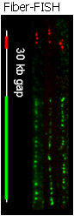
Figure 3-3
A Jumping Clone Library from Helicobacter pylori. “Jumping clone” libraries are plasmid libraries created so that the inserted DNA fragment is relatively small (2 to 6 kb), but the sequences at the two ends of the fragment are separated by 40 to 140 kb in the genome from which the library is derived from [Zab91][Col84]. We will follow published protocols [Zab91][Col84] to create jumping clone libraries which will serve as template for polony sequencing. It may be advantageous to avoid any steps in which the DNA is transformed into E.coli because each polony sequencing reaction requires very small amounts of DNA (tens to millions of molecules) as input and the transformation step will reduce the complexity of the library. Many groups have published on this method (40 citations in PubMed), and we will resolve any experimental difficulties by contacting one of these groups and asking for advice.

Multiple Amplification from Single Molecules (MASMO). Fiber-FISH (Figure 3-3) has been used to create high resolution physical maps of the human genome, to measure the physical distance between two markers, to map translocations, and to identify duplications or deletions in the human genome. In the Fiber-Fish procedure, chromosomes are stretched on the surface of a microscope slide and several dye-labeled probes are hybridized to this stretched DNA [Kra02]. The probes are visualized under a fluorescent microscope, and the images are analyzed to provide information about the physical distance between the hybridized probes. Inspired by this technology, we propose to amplify multiple polonies from stretched molecules of DNA. This would place distance and ordering constraints on all sequences
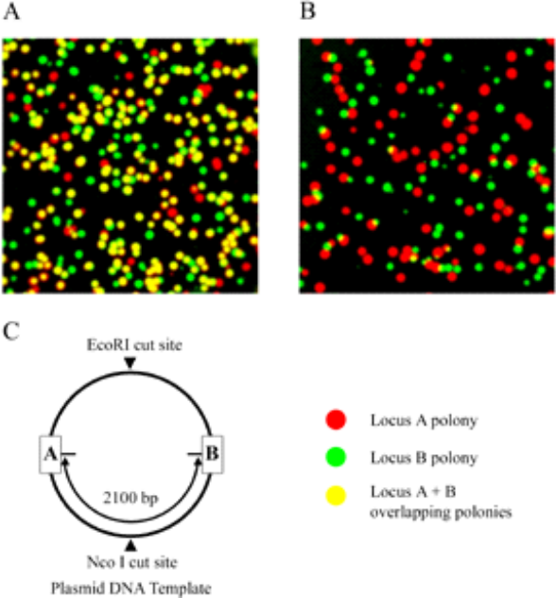
Figure 3-4: Amplification of two polonies from a single DNA molecule. We cut plasmid DNA (3-4C) with EcoRI, leaving locus A and locus B on the same template molecule, or with EcoRI and NcoI, separating the loci. We performed polony amplification with two pairs of primers designed to amplify loci A and B and hybridized cy5-labeled probe (red, locus A) and cy3-labeled probe (green, locus B) to the polonies. 86% of locus A polonies overlapped a locus B polony (and 80% of locus B polonies overlapped a locus A polony) when the plasmid was singly cut (3-4A), but less than 2% of locus A polonies significantly overlapped a locus B polony when the plasmid was doubly cut (3-4B).
acquired from a stretched fragment, providing information about long-range connectivity. We acknowledge that this strategy to obtain long-range connectivity is riskier than our other strategies, but it has the potential to provide more information. Furthermore, we are encouraged by our preliminary experiments performed to investigate the feasibility of this approach.

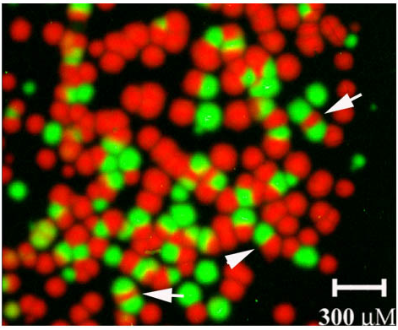
If our MASMO strategy is to work, we must overcome several technical hurdles. Firstly, we must develop an priming strategy so that polonies can be formed from a stretched DNA molecule of unknown sequence. Secondly, we must demonstrate the ability to amplify multiple polonies from a single molecule of DNA. Thirdly, we must find a way to distinguish polonies that are amplified from the same molecule of DNA. If polonies amplified from the same molecule largely overlap one another, it will be challenging to obtain accurate sequence information. We have performed preliminary experiments addressing these last two issues. To demonstrate that multiple polonies could be efficiently amplified from a single molecule, we used two different primer pairs to amplify two separate loci from a linearized plasmid template. The polonies were then visualized by hybridizing locus specific primers labeled with fluorescent dyes to the acrylamide array (Figure 3-4a). Numerous overlapping polonies could be identified after the hybridization, as evident from the large number of yellow polonies. In a separate control reaction, we cleaved the plasmid with two restriction endonucleases, so that the two loci were no longer on the same DNA molecule (Figure 3-4b). The doubly cut plasmid produced few polonies that overlapped. The polonies that did overlap did so only near their edges and were the result of two different DNA molecules falling near each other when the gel was poured. These results demonstrate that multiple polonies can be amplified from a single DNA molecule. We next focused on finding a method that would prevent nearby polonies from substantially overlapping one another. We reasoned that if we made the unattached primer a limiting reagent, then two neighboring polonies could not “grow” into one another, because at the interface between the two growing polonies, the free primer would be depleted and further growth of either polony in that region would be made impossible. To test this hypothesis, we amplified two polony templates with a reduced concentration of free primer (0.17uM, one-third of the typical concentration). Primer extension was performed using Cy3 and Cy5 labeled nucleotides to distinguish the two species. Fig. 3-5 demonstrates that polony overlap can be reduced using this strategy. Also, numerous adjacent polonies display a deformed shape (arrows in Fig. 3-5) indicating growth inhibition due to the presence of a neighbor. We refer to this phenomenon as the polony exculsion principle.

Figure 3-5

We will first develop a priming strategy so that multiple polonies can be formed from a single molecule of H.pylori DNA. In our protocol, we will stretch H.pylori DNA on the surface of a microscope slide as previously described [Kra02] [Sam95]. Next we will polymerize an acrylamide gel. In the acrylamide mix, we will include two oligonucleotides with 5’ Acrydite groups. The first, oligonucleotide Acrydite.A, contains a priming site for PCR. The second, oligonucleotide Acrydite.A.N6, contains the same priming site for PCR (designated region A) followed by a random hexamer. Because of the 5’ Acrydite modification, these oligonucleotides will be covalently attached to the acrylamide matrix after the gel polymerizes. Next, we will heat the slide to denature the H.pylori genomic DNA and then cool the slide to anneal the primer Acrydite.A.N6 to the H.pylori DNA. Next, we will add DNA polymerase and deoxynucleotides to extend the annealed oligonucleotides. By adjusting the concentration of the oligonucleotide Acrydite.A.N6, we can control how many priming events will occur (on average) per chromosome of H.pylori DNA. After extension of the immobilized primers, the genomic DNA will be electrophoresed out of the gel, using a protocol previously described [Mit02]. After this step, the immobilized DNA molecules will contain the priming site, region A, followed by sequence from the H.pylori genome. In order to perform polony PCR, the DNA must have two priming sites. Therefore, we will add oligonucleotide A.N6, a primer with the same sequence as the immobilized primer, Acrydite.A.N6, but without a 5’ Acrydite group. This primer will be extended by adding deoxynucleotides and Klenow polymerase. Unextended primer will be washed away. Next, PCR amplification will be performed by diffusing primer A, taq polymerase and deoxynucleotides into the acrylamide gel and performing PCR. Because each DNA molecule contains priming sites at each end that are complementary to one another, short amplicons can not be amplified because they form a hairpin so that the PCR primers cannot anneal to the molecule. However, longer DNA molecules are amplified by PCR because the longer DNA molecule does not form a hairpin structure as rapidly, so primers are able to anneal [Bro97]. Since all amplification products will be long, the polonies will be small. In this fashion, a single stretched chromosome of H.pylori DNA will give rise to many small polonies that do not overlap each other, due to the polony exclusion principle.

The self-complementary priming sites should help prevent short amplicons from being amplified. We will adjust the melting temperature of these primers to obtain the right balance between average amplicon size and amplification efficiency. If rapidly diffusing amplicons remain problematic, we will investigate the use of amplification primers with “drag tags” – modifications at the 5’ end of the primer designed to increase the diffusion coefficient of the primer and the amplicon.

It may be difficult to achieve random priming with immobilized Acrydite.A.N6 because we may not be able to achieve the required local concentration of random hexamers. To avoid this problem we will also perform the annealing and extension of the oligonucleotides Acrydite.A.N6 on H.pylori genomic DNA in solution. Then, the genomic DNA and extended oligonucleotide will be stretched on the surface of the slide and a gel polymerized over the stretched DNA. The annealed oligonucleotides will again be immobilized and the protocol can be completed as before.

De novo sequencing of Helicobacter pylori genome. Our efforts to achieve long-range connectivity should enable us to estimate the cost of each of our three strategies for determining long-range sequence connectivity. These cost estimates, plus the information obtained in Aim 1 about the maximum read length and accuracy of the FISSEQ protocol will enable us to computationally determine the optimal approach for assembling the Helicobacter pylori genome (see Aim 5). This analysis will provide the necessary sequence coverage that must be obtained from each of the libraries created by the above three methods. We will sequence the libraries using the protocols developed in Aim 1 and assemble the H.pylori genome using an assembly strategy developed in Aim 5.

The completion of this milestone is dependent on our ability to sequence accurately (Aim 1) and our ability to establish sequence connectivity by the above methods. If these issues have been addressed, then to complete this milestone, we must simply sequence enough polonies to ensure adequate coverage of the genome. This should not require a significant increase in polony-slide throughput. As described in Specific Aim 1, a single polony slide has the potential to yield well in excess of 10 million base-pairs of sequence information. Because the H.pylori genome is only 1.6 MB, we hope to achieve high coverage without having to process a large number of slides.

8c/d. Aim 4. Single Cells & In Situ Profiling [to top] [timeline]

Overview. The ability to assay genomic loci or transcripts in single cells in a high-throughput manner would enable many important applications, including expression profiling of differentiating stem cells and of individual single cells in complex tissues, and genotyping of individual cancer cells in a tumor. In this aim we develop and apply such assays to biological problems concerning the function of individual neurons, stem cell development, and asymmetric stem cell kinetics. Single cell assays may be classified according to the number of individual cells that may be analyzed at a time while preserving the identity of each (unicell vs. multi cell), and the number of loci or transcripts analyzed together (small number = low-plex vs. large number = multiplex). Additionally, a multi-cell assay may examine dispersed single cells, or complexes of cells in situ in which cell identity and location information is preserved.
In general, information becomes increasingly more difficult to obtain as one assays either multiple individual cells or multiple individual loci or transcripts at one time. Unicellular genotyping and expression profiling has been achieved by extracting and amplifying the contents of a cell, followed by blotting and probing or application to microarrays [Ebe92] [Ebe01], but multiple cells cannot be processed in this way and subcellular location information is lost. The use of polonies should enable improvements because they permit locations—of cells, and of loci and transcripts—to be preserved during amplification. In this Aim we develop and exploit this advantage (Aim 4a) in low-plex multicellular assays in the context of the biological systems mentioned above. We also take steps toward the more challenging multiplex multicellular assays (Aim 4b), where we will focus on adult stem cell ’immortal’ DNA strand structure.
The starting point for Aim 4 is to profile multiple cells in a way that keeps cell contents localized to the individual cells. A key prerequisite is that target DNA/RNA must be directly amplified from the cells without isolation. To prove the concept of an in situ polony, we first tested the accessibility of target cellular nucleic acid to primers anchored to acrylamide gel matrix. We targeted a mouse creatine kinase gene for polony amplification, choosing a genomic locus vs. an mRNA to assure a more interior target within the cell. To simplify the system and mimic real tissues, we arrayed mouse spleen cells onto slides by cell sorter (FACS). Acrylamide gel, together with the amplification mix, was directly poured onto the slides. After polymerization, slides were cycled by a standard polony protocol. As shown in figure 4-1, we detected polony from ~80% cells where the polonies remained in or near the original cells on the slide. We concluded that it is possible to generate in-situ polonies.
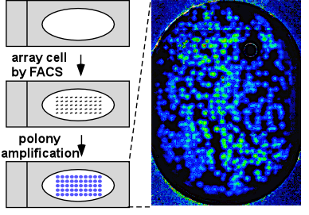
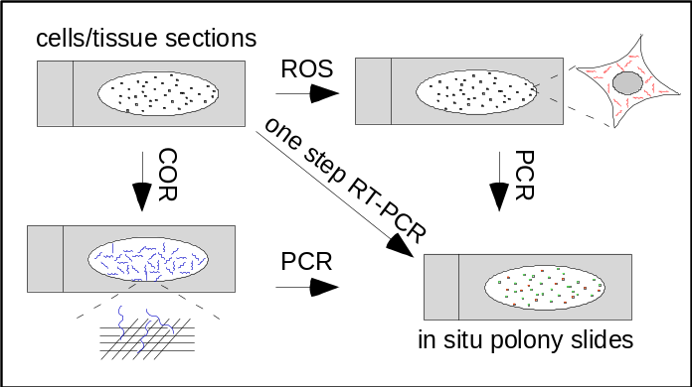
Figure 4-1: Generation of muticellular in situ polonies
Figure 4-2: In situ RT-PCR polony protocol

Our next step will be to develop this strategy into a protocol for generating in-situ polonies from cellular RNA. We will explore two directions (Figure 4-2): (1) We will follow established RT in situ PCR protocols on cells that are first fixed with formaldehyde. Though the underlying parameters are not fully characterized, it is believed that cross-linking of cellular components by formalin creates an “amplicon migration barrier” that retains cDNAs and subsequent amplicons within cells [Nuo96]. In the adapted polony version, the reverse transcription will be performed in solution on the slide surface (RT on surface = ROS), while the PCR step will be carried out within a acrylamide gel. If reproducible, we expect the restricted amplicon diffusion to be more pronounced in that the gel matrix behaves as an additional barrier. (2) We will physically link amplicon to acrylamide gel matrix by using acrydite modified reverse transcription primers in a process we call “catch-on” RT-PCR (COR). In this protocol, we use as primers an oligo-dT primer and a primer with a degenerate 3’ end and fixed 5’ end complementary to the primer tethered in the gel. An initial RT step generates cDNA sequences that can then be polony-amplified. This modification will prevent potential amplicon loss (as in ROS) during slide handling steps. The subsequent PCR step will be initiated by heat-activation (one step RT-PCR) or by washing out RT reagents and diffusing in PCR mix. Using a “catch-on” primer overcomes a limitation that would arise if we directly tethered randomers to the gel: The concentration of any one tethered random sequence would be too low to support efficient amplification. Since COR requires reverse transcription to be carried out in an acrylamide gel, we performed preliminary experiments using a reverse transcriptase directly in the gel. Our estimated RT efficiency in gel is 5-10%. Though relatively low, it is a good starting point for further optimization.

Transcripts or loci within a single cell may be so close that polonies formed from them contain multiple rather than single sequences (mixed polonies): Mammalian cells are typically from 5-20 um but the smallest polonies we have obtained to date are ~6 um in radius. Mixed polonies raise issues for assessment of expression levels and long range connectivity. We will explore several ways of addressing these issues: (i) The most direct way is to develop methods that reduce polony size and thereby restore discrete single-species polonies via polymer chemistry (Aim 1) or “drag tags” (Aim 3). Short of these improvements, several means of measurement can be applied at the cost of partial loss of comprehensiveness and precision: (ii) If cells are sufficiently dispersed and subcellular location data are not needed, we can try to burst the cells and dilute their contents locally before amplification. (iii) Where only the presence or absence of a NA sequence is of interest (binary readout) and this can be determined by single FISSEQ (Aim 1) reads (i.e., long range connectivity is not assayed), such data can be obtained from mixed polonies (see sub-aim 4b for an example). (iv) We can try to quantitate sequences in mixed polonies in an analog fashion (again, connectivity cannot be assessed). (v) Low-plex assays are less affected by polony mixing because, if fewer sequences are amplified at once, amplified NAs will be further apart. Thus, mixing may be reduced by generating a set of lower-plex assays by limiting the degeneracy of the catch-on primers during amplification. E.g., with respect to transcript assays, we can generate amplicons of 1/64th complexity by using primers with a fixed trinucleotide 3’ end (e.g., 5’-catch-on sequence-NNN..NNNCCC). Here, only a single degenerate amplicon representing part of the transcriptome is generated from a single cell on any given slide, but this limitation may be partly overcome: (v.1) If cells come from tissue that is sufficiently finely sectioned, we could assay different sections of the same cells on different slides. (v-2) We could statistically reconstruct the transcriptome by combining data from multiple similar cells. For instance, we could prepare 63 slides, each amplified with a primer ending -GTC and a primer ending with a second, different trinucleotide, to quantitate one common set of transcripts across all cells on all slides and a distinct set on each individual slide. After clustering cells on all slides by the expression profile of the common transcript set, we could then, within each cell cluster, average the expression profiles for each other transcript sets.
Aim 4a. Low-plex multicellular profiling. Low-plex multicellular assays entail the amplification and/or detection and quantitation of only a small number of loci or transcripts from many individual cells. Low-plex quantitation of dispersed sequences and splice variants has already been demonstrated with currently available methods (FISSEQ in Aim 1, FISSEQ and probing of splice variants in Aim 2, FISSEQ haplotyping in Aim 3). The key requirement for performing such assays in a multicellular context is thus the refinement of in situ polony generation methods and development of one of the quantitation methods (i-v) considered above. Note that, as mentioned above, low-plex assays are intrinsically less affected by polony mixing. As we refine these techniques we will immediately apply them to biological problems that represent long-standing interests of MGIC investigators and collaborators in neuronal development and stem cell differentiation. Our initial focus will be on low-plex multicellular profiling of model cell lines.

Alternative splicing of protocadherin in mouse neurons and embryonic stem (ES) cells: The protocadherin (Pcdh) gene families (a, b and γ) display an unusual genome organization that is reminiscent of the immunoglobulin and TCR loci [WuQ99][WuQ00], and contains tandemly arranged variable exons. A total of 58 potential Pcdh isoforms can be generated which show cell-specific expression patterns and which are suspected of supporting the diversity of neural cell types and behaviors. For instance, if each mouse neuron were to express 10 isoforms, approximately 50 billion combinations could result. In the course of in situ polony technology development, we will determine the absolute expression level of Pcdh mRNAs in single Neuro2A cells using internal standards and/or exogenous RNAs spike-ins, and assay cell-specific expression of individual Pcdh isoforms in these cells and also during mouse ES cell differentiation, in order to elucidate the functional role of Pcdh in neuronal connectivity.

Analysis of splice variants of the Tau gene in individual cells of human brain clinical samples: This simply extends the Tau splice variant analysis, described for cell populations in Aim 2b, to individual cells.

Detection of naturally existing dsRNA in mouse ES cells: Endogenous antisense RNAs can be broadly divided into two categories. Antisense RNAs transcribed from loci distinct from their putative targets (microRNAs), such as lin-4, are generally short and have the potential to from imperfect duplexes with complementary regions of their sense counterparts [Gra03]. In contrast, antisense transcripts that originate from the same genomic region but with opposing orientation have the potential to from long perfect duplexes. Until recently, it has been suggested at least 8% of human transcripts have antisense counterpart, and support the concept that antisense regulation in genome may be more pervasive than previously appreciated [Car03]. Identified in silico, some antisense RNAs may be confirmed experimentally by strand-specific RT-PCR and/or microarray. But no approach to date addresses whether such sense-antisense pairs form functional duplexes within a single cell. We are currently identifying a subset of functional RNA duplexes as substrates for dicer and/or ADAR in mouse ES cells by a microarray approach. The resulting dsRNA will be further examined at single cell level with in situ polony technology.

Asymmetric stem cell kinetics in adult stem cells: Adult stem cells undergo asymmetric stem cell kinetics when they divide into daughters, one of which retains stem cell properties including the ability to divide indefinitely, while the other differentiates and is only capable of limited subsequent division. Asymmetric kinetics are essential for normal adult stem cells to produce differentiating progeny and simultaneously maintain their own undifferentiated character [Loe97]. A pathway involving p53, IMPDH (inosine monophosphate dehydrogenase), and guanine ribonucleotides (rGNPs), has been shown to control asymmetric kinetics, and there are reasons to believe that p21, p63, and pten may interact with it [She02][Lee03]. We will use polonies to explore the expression levels of these and other related genes in individual rat adult hepatic stem cells as they undergo both symmetric and asymmetric kinetics.

Aim 4b. Multiplex multicellular profiling. From a polony perspective, multicellular multiplex assays differ from low-plex single cell assays by requiring more effective versions of quantitation methods (i-v) considered above to reduce polony mixing. While ultimately we plan to apply these methods to expression profiling of adult stem cells, we begin by developing method (iii) for use in the following biological question:
Molecular structure of chromosomes in adult stem cells: There is evidence that stem cells undergoing asymmetrical kinetics control chromosome segregation so as to always retain one particular strand per chromosome (“immortal” strand), a strand that was present when the cell acquired its original stem cell fate [Mer02]. This behavior was proposed as a critical protective mechanism against the development of human cancers [Cai75]. We have performed initial experiments exploring the molecular basis of immortal strand co-segregation [Sherley, unpublished]: By labeling cells so that the immortal strand is BrdU-free or BrdU-substituted, we can prepare purified fractions of chromosomal DNA with immortal DNA strands. While no significant difference in base composition or base methylation has been detected, we have consistently noted anomalous buoyant densities in CsCl gradients that are consistent with the hypothesis that chromosomes with an immortal DNA strand have a meta-stable, single-stranded DNA character. Cytological analyses also suggest single-stranded structure in chromosomes with immortal DNA strands. There are well-described methods for evaluating the average strand character (single versus double) of populations of DNA molecules (e.g., S1 nuclease sensitivity). However, such methods do not provide molecular scale information on the strand character of individual DNA molecules. For example, chromosomes with immortal DNA strands may have both single-stranded and double-stranded regions. Similarly, single-stranded regions may be limited to particular chromosome sequences (e.g., centromeric or telomeric). We will therefore apply polony technology to these questions.

Polony assays will be performed on DNA in cells undergoing chromosome co-segregation or random chromosome segregation with the aim of determining the location and extent of (a) single-stranded segments and (b) priming elements already in the cell. We will detect these regions by strand extension adding (a) random primers and (b) no primers. These extensions will be polony-amplified and then identified using FISSEQ (Aim 1). It is important to amplify only the extensions from random primers or internal priming elements. We propose to extend with alpha-thio-dNTPs using a non-strand-displacing polymerase, and then degrade all non-thio-DNA. Extension must take place with non-denatured chromosomes. For FISSEQ sequencing (Aim 1), we will use a small set of unrelated primers that are expected to hybridize to at most one site per extended, amplified sequence, and sequence as far as required to obtain unique full or compressed (see Aim 2) sequence tags. If we find we generate too many mixed polonies, we will first perform this assay on dispersed chromosomes isolated from cells, where mixing will not be a problem, so that we may identify single stranded sequences on a cell population level. We will then use these sequences to define sequencing primers that can be used to assay for the presence of distinct molecular species in the mixed in situ polonies generated within multiple individual cells.
8c/d. Aim 5. Computational Methods and Systems Biology [to top] [timeline]

Overview. The development and use of polony technology detailed in Aims 1-4 requires a robust set of computational methods, while the new biological data it can acquire creates new opportunities for systems biology. In this Aim we both develop the computational infrastructure required for technology development and mine the new data acquired by the biological projects. An extensive software infrastructure is required for polony sequencing: Sequence data acquisition requires algorithms that align and process series of TIFF images to yield nucleotide sequences for each polony (Aim 5a). Sequence assembly based on polony sequencing may require algorithms that use shorter reads than generated by electrophoretic methods and in which the lengths of mononucleotide runs may not always be resolved (Aim 5b). At a more basic level, the protocols being developed for polony growth and usage can be enhanced and optimized with the aid of mathematical models of polony growth (Aim 5c). Meanwhile, biological applications of polony technology to mRNA splice variant analysis, long-range haplotyping, and single cell studies will require adaptation of digital statistical error models such as used in SAGE (Aim 5d). Finally, in Aim 5e, we analyze data acquired by splice variant analysis and single-cell studies at a systems level by identifying associations between SNPs and phenotypes with pathway activation. Overall, we intend in this Aim to assemble a suite of open-source, robust, and user-friendly software tools for acquisition and management of polony-generated sequences, develop well-founded methods for polony-based sequence assembly, polony simulation, and data error analysis, and demonstrate compelling examples of systems biology from polony-acquired data.

Aim 5a. Software suite for acquisition, analysis, and determination of polony sequences. The basic principles of polony sequencing and a preliminary set of software tools have been developed [Mit03B][Zhu03]: TIFF images acquired after each base addition are aligned, filtered for noise, and base called, resulting in a base sequence signature for each pixel. Base sequence signatures are themselves filtered and contiguous pixels are assembled into objects. Each sequence-called polony that results from this processing represents a single molecule of a DNA or RNA species. For polony technology to be made widely accessible, this provisional set of software tools must be refined into an organized, available, and user-friendly package. We plan to make software available as open-source code on our web site along with documentation on installation procedures and usage. As work on Aim 1 will result in a steady stream of refinements, we envision that there will be multiple releases, starting with an initial release that corresponds closely to current practice that we will make available by the fall of 2003, but followed by updates that incorporate new advances. We expect to make the following enhancements over the course of this grant:

(i) Convert software to C/C++ for performance and portability: The current software, in MatLab and perl scripts, is slow and forces users to have MatLab licenses. The importance of this conversion may be illustrated: Base calling requires aligning and analyzing one TIFF file per base extension cycle. Assuming each cycle enables calling of a single base (an assumption protocol improvements may overcome), we find by simulation based on equiprobable and independent nucleotides that 62 extensions are needed to sequence 95% of a set of 34nt fragments if mononucleotide runs are not resolved. With reversible 3’ terminators (Aim 1), 95 extensions are required. To sequence an organism such as H. pylori (Aim 3) using 34nt reads will require 11 slides of polonies [using assumptions of polony cost model], and thus requires 682-1045 images. With current polony sequencing software [Mit03B] image alignment alone requires ~2 min/image; thus, simply aligning images would take 23-35 hours. As we commonly obtain performance improvements of ~150x using C/C++ vs. perl or third-party products like MatLab, conversion to C/C++ should reduce processing time to ~9-14 minutes. We will also fully parameterize the code so that options and thresholds can be put under direct user control. This will be increasingly important as options increase due to protocol refinements (e.g., new fluorophores, base terminators). Finally, we will take a phased approach to developing a graphical user interface (GUI) for the programs. After developed software stabilizes, we will do initial prototyping for a GUI using simple development tools such as VisualBasic and then migrate to platform-independent tools.

(ii) Base calling improvements: Polony sequences are read through signal generated by labeled single base extensions. Currently signals are generated by fluorescent dyes (for alternatives, see Aim 1), and improvements in base calling can be made with appropriate software processing, including: (a) Resolution of mononucleotide runs: As noted (Aim 1), current procedures do not attempt this and protocol enhancements may eliminate the problem (e.g., reversible terminators, Aim 1). However, similar to pyrosequencing, we expect to be able resolve small runs by calibration and measurement of fluorescence intensities [Gha02] and will incorporate these into the software. (b) Signal generated by some single base extensions has been found to depend on sequence context. These context dependencies need to be incorporated into the software as they are characterized.

(iii) Equipment control: Full automation of polony sequencing will require automation of scanning, reagent addition, and washing. Regarding the latter, we have recently developed a prototype instrument (Aim 1b, Figure 1-3, dipping device). We aim to develop tested prototype software for control of this instrument that can be integrated with software controlling scanners.

(iv) LIMS and data management: As illustrated in (i), analysis of polonies entails the accumulation of large TIFF files. Processing of these files to call sequence signatures generates additional information. Appropriate management of these data types is important for polony development and applications. In the long term, use of polonies will be improved by a Laboratory Information Management System (LIMS). However, LIMS cannot be usefully developed until workflow and protocols are sufficiently stable [Ave00], a condition that won’t be met until key goals of this grant have been met. We thus envision a three tiered approach: (a) For immediate MGIC needs, the Church group will design naming conventions for the various kinds of data to be managed, to be posted on the Center website (CDROM copy). Meanwhile, Center sites will acquire hardware adequate for their storage needs. These may be estimated by TIFF files. E.g., assuming a high-density polony slide image is stored as a ~300MB TIFF image (2μm/pixel, 20x60mm slide), sequencing of H. pylori (Aim 3) would require 682-1045 300MB files = 205-314 GB. Other Aims with potentially large storage requirements are 1d (rare mutations in genomic CpGs) and 2b (splice analysis of ~500 genes). A budget item pertaining to this storage has been added. (b) As procedures stabilize, we will develop a data model for the various kinds of information that must be managed, post it on the MGIC website and solicit input from the polony community. We will leverage sample annotation standards developed by MIAME [Bra01] and biological image annotation standards being developed by OME [Swe03]. (c) After suitable input has been gathered, we will work with collaborators with already existing LIMS (e.g., Bob Steen from the Biopolymers Facility at Harvard Medical School and Eric Lander's from the Whitehead Institute) to prototype the system, and publish results.

Aim 5b. Polony sequence assembly algorithms. Aim 3 of this grant describes the use of polonies to sequence an entire genome. Several aspects of polony reads must be taken into account by assembly routines: (i) Polony reads will likely be shorter than electrophoretically derived reads (the average read length for the human genome project was ~500nt [Lan01,Ven01]). To overcome the assembly limitations of short read lengths, several methods of obtaining distance information are being explored in Aim 3, but these, too, will likely result in a different distribution of distances than used by sequencing efforts to date (e.g., mated pair reads in Aim 3 will likely be shorter). (ii) Polony sequences will have base calling error profiles that differ from those of electrophoretically derived reads. (iii) To the extent that polony sequencing remains limited in resolving mononucleotide runs, or that it is desirable to use reads with unresolved run lengths, the sequence matching that underlies sequence assembly will need to be tolerant of mismatched run lengths in reads.

The purpose of this aim is to evaluate standard sequence assembly algorithms [Ken01][Mye00][Jaf03][Gre94] for their ability to assemble sequence data derived from polonies, and to develop new assembly algorithms as required. (i) We will computationally break up a genome sequence into reads and mated pairs characteristic of polony sequencing data and reassemble them using standard algorithms. As we have collaborators who have developed assemblers (WI-CGR & TIGR) we will use these for assembly and as starting points for small modifications. (ii) Polony sequence base error calling statistics gathered in Aim 1 will be used to construct a quality score similar to a PHRED score [Ewi98] and these will incorporated into assembly algorithm evaluation and development. (iii) The entry point to most sequence assembly is pairwise alignment of all reads against each other. Alignment algorithms typically use word matching (e.g., [Nin01]) that may be extended by dynamic programming (e.g., [Alt97][Bat02]). Both may be adjusted to handle mononucleotide run mismatch lengths. Initial word matching may be based on comparing compressed sequence tags (Aim 2) in query and target sequences; this may be supplemented by storing and comparing length information for each tag instance in the word table; this may be memory-intensive and a budget item pertaining to a large memory machine has been added. Dynamic programming can be adjusted by allowing gap start and extension penalties to be lower for insert/deletions of a base into a run of the same base than insert/deletions into other bases. We note that the Church Lab has had experience developing dynamic programming applications for both sequence [Gra03] and expression data [Aac01B]. We will develop algorithms initially for modestly sized assembly projects such as H. pylori (Aim 3) whose performance may require enhancement for large genomes as the sequence data collection scales up.

Aim 5c. Mathematical modeling for optimization of polony technology. Many of the directions being explored for polony protocol and application development would benefit from an increased understanding of the dynamics of polony growth. A preliminary partial differential equation model of polony growth has already been developed and has led to valuable insights [Aac03]. In this aim we will enhance and employ this model to better simulate the polony environment and explore optimizations being pursued in Aim 1. Questions to be addressed include: (i) Choice of polony product: The products of polony growth are free strands and tethered strands. Current protocols entail diffusing away the free strands and sequencing or probing the remaining tethered strands. However, modeling indicates a much greater yield of free vs. tethered strand in polonies, suggesting an alternative strategy: Anchor free strand into the polony after the last cycle and use it in place of the tethered strand. Further simulations should show how to optimize this product. (ii) Polony exclusion: Another way of increasing overall polony density on a slide is to find ways of preventing overgrowth of neighboring polonies. An experimentally observed phenomenon indicating that polonies tend to exclude each other has been simulated by current models [Aac03] (see Figure 5-1). We will systematically change combinations of parameters to provide leads on optimizing this effect. (iii) Alternative protocols: Modeling provides an in silico way of exploring alternative protocols for polony growth that are under consideration, e.g., the yield and exclusion characteristics of mated pair polonies (Aim 3) can be explored by running simulations. (iv) More realistic parameters: A substantial list of enhancements will make the polony model more realistic, including (a) modeling the effect of PCR phase temperatures on diffusion coefficients, (b) modeling variations in diffusion coefficient due to the accumulation of product concentrations, (d) modeling of diffusion throughout the replication phase, (d) fitting of annealing rate constant parameters to actual data (current rate constants are literature-derived from reactions that are not gel-based).

Aim 5d. Error models for polony applications. While the digital readout provided by polonies generally simplifies statistics, but Poisson error for rare events requires careful evaluation. In this sub-aim, we will evaluate statistical methodologies developed for SAGE on polony data [Rui02][Man00][Sto00][Che98][Aud97] [Mad97]. Specific polony applications entail additional issues that require consideration. For instance, in long range haplotype phasing (Aim 3, [Mit03]) multiple regions, each containing a SNP, are polony-amplified on the same molecules, and SNPs called by single base extensions. Haplotypes are called by colocalization of SNP-called polonies and must be distinguished from random overlaps. The error model of [Mit03] computed the statistics of random overlaps directly, but another approach would be to adapt the statistics of radiation hybrid mapping [Cox90], which takes into account the probabilities of breakage of long molecules.
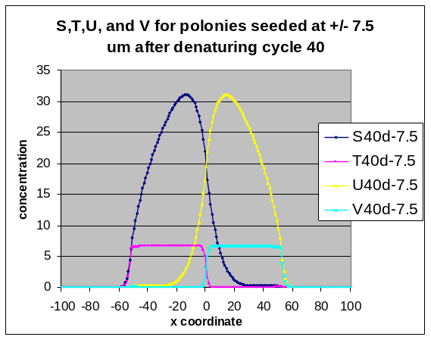
Figure 5-1 Explanation of polony exclusion based on mathematical model. Left: Image of polonies that appear to deform against each other rather than interpenetrate (from [Mit03B]). Right: Result of 1D mathematical model of two adjacently grown polonies, one with free strand S and tethered strand T, the other with free strand U and tethered strand V. Even though S and U diffuse into the adjacent polonies, T and V cannot become established there because the tethered primers from which they are generated are exhausted.

Aim 5e. Systems biology. A key goal of systems biology is to integrate different kinds of biological data and develop models of overall cell function. By making it simple and practical to perform long-range SNP haplotyping, unequivocally identify splice variants, and determine differences in allelic expression, polony technology enables access to types of data that have until now been difficult to obtain and thereby provides new opportunities for systems analysis. Additionally, for model building to succeed, it is important to have data that exhibit variability in the factors to be related, allowing dependencies to be identified. The ability to use polonies to analyze single cells (Aim 4) will thus greatly abet systems analysis, as this will allow variations at the single cell level to be related to differences in microenvironment, cell state and morphology, and genotype (e.g., cancer cell loss of heterozygosity, transposon/virus insertion location, etc.). In this sub-aim, we will correlate and integrate biological data acquired by Aims 1-4 of this grant to demonstrate the systems biological opportunities made available by polony technology.

As an example of the kinds of systems analyses we will perform, we focus here on pathway analysis. The new kinds of biological data gathered by polonies are of interest not simply because they clarify the expression state of individual genes, but because they can be further analyzed to find how these data correlate with pathway activation. For instance, in Aim 2b we propose to digitally quantify alternative splicing in ~500 mammalian genes across a range of tissues and/or individuals. However, (1) these data may also be analyzed with an eye to examining whether particular splice variants of two or more genes in the same pathway are correlated. (2) We can also assess whether particular splice variants in one gene are associated with up- or down-regulation of pathways containing or related to the gene. The only pre-requisite for (1) is that the ~500 selected genes contain multiple genes in the same pathways. Thus, part of this sub-aim will be to assist selection of these genes. The prerequisite for (2) is that the level of activation of a pathway can be measured. This can be accomplished easily by searching the literature and available published data sets for genes whose expression level generally reflects that of a given pathway. The level of activation of a pathway can then be determined based on these ‘sentinel’ genes from the same polony assays as the splice variant analysis, if suitable controls are included to calibrate overall mRNA abundance. Many such sentinels may be among the ~500, but it could be necessary to add some additional genes. Pathways to be examined will be identified from the literature or published data as being functional or variable in activity across the range of available samples. Similar pathway analyses may be possible with many other kinds of data that may potentially be gathered by the MGIC. E.g., the project of identifying haplotypes that may regulate ApoE allele expression could be combined with an assessment of activation levels of pathways suspected of involvement in progression to Alzheimer’s disease.

However, pathway analysis is not only kind of systems biology that we hope to pursue with polony-acquired data. We briefly mention other directions under consideration; the precise set of projects we will follow will depend on the specifics of what kinds of data are obtained by and available to the MGIC. Stem cell classification: In Aim 4, multiplex, multicellular in-situ studies are proposed for stem cells. These data may be clustered to identify sets of molecular phenotypes of stem cells undergoing differentiation or correlation with other molecular markers. Cancer cell classification and lineage: A similar classification could be performed on cancer cells in a complex tumor and expression patterns related to polony-derived genotypes of these cells. Polony-derived genotypes of a primary tumor and metastases could be performed to identify the cell state and region of the primary tumor that gave rise to the metastases. Stem cell generation model: We have developed a mathematical model that describes the evolution of cultures derived from adult stem cells taking into account their asymmetrical kinetics [Craft and Sherley, unpublished]. We would aim to integrate molecular data derived from Aim 4 with this model. Comparative genomics: The sequencing of a new strain of H. pylori in Aim 3 can be compared with existing H. pylori sequences to understand the mechanisms of evolutionary change in a highly variable pathogen and, potentially, to better identify genes and regulatory regions (as has been done with microbes, yeast, and primates [McG00][Cli01][Bof03]).

8e. Human Subjects Research [to top] [timeline]

http://grants1.nih.gov/grants/funding/phs398/section_1.html#e_humansubs

We are exempt from the regulations at 45 CFR part 46 because our research protocols meet the criteria for exemption (category 4) under Section 46.101(b)(4). (“Exemption 4. Research involving the collection or study of existing data, documents, records, pathological specimens, or diagnostic specimens, if these sources are publicly available or if the information is recorded by the investigator in such a manner that subjects cannot be identified, directly or through identifiers linked to the subjects.")

Justification: We used the decision chart located on the OHRP website to determine that we are exempt from the regulations at 45 CFR part 46. The chart is shown below:

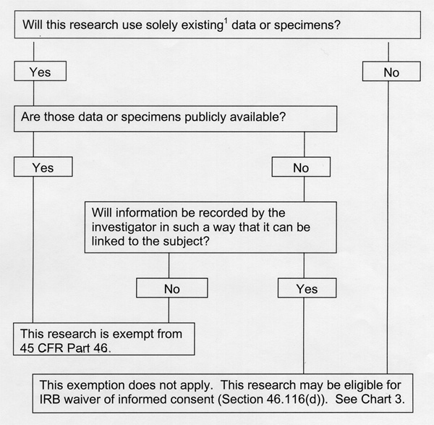

Our answers to these questions are as follows: (1) Will this research use solely existing data or specimens? Yes; (2) Are those data or specimens publicly available? No. (3) Will information be recorded by the investigator in such a way that it can be linked to the subject? No. Neither the principle investigator nor any of the co-investigators, nor any lab personnel will be able to link the data or specimen to the subject.

Therefore, we conclude that we are exempt from 45 CFR part 46.

‘”When research involving human subjects will take place at collaborating site(s) or other performance site(s), the principal investigator must provide in this section of the application a list of the collaborating sites and their OHRP assurance numbers.”

These will mainly involve two collaborating research groups below. Our group will mainly provide experimental and computational technology development and background. We will very proactively plan for potential impact of our research in the future and/or outside of this P50 by way of our ELSI project below.

Dr. David Hunter (Harvard School of Public Health) See attached IRB list, for "Nurses' Health Studies" and related protocols.

Dr. Brad Hyman's (MGH) study titled "Molecular Genetics of Alzheimer's Disease," which includes both the cases and controls: 1999 P 008684.
Elsi [to top] [timeline]

Privacy of genetic information is a key ELSI concern. The potential for genetic discrimination in insurance coverage and in the workplace are the central issues around which debates, legislation, and lawsuits concerned with privacy have focused [ORNL03]. However, ongoing efforts of the research community, in part supported by the Human Genome Project, have made it increasingly easy and inexpensive to gather large amounts of sequence and expression data, and technologies to gather large amounts of other kinds of data (protein, interaction, single cell …) are in various stages of development. In addition, a key direction of recent research has been to demonstrate how diverse kinds of data may be integrated—indeed, must be integrated—in order to understand biological processes. Finally, as an ultimate goal of nearly all such efforts is to apply these technologies and data to clinical diagnosis and therapeutics, these techniques will eventually be applied to human beings on a wide scale. Through its development of polony technology, the MGIC is part of this research direction, and shares this interest in clinical application.

The core question is: How may the gathering of increasing amounts of genetic information be made compatible with ethical and legal requirements for privacy? Anything approaching a comprehensive genotype or phenotype (including molecular phenotypes) ultimately reveals subjects’ identity in our increasingly wired world as surely as conventional identifiers like name and social security number. We call this “comprehensive identifying” genetic information. This raises numerous specific questions:

- Are current informed consent practices sufficient to give human subjects adequate understanding of the potential that their identity may be discernible in large genetic data sets obtained from them?
- Is enough protection afforded by allowing researchers open access to such data sets so long as they agree not to take the analytical steps that would link these data to a specific person, or is this inadequate and impractical?
- Is there a kind and level of genetic information for which it would be virtually impossible for a researcher not to link it with a specific person?

Yet at the same time, the course of recent research shows ever more convincingly that availability of large, correlated sets of genetic data by the research community is required to understand and manage human health and disease. As scientists dedicated to such projects, we must therefore ask about the other side of the issue: How can comprehensive identifying genetic information be gathered and made available to the research community? A small number of comprehensive identifying data sets (not necessarily genetic) are openly available, and their origins indicate how extraordinary are the circumstances by which they have been derived: Craig Venter has published his own genome. A comprehensive identifying set of CT, MRI and cryosection images (at 0.33 to 1 mm resolution) was made from the prisoner Joseph Jernigan shortly after his execution [NLM03]; the corresponding human Visible Human Female subject is as yet anonymous. Though we applaud the scientific altruism that might encourage an individual to make his or her comprehensive identifying data public, we wonder whether some framework compatible with ELSI principles is possible that will increase the number of such data sets and move towards availability of more statistically unbiased samples.

The MGIC would like to increase public understanding and debate of this issue. As part of our Training Plan, we have dedicated three of 12 seminars to ELSI issues, and will ask our speakers to address both the problems and the promise of comprehensive identifying genetic data. Comments and discussion relevant to this topic will be posted on our project website.

8f. Vertebrate Animals [to top] [timeline]

The Church Lab has an approved animal experimental protocol with the Harvard Medical Area Standing Committee on Animals (#03413, renewed 10/02). Research involving vertebrate animals will take place exclusively at Harvard Medical School, unless a collaborating site obtains appropriate approval for an animal experimental protocol from its host institution. However, even in these cases, the MGIC will not perform experiments involving living animals (i.e. post-euthanasia only).

The mouse has served remarkably well as a genetic model in the mapping of observed phenotypes, often powerful models of human disease. Many of the experiments described in this proposal are aimed at developing technologies to precisely quantify the genetic variation that underlies phenotypic variation. As differences between mice (both natural and disease-bearing strains) can provide promising models for human variation and human disease, developing technologies to query differences at the level of genomes and transcriptomes may lead to a greater understanding of the genetic basic for phenotypic differences between individual humans.

Specific experiments described in this proposal require that we obtain mRNA, genomic DNA and/or tissue from laboratory mice (Mus musculus). However, none of the experiments need to be performed on living animals. Therefore, no procedures other than euthanasia will be performed on living animals. Inbred strain animals and F1 hybrids will be euthanised, followed by tissue / organ harvesting. In pursuing experiments described in this proposal, we anticipate that 20 to 30 mice will be euthanised per year. Prior to sacrifice, animals will receive adequate veterinary care in appropriate facilities run by the host institutions.

Our specific methods for euthanasia will be as follows:

Adult mice & newborns: Carbon dioxide-induced anesthesia (chamber method) until cessation of breathing, followed by immediate cervical dislocation of the anesthetized mouse.

Fetuses (15 days & above only): euthanasia of mother by above method, followed by removal of all fetuses & immediate decapitation with surgical scissors.

8g. Literature Cited [to top] [timeline]

Note: Key papers & preprints on this CD-ROM are indicated by a hypertext underline, e.g. [Mit03B].

[Aac01] Aach, J., Bulyk, ML., Church, GM, Comander, J, Derti, A. Shendure, J (2001) Computational comparison of two draft sequences of the human genome. Nature 409, 856-859.
[Aac01B] Aach, J and Church, G.M. 2001 Aligning gene expression time series with time warping algorithms. Bioinformatics 17:495-508.
[Aac03] Aach, J. 2003. Mathematical models of polony growth - Progress report.
[Ack01] Ackerman MJ, Yoo T, and Jenkins D. (2001). From data to knowledge--the Visible Human Project continues. Medinfo 10(Pt 2):887-90.
[Ada91] Adams, M.D., et al., (1991) Complementary DNA sequencing: expressed sequence tags and human genome project. Science 252:1651-6.
[Ada00] Adams, M. D., Celniker, S. E., Holt, R. A., Evans, C. A., Gocayne, J. D., Amanatides, P. G., Scherer, S. E., Li, P. W., Hoskins, R. A., Galle, R. F., et al. (2000). The genome sequence of Drosophila melanogaster. Science 287, 2185-95.
[Aeb03] Aebersold R, Mann M. (2003) Mass spectrometry-based proteomics Nature 13;422(6928):198-207
[Alm99] Alm RA, et al. (1999) Genomic-sequence comparison of two unrelated isolates of the human gastric pathogen Helicobacter pylori. Nature 14:176-80.
[Alt97] Altschul, S.F., Madden, T.L., Schäffer, A.A., Zhang, J., Zhang, Z., Miller, W., and Lipman, D.J. (1997) Gapped BLAST and PSI-BLAST: a new generation of protein database search programs. Nucleic Acids Res. 25:3389-3402.
[Alz02] Alzahrani AJ, Vallely PJ, and McMahon RF. (2002) Development of a novel nested in situ PCR-ISH method for detection of hepatitis C virus RNA in liver tissue. J Virol Methods 99:53-61.
[Aud97] Audic, S. and Claverie, J.M. (1997) The Significance of Digital Gene Expression Profiles. Genome Res. 7: 986-995.
[Ave00] Avery, G., McGee, C., and Falk, S. (2000) Implementing LIMS: A "How-To" Guide. Analyt. Chemistry 72(1):57A-62A.
[Bad01] Badarinarayana, V., Estep, P. W., Shendure, J., Edwards, J., Tavazoie, S., Lam, F. and G. M. Church. (2001) Selection analyses of insertional mutants using subgenic-resolution arrays. Nature Biotechnology 19: 1060-5.
[Bai95] Bain, G., D. Kitchens, M. Yao, J.E. Huettner, and D.I. Gottlieb. (1995) Embryonic stem cells express neuronal properties in vitro. Dev Biol. 168:342-57.
[Bai00] Bain G, Mansergh FC, Wride MA, Hance JE, Isogawa A, Rancourt SL, Ray WJ, Yoshimura Y, Tsuzuki T, Gottlieb DI, Rancourt DE. (2000) ES cell neural differentiation reveals a substantial number of novel ESTs. Funct Integr Genomics 1:127-39
[Bal01] Balasubramanian,S, (2001) Polynucleotide sequencing. Patent WO 01/23601A2
[Ban02] Bansal A, van den Boom D, Kammerer S, Honisch C, Adam G, Cantor CR, Kleyn P, Braun A. (2002) Association testing by DNA pooling: an effective initial screen. Proc Natl Acad Sci U S A. 99:16871-4.
[Beg02] Begley DA, and Ringwald M. (2002) Electronic tools to manage gene expression data. Trends Genet 18:108-110.
[Bel89] Belyavsky, A., T. Vinogradova, and K. Rajewsky. (1989) PCR-based cDNA library construction: general cDNA libraries at the level of a few cells. Nucleic Acids Res. 17: 2919-32.
[Bin96] Bing, DH, Boles, C, Rehman, FN, Audeh, M, Belmarsh, M, Kelley, B, and Adams, CP Bridge Amplification: A Solid Phase PCR System for the Amplification and Detection of Allelic Differences in Single Copy Genes. 7th International Symposium on Human Identification - 1996
[Bis74] Bishop, J.O., et al., Three abundance classes in HeLa cell messenger RNA. (1974) Nature 250:199-204.
[Boe03] Boffelli D, McAuliffe J, Ovcharenko D, Lewis KD, Ovcharenko I, Pachter L, Rubin EM. (2003) Phylogenetic shadowing of primate sequences to find functional regions of the human genome. Science 299(5611):1391-4
[Bra00] Brady, G. (2000) Expression profiling of single mammalian cells--small is beautiful. Yeast 17: 211-7.
[Bra01] Brazma A., Hingamp P., Quackenbush J., Sherlock G, Spellman P., Stoeckert C., Aach J., Ansorge W., Ball C.A., Causton H.C., Gaasterland T., Glenisson P., Holstege F.C., Kim I.F., Markowitz V, Matese J.C., Parkinson H., Robinson A., Sarkans U., Schulze-Kremer S., Stewart J., Taylor R., Vilo J., and Vingron M. (2001) Minimum information about a microarray experiment (MIAME)-toward standards for microarray data. Nat Genet 29: 365-71.
[Bra02] Braich RS, Chelyapov N, Johnson C, Rothemund PW, Adleman L. (2002) Solution of a 20-variable 3-SAT problem on a DNA computer. Science 296(5567):499-50.
[Bra03] Braslavsky I, Hebert B, Kartalov E, Quake SR. (2003) Sequence information can be obtained from single DNA molecules. Proc Natl Acad Sci U S A. 100(7):3960-4.
[Bre00] Brenner S, et al. (2000) Gene expression analysis by massively parallel signature sequencing (MPSS) on microbead arrays. Nat Biotechnol.18: 630-4.
[Bri03] Brivanlou, A.H., F.H. Gage, R. Jaenisch, T. Jessell, D. Melton, and J. Rossant. (2003) Stem cells. Setting standards for human embryonic stem cells. Science. 300:913-6.
[Bro02] Brown VM, Ossadtchi A, Khan AH, Cherry SR, Leahy RM, and Smith DJ. (2002) High-throughput imaging of brain gene expression. Genome Res. 12:244-54.
[Bro97] Brownie, J., Shawcross, S., Theaker, J., Whitcombe, D., Ferrie, R., Newton, C. and Little, S. (1997) The elimination of primer-dimer accumulation in PCR. Nucleic Acids Res 25, 3235-41.
[Bul98] Bullido, M. J., Artiga, M. J., Recuero, M., Sastre, I., Garcia, M. A., Aldudo, J., Lendon, C., Han, S. W., Morris, J. C., Frank, A., et al. (1998) A polymorphism in the regulatory region of ApoE associated with risk for Alzheimer's dementia. Nat Genet 18: 69-71.
[Bul99] Bulyk, M.L., Gentalen, E. Lockhart, D.J., and Church, G.M. (1999) Quantifying DNA-protein interactions by double-stranded DNA arrays. Nature Biotechnology 17: 573-7.
[Cai75] Cairns, J. (1975). Mutation selection and the natural history of cancer. Nature 255, 197-200.
[Car01] Cartegni L, Chew SL, Krainer AR. (2002) Listening to silence and understanding nonsense: exonic mutations that affect splicing. Nat Rev Genet 3(4):285-98.
[Car02] Carson JP, Thaller C, Eichele G. (2002) A transcriptome atlas of the mouse brain at cellular resolution. Curr Opin Neurobiol 12(5): 562-5.
[Cer02] Cerchia L, Hamm J, Libri D, Tavitian B, de Franciscis V. (2002) Nucleic acid aptamers in cancer medicine. FEBS Lett 528(1-3):12-6
[Cha02] Chanto G, Occhialini A, Gras N, Alm RA, Megraud F, Marais A. (2002) Identification of strain-specific genes located outside the plasticity zone in nine clinical isolates of Helicobacter pylori. Microbiology 148(Pt 11):3671-80.
[Cha94] Chartier-Harlin, M. C., Parfitt, M., Legrain, S., Perez-Tur, J., Brousseau, T., Evans, A., Berr, C., Vidal, O., Roques, P., Gourlet, V., et al. (1994) Apolipoprotein E, epsilon 4 allele as a major risk factor for sporadic early and late-onset forms of Alzheimer's disease: analysis of the 19q13.2 chromosomal region. Hum Mol Genet 3, 569-74.
[Che94] Cheeseman, PC. US patent #5,302,509 Method for sequencing polynucleotides.
[Che01] Chen, T, Jaffe, JD. and Church, G.M. (2001) Algorithms for Identifying Protein Cross-links via Tandem Mass Spectrometry . Recomb J Comput Biol. 8:571-583.
[Che98] Chen, H., Centola, M., Altschul, S.F., and Metzger, H. (1998) Characterization of gene expression in resting and activated mast cells. J Exp Med. 188(9):1657-68.
[Che97] Chen, C. S., M. Mrksich, S. Huang, G. M. Whitesides, and D. E. Ingber. (1997) Geometric control of cell life and death. Science 276: 1425-1428.
[Che02] Chen, J., et al., (2002) Identifying novel transcripts and novel genes in the human genome by using novel SAGE tags. Proc Natl Acad Sci U S A, 99(19):12257-62.
[Che03] Cheung VG, Conlin LK, Weber TM, Arcaro M, Jen KY, Morley M, Spielman RS. (2003) Natural variation in human gene expression assessed in lymphoblastoid cells. Nat Genet 33(3):422-5
[Che96] Cheung V, Nelson S (1996) Whole genome amplification using a degenerate oligonucleotide primer allows hundreds of genotypes to be performed on less than one nanogram of genomic DNA. Proc Natl Acad Sci USA 93, 14676-9.
[Chi00] Chiu, D. T., N. L. Jeon, S. Huang, R. S. Kane, C. J. Wargo, I. S. Choi, D. E. Ingber, and G. M. Whitesides. (2000) Patterned deposition of cells and proteins onto surfaces by using three-dimensional microfluidic systems. Proc Natl Acad Sci USA 97: 2408-13.
[Chi03] Chiang, M.K, and Melton, D.A. (2003) Single-cell transcript analysis of pancreas development. Dev. Cell. 4(3):383-93.
[Chu84] Church GM, Gilbert W. (1984) Genomic sequencing. Proc Natl Acad Sci U S A 81(7):1991-5
[Chu88] Church, G.M., and Kieffer-Higgins, S. (1988) Multiplex DNA sequencing. Science 240:185-188.
[Chu94] Church, G.M., Gryan, G., Lakey, N., Kieffer-Higgins, S., Mintz, L., Temple, M., Rubenfield, M., Jaehn, L., Ghazizadeh, H., Robison, K., and Richterich, P. (1994) Automated Multiplex Sequencing. Automated DNA sequencing and analysis techniques, pp. 11-16. (eds. Adams, M.D., Fields, C., and Venter, J.C. (Academic Press, San Diego).
[Cli01] Cliften, P.F., Hillier, L.W., Fulton, L., Graves, T., Miner, T., Gish, W.R., Waterston, R.H., and Johnston, M. (2001) Surveying Saccharomyses Genomes to Identify Functional Elements by Comparative DNA Sequence Analysis. Genome Res. 11:1175-86.
[Coh00] Cohen, B.A., Mitra, R.D., Hughes, J.D., and Church, G.M. (2000) A computational analysis of whole genome expression data reveals chromosomal domains of gene expression. Nature Genetics 26:183-186.
[Col84] Collins, F. S. and Weissman, S. M. (1984) Directional cloning of DNA fragments at a large distance from an initial probe: a circularization method. Proc Natl Acad Sci U S A 81: 6812-6.
[Col03] Collins FS, Morgan M, Patrinos A. (2003) The human genome project: lessons from large-scale biology. Science Apr 11;300(5617):286-90
[Con01] Conrath K.E., Lauwereys M., Galleni M., Matagne A., Frere J.M., Kinne J., Wyns L., and Muyldermans S. (2001) Beta-lactamase inhibitors derived from single-domain antibody fragments elicited in the camelidae. Antimicrob Agents Chemother. 45: 2807-12.
[Coo98] Cook, D. L., A.N. Gerber, and S.J. Tapscott. (1998) Modeling stochastic gene expression: Implications for haploinsufficiency. Proc. Nat. Acad. Sci. USA 95: 15641-15646.
[Coo88] Cooper DN and Youssoufian H (1998) The CpG dinucleotide and human genetic disease. Hum Genet. 78(2):151-5.
[Coo03] Cooper TF, Rozen DE, Lenski RE. (2003) Parallel changes in gene expression after 20,000 generations of evolution in Escherichia coli. Proc Natl Acad Sci U S A 100(3):1072-7
[Cor02] Cortez-Retamozo V., Lauwereys M., Hassanzadeh Gh. G., Gobert M., Conrath K., Muyldermans S., De Baetselier P., and Revets H. (2002) Efficient tumor targeting by single-domain antibody fragments of camels. Int J Cancer 98: 456-62.
[Cou02] Couzin J. (2002) Genomics. New mapping project splits the community. Science 296:1391-3.
[Cow02] Cowles CR, Joel N H, Altshuler D, Lander ES. (2002) Detection of regulatory variation in mouse genes. Nat Genet. 32(3):432-7.
[Cox90] Cox, D.R., Burmeister, M., Roydon Price, E., Kim, S., and Myers, R.M. (1990) Radiation Hybrid Mapping: A Somatic Cell Genetic Method for Constructing High-Resolution Maps of Mammalian Chromosomes. Science 250:245-50.
[Dal01] Daly, M. J., Rioux, J. D., Schaffner, S. F., Hudson, T. J. & Lander, E. S. (2001) High-resolution haplotype structure in the human genome. Nat. Genet. 29, 229–232.
[Dav00] Davidson, S. (2000) Research suggests importance of haplotypes over SNPs. Nat. Biotechnol. 18, 1134–1135.
[Dav02] Davies, P. A. and Gray, G. (2002). Long-range PCR. Methods Mol Biol 187, 51-5.
[Dea01] Dean, F. B., Nelson, J. R., Giesler, T. L. and Lasken, R. S. (2001). Rapid amplification of plasmid and phage DNA using Phi 29 DNA polymerase and multiply-primed rolling circle amplification. Genome Res 11, 1095-9.
[Dea02] Dean FB, Hosono S, Fang L, Wu X, Faruqi AF, Bray-Ward P, Sun Z, Zong Q, Du Y, Du J, Driscoll M, Song W, Kingsmore SF, Egholm M, Lasken RS. (2002) Comprehensive human genome amplification using multiple displacement amplification. Proc Natl Acad Sci, 99:5261-6.
[Der97] DeRisi , J.L., Iyer, V.I., and Brown, P.O. (1997) Exploring the Metabolic and Genetic Control of Gene Expression on a Genomic Scale. Science 278(5338):680-6.
[Dix00] Dixon, A. K., P. J. Richardson, R. D. Pinnock, and K. Lee. (2000) Gene-expression analysis at the single-cell level. Trends Pharmacol Sci. 21: 65-70.
[Dou01] Douglas, J. A., Boehnke, M., Gillanders, E., Trent, J. M. & Gruber, S. B. (2001) Experimentally-derived haplotypes substantially increase the efficiency of linkage disequilibrium studies. Nat. Genet. 28: 361–364.
[Dru02] Drummond D.R., Carter N., Cross R.A. (2002) Multiphoton versus confocal high resolution z-sectioning of enhanced green fluorescent microtubules: increased multiphoton photobleaching within the focal plane can be compensated using a Pockels cell and dual widefield detectors. J Microsc. 206:161-9.
[Dry00] Drysdale, C. M., McGraw, D. W., Stack, C. B., Stephens, J. C., Judson, R. S., Nandabalan, K., Arnold, K., Ruano, G.&Liggett, S. B. (2000) Complex promoter and coding region beta 2-adrenergic receptor haplotypes alter receptor expression and predict in vivo responsiveness. Proc. Natl. Acad. Sci. USA 97, 10483–10488.
[Dub99] Dubiley, S., Kirillov, E. and Mirzabekov, A. (1999). Polymorphism analysis and gene detection by minisequencing on an array of gel-immobilized primers. Nucleic Acids Res 27, e19.
[Dud02] Dudley, A.M., Aach, J., Steffen, M.A., and Church, G.M. (2002) Measuring absolute expression with microarrays using a calibrated reference sample and an extended signal intensity range. Proc. Nat. Acad. Sci. 99:7554-59.
[Dym02] Dymecki SM, Rodriguez CI, Awatramani RB. (2002) Switching on lineage tracers using site-specific recombination. Methods Mol Biol 185:309-34
[Ebe92] Eberwine, J. Yeh, H., Miyashiro, K., Cao, Y., Nair, S., Finnell, R., Zettel, M., and Coleman, P. (1992) Analysis of Gene Expression in Single Live Neurons. Proc. Natl. Acad. Sci. USA 89:3010-3014.
[Ebe01] Eberwine, J., Kacharmina, J.E., Andrews, C., Miyashiro, K., McIntosh, T., Becker, K., Barrett, T., Hinkle, D., Dent, G., and Marciano, P. (2001) mRNA expression analysis of tissue sections and single cells. J. Neurosci 21(21):8310-4.
[Edw02] Edwards JS, Covert M, Palsson B. (2002) Metabolic modelling of microbes: the flux-balance approach. Environ Microbiol 4(3):133-40.
[Egn02] Egner A, Jakobs S, and Hell SW. (2002) Fast 100-nm resolution three-dimensional microscope reveals structural plasticity of mitochondria in live yeast. Proc Natl Acad Sci USA 99:3370-5.
[Elo02] Elowitz MB, Levine AJ, Siggia ED, Swain PS (2002) Stochastic gene expression in a single cell. Science 297(5584):1183-6.
[Eva03] Evans, W.E.and McLeod, H.L. (2003) Pharmacogenomics—Drug Disposition, Drug Targets, and Side Effects. NEJM. 348;6:538.
[Ewi98] Ewing, B., and Green, P. (1998) Base-calling of automated sequencer traces using phred. II. Error probabilities. Genome Res. 8(3):186-94.
[Far03] Farooqi IS, Keogh JM, Yeo GS, Lank EJ, Cheetham T, O'Rahilly S. (2003) Clinical spectrum of obesity and mutations in the melanocortin 4 receptor gene. N Engl J Med 348(12):1085-95.
[Fau00] Faustman, E, Gearhart, J, and Brown, N. Committee on Developmental Toxicology, Board on Environmental Studies and Toxicology, National Research Council (NRC-NAS) 2000 "Scientific Frontiers in Developmental Toxicology and Risk Assessment”
[Fer98] Ferrell JE Jr, Machleder EM. (1998) The biochemical basis of an all-or-none cell fate switch in Xenopus oocytes. Science 280(5365):895-8.
[Feu02] Feugate JE, Li Q, Wong L, and Martins-Green M. (2002) The cxc chemokine cCAF stimulates differentiation of fibroblasts into myofibroblasts and accelerates wound closure. J Cell Biol. 156:161-72.
[Fra95] Fraichard, A., O. Chassande, G. Bilbaut, C. Dehay, P. Savatier, and J. Samarut. (1995) In vitro differentiation of embryonic stem cells into glial cells and functional neurons. J Cell Sci. 108:3181-8.
[Fra02] Frank TS, et al. Clinical characteristics of individuals with germline mutations in BRCA1 and BRCA2: analysis of 10,000 individuals. J Clin Oncol 20(6):1480-90.
[Fu99] Fu, A. Y., C. Spence, A. Scherer, F. H. Arnold, and S. R. Quake. (1999) A microfabricated fluorescence-activated cell sorter. Nat Biotechnol. 17: 1109-11.
[Gab02] Gabriel, S. B., Schaffner, S. F., Nguyen, H., Moore, J. M., Roy, J., Blumenstiel, B., Higgins, J., DeFelice, M., Lochner, A., Faggart, M. (2002) The structure of haplotype blocks in the human genome. Science 296:2225–2229.
[Ge01] Ge, H., Church, G.M., and Vidal, M. (2001) Correlation between transcriptome and interactome data obtained from S. cerevisiae. Nature Genetics 29:482-6.
[Gha02] Gharizadeh B, Nordstrom T, Ahmadian A, Ronaghi M, Nyren P. (2002) Long-read pyrosequencing using pure 2'-deoxyadenosine-5'-O'-(1-thiotriphosphate) Sp-isomer. Anal Biochem 1;301(1):82-90.
[Gil02] Gillespie DE, Brady SF, Bettermann AD, Cianciotto NP, Liles MR, Rondon MR, Clardy J, Goodman RM, Handelsman J. (2002) Isolation of antibiotics turbomycin a and B from a metagenomic library of soil microbial DNA. Appl Environ Microbiol 68(9):4301-6
[Gim98] Gimsa J. (1998) A possible molecular mechanism governing human erythrocyte shape. Biophys J. 75:568-9.
[Gol99] Golub, T.R., et al., (1999) Molecular classification of cancer: class discovery and class prediction by gene expression monitoring. Science 286(5439): p. 531-7.
[Got99] Gottlieb, D. I., and J. E. Huettner. (1999). An in vitro pathway from embryonic stem cells to neurons and glia. Cells Tissues Organs. 165: 165-172.
[Gra03] Grad Y, Kim J, Aach J, Hayes G, Reinhart B, Church GM, Ruvkun G. (2003) Computational and Experimental Identification of C. elegans microRNAs Molecular Cell 11:1253-63.
[Gre94] Green, P. (1994) The Phred/Phrap/Consed System Home Page. http://www.phrap.org/
[Gru01] Grunau C, Clark SJ, and Rosenthal A. (2001) Bisulfite genomic sequencing: systematic investigation of critical experimental parameters. Nucleic Acids Res 29: E65-5.
[Gu02] Gu, X., Wang, Y., and Gu, J. (2002) Age distribution of human gene families shows significant roles of both large- and small-scale duplications in vertebrate evolution. Nat. Genetics 31:205-9;
[Fer98] Ferrell JE Jr, and Machleder EM. (1998) The biochemical basis of an all-or-none cell fate switch in Xenopus oocytes. Science 280:895-8.
[Fle95] Fleischmann, R. D., Adams, M. D., White, O., Clayton, R. A., Kirkness, E. F., Kerlavage, A. R., Bult, C. J., Tomb, J. F., Dougherty, B. A., Merrick, J. M. (1995). Whole-genome random sequencing and assembly of Haemophilus influenzae Rd. Science 269, 496-512.
[Gas02] Gasser, S.M. (2002) Visualizing chromatin dynamics in interphase nuclei. Science 296:1412-6.
[Gib02] Gibson G. (2002) Developmental evolution: getting robust about robustness. Curr Biol.12: R347-9
[Gor94] Goryshin IYu, Kil YV, Reznikoff WS. (1994) DNA length, bending, and twisting constraints on IS50 transposition. Proc Natl Acad Sci U S A. 91(23):10834-8. http://www.epicentre.com/category.asp?CatID=11 http://www.invitrogen.com/content.cfm?pageID=8012&sku=T105501
[Got02] Gottlieb, D.I. (2002) Large-scale sources of neural stem cells. Annu Rev Neurosci. 25:381-407.
[Hah02] Hahn W. C., Weinberg R. A. (2002) Mechanisms of Disease: Rules for Making Human Tumor Cells. N Engl J Med 347:1593-1603,
[Hah87] Hahn EC, Hahn PS (1987). Properties of acrylamide gels cross-linked with low concentrations of N,N'-diallyltartardiamide. J Virol Methods.15(1):41-52.
[Hah00] Hahn, S., X. Y. Zhong, C. Troeger, R. Burgemeister, K. Gloning, and W. Holzgreve. (2000) Current applications of single-cell PCR. Cell Mol Life Sci. 57: 96-105.
[Håk01] Håkelien, A-M, Landsverk, HB, Rob, JM, Skålhegg, BS and Collas, P. (2001) Reprogramming fibroblasts to express T-cell functions using cell extracts. Nature Biotech 20: 460-466.
[Hal02] Halfon, M.S., Grad, Y., Church, G.M., and Michelson, A.M. (2002) Computation-based discovery of related transcriptional regulatory modules and motifs from a combinatorial model. Genome Research 12(7):1019-28.
[Har01] Harrison LG, Wehner S, and Holloway DM. (2001). Complex morphogenesis of surfaces: theory and experiment on coupling of reaction-diffusion patterning to growth. Faraday Discuss. 120:277-94; discussion 325-51.
[Har01] Harborth J, Elbashir SM, Bechert K, Tuschl T, and Weber K. (2001) Identification of essential genes in cultured mammalian cells using small interfering RNAs. J Cell Sci. 114:4557-65.
[Har01] Harrer T, Schwinger E, and Mennicke K. (2001) A new technique for cyclic in situ amplification and a case report about amplification of a single copy gene sequence in human metaphase chromosomes through PCR-PRINS. Hum Mutat. 17:131-40.
[Has01] Hassold T, and Hunt P. (2001)To err (meiotically) is human: the genesis of human aneuploidy. Nat Rev Genet 2:280-91.
[Haw95] Hawley, M. E. & Kidd, K. K. (1995) HAPLO: a program using the EM algorithm to estimate the frequencies of multi-site haplotypes. J. Hered. 86, 409–411.
[Haw02] Hawkins TL, Detter JC, Richardson PM (2002) Whole genome amplification - applications and advances. Curr Opin Biotechnol 13: 65-7.
[Hem01] Hemmi, H., H. Okuyama, T. Yamane, S. Nishikawa, T. Nakano, H. Yamazaki, T. Kunisada, and S. Hayashi. (2001) Temporal and spatial localization of osteoclasts in colonies from embryonic stem cells. Biochem Biophys Res Commun. 280: 526-34.
[Hen00] Henegariu O, Bray-Ward P, Ward DC. (2000) Custom fluorescent-nucleotide synthesis as an alternative method for nucleic acid labeling. Nat Biotechnol. 18(3):345-8.
[Hia99] Hiatt,AC, (1999) US Patent #5,872,244. 3' protected nucleotide triphosphates for enzyme catalyzed template independent creation of phophodiester bonds.
[Hoe00] Hoehe, M. R., Kopke, K., Wendel, B., Rohde, K., Flachmeier, C., Kidd, K. K., Berrettini, W. H. & Church, G. M. (2000) Sequence variability and candidate gene analysis in complex disease: association of mu opioid receptor gene variation with substance dependence. Hum. Mol. Genet. 9: 2895–2908.
[Hu99] Hu, X, Aston C, and Schwartz DC. (1999) Optical mapping of DNA polymerase I action and products. Biochem Biophys Res Commun. 254:466-73.
[Hua02] Huang LR, Tegenfeldt JO, Kraeft JJ, Sturm JC, Austin RH, Cox EC. (2002) A DNA prism for high-speed continuous fractionation of large DNA molecules. Nat Biotechnol 20(10):1048-51
[Hug01] Hughes, T.R., M. Mao, A. R. Jones, J. Burchard, M. J. Marton, K. W. Shannon, S. M. Lefkowitz, M. Ziman, J. M. Schelter, M. R. Meyer, S. Kobayashi, C. Davis, H. Dai, Y. D. He, S. B. Stephaniants, G. Cavet, W. L. Walker, A. West, E. Coffey, D. D. Shoemaker, R. Stoughton, A. P. Blanchard, S. H. Friend, and P. S. Linsley. (2001) Expression profiling using microarrays fabricated by an ink-jet oligonucleotide synthesizer. Nat Biotechnol. 19: 342-7.
[Hus01] Huson DH, Reinert K, Kravitz SA, Remington KA, Delcher AL, Dew IM, Flanigan M, Halpern AL, Lai Z, Mobarry CM, Sutton GG, Myers EW. (2001) Design of a compartmentalized shotgun assembler for the human genome. Bioinformatics 17 (Suppl 1):S132-9
[Ide02] Ideker, T., Ozier, O., Schwikowski, B., and Siegel, A.F. (2002) Discovering regulatory and signalling circuits in molecular interaction networks. Bioinformatics 18 (Suppl 1):S233-4.
[Ish99] Ishida Y, and Leder P. (1999) A poly A-trap retrovirus vector for reversible disruption and expression monitoring of genes in living cells. Nucleic Acids Res 27:e35 RET
[Isr01] Israel, D.A., Salama, N., Krishna, U/, Rieger, U.M., Atherton, J.C., Falkow, S., Peek, R.M. (2001) Helicobacter pylori genetic diversity within the gastric niche of a single human host. Proc Natl Acad Sci. 98(25): 14625-30.
[Jaf03] Jaffe, D.B., Butler, J., Gnerre, S., Mauceli, E., Lindblad-Toh, K., Mesirov, J.P., Zody, M.C., and Lander, E.S. (2003) Whole-genome sequence assembly for mammalian genomes: Arachne 2. Genome Res 13(1):91-6.
[Joh00] Johnson NA, and Porter AH. (2000) Rapid speciation via parallel, directional selection on regulatory genetic pathways. J Theor Biol. 205:527-42.
[Jon01] Joneitz, E (2001) Personal Genomes, Technology Review
[Jon03] Jongeneel, C.V., et al., (2003) Comprehensive sampling of gene expression in human cell lines with massively parallel signature sequencing. Proc Natl Acad Sci U S A 100(8): p. 4702-5.
[Kal01] Kalbfuss B, Mabon SA, and Misteli T. (2001) Correction of alternative splicing of tau in frontotemporal dementia and parkinsonism linked to chromosome 17. J. Biol Chem 276: 42986-93
[Kaw00] Kawasaki, H., K. Mizuseki, S. Nishikawa, S. Kaneko, Y. Kuwana, S. Nakanishi, and Y. Sasai. (2000) Induction of midbrain dopaminergic neurons from ES cells by stromal cell-derived inducing activity. Neuron 28: 31-40.
[Kap99] Kapur, R., K. A. Giuliano, M. Campana, T. Adams, K. Olson, D. Jung, M. Mrksich, C. Vasudevan, and D. L. Taylor. (1999) Streamlining the drug discovery process by integrating miniaturization, high throughput screening, high content screening, and automation on the CellChip system. Biomedical Microdevices. 2: 99-109.
[Ken01] Kent, W.J., and Haussler, D. (2001) Assembly of the working draft of the human genome with GigAssembler. Genome Res 11(9):1541-8.
[Kim03] Kim, UK, Jorgenson, E, Coon, H, Leppert, M, Risch, N, Drayna, D. (2003) Positional cloning of the human quantitative trait locus underlying taste sensitivity to phenylthiocarbamide. Science 299:1221-5.
[Kin03] King, OD, Lee, JC, Dudley, AM, Janse, DM, Church, GM, Roth, FP (2003) Predicting Phenotype from Patterns of Annotation. ISMB in press.
[Kir98] Kirschner M, and Gerhart J. (1998) Evolvability. Proc Natl Acad Sci USA 95: 8420-7
[Koc01] Kochunov P, Lancaster JL, Thompson P, Woods R, Mazziotta J, Hardies J, and Fox P. (2001) Regional spatial normalization: toward an optimal target. J Comput Assist Tomogr. 5:805-16.
[Koh01] Kohara, Y. (2001) NEXTDB, The Nematode Expression Pattern DataBase http://nematode.lab.nig.ac.jp/index.html
[Kon03] Kondrashov AS. (2003) Direct estimates of human per nucleotide mutation rates at 20 loci causing Mendelian diseases. Hum Mutat. 21(1):12-27.
[Kra02] Kraan, J., von Bergh, A. R., Kleiverda, K., Vaandrager, J. W., Jordanova, E. S., Raap, A. K., Kluin, P. M. and Schuuring, E. (2002). Multicolor Fiber FISH. Methods Mol Biol 204, 143-53.
[Kwi01] Kwiatkowski, M (2001) US Patent #6,255,475 Chain terminators, the use thereof for nucleic acid sequencing and synthesis and a method of their preparation.
[Lac00] Lacoste, TD, Michalet, X, Pinaud, F, Chemla, DS, Alivisatos, AP, and S. Weiss. (2000) Ultrahigh-resolution multicolor colocalization of single fluorescent probes Proc. Natl. Acad. Sci. USA 97: 9461-9466.
[Lag01] Lagasse, E., J.A. Shizuru, N. Uchida, A. Tsukamoto, and I.L. Weissman. (2001) Toward regenerative medicine. Immunity. 14:425-36.
[Lam96] Lamb NE, Feingold E, and Sherman SL. (1996) Statistical models for trisomic phenotypes. Am J Hum Genet. 58: 201-12
[Lam97] Lambert, J. C., Perez-Tur, J., Dupire, M. J., Galasko, D., Mann, D., Amouyel, P., Hardy, J., Delacourte, A. and Chartier-Harlin, M. C. (1997) Distortion of allelic expression of apolipoprotein E in Alzheimer's disease. Hum Mol Genet 6, 2151-4.
[Lam98] Lambert, J. C., Berr, C., Pasquier, F., Delacourte, A., Frigard, B., Cottel, D., Perez-Tur, J., Mouroux, V., Mohr, M., Cecyre, D. (1998) Pronounced impact of Th1/E47cs mutation compared with -491 AT mutation on neural ApoE gene expression and risk of developing Alzheimer's disease. Hum Mol Genet 7, 1511-6.
[Lan01] Lander, E.S., et al., (2001) Initial sequencing and analysis of the human genome. Nature 409(6822): 860-921.
[Lat96] Latham, K.M., S.W. Eastman, A. Wong, and P.W. Hinds. (1996) Inhibition of p53-mediated growth arrest by overexpression of cyclin-dependent kinases. Mol. Cell. Biol. 16, 4445-4455.
[Lau01] Lauffenburger, D.A. and L.G. Griffith, (2001) Who's Got Pull Around Here? Cell Organization in Development and Tissue Engineering. Proc. Natl. Acad. Sci. USA 98: 4282-4284
[Law99] Laws, S. M., Taddei, K., Martins, G., Paton, A., Fisher, C., Clarnette, R., Hallmayer, J., Brooks, W. S., Gandy, S. E. and Martins, R. N. (1999). The -491AA polymorphism in the ApoE gene is associated with increased plasma apoE levels in Alzheimer's disease. Neuroreport 10: 879-82.
[Lee00] Lee, S. H., N. Lumelsky, L. Studer, J. M. Auerbach, and R. D. McKay. (2000) Efficient generation of midbrain and hindbrain neurons from mouse embryonic stem cells. Nat Biotechnol. 18: 675-9.
[Lee01] Lee VM, Goedert M, Trojanowski JQ. (2001) Neurodegenerative tauopathies. Annu Rev Neurosci 24:1121-59.
[Lee02] Lee, J. T. (2002) Is X-chromosome inactivation a homology effect? Adv. Genet. 46: 25-48.
[Lee03] Lee, H.-S., Crane, G. G., Merok, J. R., Tunstead, J. R., Hatch, N., Panchalingham, K., Powers, M. J., Griffith, L., and Sherley, J. L. (2003) Clonal expansion of adult rat hepatic stem cell lines by suppression of asymmetric cell kinetics (SACK), Biotech. and Bioeng., in press.
[Lee03B] Lee, H.-S., Sherley, J. L., Chiou, L.-L., Chen, J. J. W., Lai, H.-S., Chiu, C.-C., Chen, C.-H., Huang, G.-T., Sheu, J.-C., and Yang, P.-C. (2003) Differential expression of neogenin and epithelial membrane protein-1 (EMP-1) in an adult rat liver stem cell line. Submitted.
[Len03] Lenski RE, Winkworth CL, Riley MA. (2003) Rates of DNA Sequence Evolution in Experimental Populations of Escherichia coli During 20,000 Generations. J Mol Evol 56(4):498-508
[Lev02] Levenberg S, Golub JS, Amit M, Itskovitz-Eldor J, Langer R. Proc Natl Acad Sci USA 2002 Apr 2;99(7):4391-6 Endothelial cells derived from human embryonic stem cells.
[Lev00] Levy, H.L., Albers, S. (2000). Genetic Screening of Newborns. Annu. Rev. Genomics Hum. 01:137-77.
[Li02] Li, L.-C. (2002) Li LC, Dahiya R. MethPrimer: designing primers for methylation PCRs. Bioinformatics 18(11):1427-31. http://itsa.ucsf.edu/~urolab/methprimer
[Lin00] Lin SD, Cooper P, Fung J, Weier HU, and Rubin EM. (2000) Genome scan identifies a locus affecting gamma-globin level in human beta-cluster YAC transgenic mice. Mamm Genome 11:1024-9
[Lin97] Link, A.J., Robison, K. and Church, G.M. (1997) Comparing the predicted and observed properties of proteins encoded in the genome of Escherichia coli. Electrophoresis 18:1259-1313.
[Lin94] Lin, D., Fiscella, M., O'Connor, P. M., Jackman, J., Chen, M., Luo, L. L., Sala, A., Travali, S., Appella, E., Mercer, W. E. (1994). Constitutive expression of B-myb can bypass p53-induced Waf1/Cip1-mediated G1 arrest. Proc. Natl. Acad. Sci. USA 91: 10079-10083.
[Liu98] Liu, Y., Bohn, S. A., and Sherley, J. L. (1998a) Inosine-5'-monophosphate dehydrogenase is a rate-determining factor for p53-dependent growth regulation. Mol. Biol. Cell 9, 15-28.
[Liu98B] Liu, Y., Riley, L. B., Bohn, S. A., Boice, J. A., Stadler, P. B., and Sherley, J. L. (1998b) Comparison of Bax, Waf1, and IMP dehydrogenase regulation in response to wild-type p53 expression under normal growth conditions. J. Cellular Physiology 177, 364-376.
[Liv01] Livesey FJ, and Cepko CL. (2001) Vertebrate neural cell-fate determination: lessons from the retina. Nat Rev Neurosci. 2:109-18.
[Liz00] Lizardi, P.M. (2000) "Multiple displacement amplification," US Patent# 6,124,120,.
[Liz98] Lizardi, P.M., Huang, X., Zhu, Z., Bray-Ward, P., Thomas, D.C., and Ward, D.C. (1998) Mutation detection and single-molecule counting using isothermal rolling-circle amplification. Nature Genet. 19: 225-232.
[Loc00] Lockhart, D. J., and E.A. Winzeler. (2000) Genomics, gene expression, and DNA arrays. Nature 405: 827-36.
[Loe97] Loeffler, M. and Potten, C. S. (1997). Stem cells and cellular pedigrees - a conceptual introduction. In Stem Cells, C. S. Potten, ed. (San Diego, CA: Harcourt Brace & Co.), pp.1-28.
[Mad97] Madden, S.L., Galella, E.A., Zhu, J., Bertelsen, A.H., and Beaudry, G.A. (1997) SAGE transcript profiles for p53-dependent growth regulation. Oncogene 1997 15(9):1079-85.
[Mai97] Maiti, S., Shear, J.B., Williams, R.M., Zipfel, W., and Webb, W.W. (1997) Measuring Serotonin Distribution in Live Cells with Three-Photon Excitation. Science 275: 530-532.
[Man00] Man, M.Z., Xuning, W., and Wang, Y. (2000) POWER-SAGE: comparing statistical tests for SAGE experiments. Bioinformatics 16: 953-959.
[May93] Mayeux, R., Stern, Y., Ottman, R., Tatemichi, T. K., Tang, M. X., Maestre, G., Ngai, C., Tycko, B. and Ginsberg, H. (1993). The apolipoprotein epsilon 4 allele in patients with Alzheimer's disease. Ann Neurol 34, 752-4.
[McG00] McGuire, A.M., Hughes, J.D., and Church, G.M. (2000) Conservation of DNA regulatory motifs and discovery of new motifs in microbial genomes. Genome Res. 10(6): 744-57.
[Mel89] Melamede, RJ (1989) US Patent # 4863849. Automatable process for sequencing nucleotide.
[Met94] Metzker ML, Raghavachari R, Richards S, Jacutin SE, Civitello A, Burgess K, Gibbs RA. (1994) Termination of DNA synthesis by novel 3'-modified-deoxyribonucleoside 5'-triphosphates.Nucleic Acids Res. 22(20):4259-67.
[Mer01] Merok, J. R. and Sherley, J. L. (2001) Breaching the kinetic barrier to in vitro somatic stem cell propagation. J. Biomed. Biotech. 1, 25-27.
[Mer02] Merok, J. R., Lansita, J. A., Tunstead, J. R., and Sherley, J. L. (2002) Co-segregation of chromosomes containing immortal DNA strands in cells that cycle with asymmetric stem cell kinetics. Cancer Res. 62, 6791-6795.
[Mer03] Merritt, J, DiTonno, JR, Mitra, RD, Church, GM, Edwards, JS (2003) Functional characterization of mutant yeast PGK1 within the context of the whole cell. submitted to PNAS Feb 2003. Supplement.
[MGI03] MGI: Mouse Genome Informatics http://www.informatics.jax.org/mgihome/other/citation.shtml and references therein.
[Mic96] Michalatos-Beloin, S., Tishkoff, S. A., Bentley, K. L., Kidd, K. K. & Ruano, G. (1996) Nucleic Acids Res. 24, 4841–4843.
[Mil03] Mikkilineni,V, Mitra, RD, Merritt, J, DiTonno, JR, Lemieux, B, Church, GM, Ogunnaike, B and Edwards, JS (2003) Digital Analysis of Gene Expression for quantitative monitoring of gene expression (in prep)
[Mit99] Mitra,R. D. and Church, G.M. (1999) In situ localized amplification and contact replication of many individual DNA molecules. Nucleic Acids Res. 27: e34.
[Mit03] Mitra, RD, Butty, V, Shendure, J, Williams, BR, Housman, DE, and Church, GM (2003) Digital Genotyping and Haplotyping with Polymerase Colonies. Proc Natl Acad Sci, 100(10): 5926-5931.
[Mit03B] Mitra,RD, Shendure,J, Olejnik,J, Olejnik,EK, and Church,GM (2003) Fluorescent in situ Sequencing on Polymerase Colonies. Analyt. Biochem (in Press) Protocol & software supplement.
[Mod01] Modrek, B., Resch, A., Grasso, C., and Lee, C. (2001) Genome-wide analysis of alternative splicing using human expressed sequence data. Nucleic Acids Research 29: 2850-2859.
[Mod02] Modrek B., and Lee C. (2002) A genomic view of alternative splicing. Nat Genet 30:13-9.
[Moh02] Mohlke KL, Erdos MR, Scott LJ, Fingerlin TE, Jackson AU, Silander K, Hollstein P, Boehnke M, Collins FS. (2002) High-throughput screening for evidence of association by using mass spectrometry genotyping on DNA pools. Proc Natl Acad Sci U S A 99(26):16928-33
[Mur02B] Muruganandam A., Tanha J., Narang S., and Stanimirovic D. (2002) Selection of phage-displayed llama single-domain antibodies that transmigrate across human blood-brain barrier endothelium. FASEB J 16: 240-2.
[Mur02] Mural, R. J., Adams, M. D., Myers, E. W., Smith, H. O., Miklos, G. L., Wides, R., Halpern, A., Li, P. W., Sutton, G. G., Nadeau, J., et al. (2002) A comparison of whole-genome shotgun-derived mouse chromosome 16 and the human genome. Science 296:1661-71.
[Mye00] Myers, E. W., Sutton, G. G., Delcher, A. L., Dew, I. M., Fasulo, D. P., Flanigan, M. J., Kravitz, S. A., Mobarry, C. M., Reinert, K. H., Remington, K. A.(2000). A whole-genome assembly of Drosophila. Science 287: 2196-204.
[NLM03] National Library of Medicine. The Visible Human Project. http://www.nlm.nih.gov/research/visible/visible_human.html)
[Nin01] Ning, Z., Cox, A.J., and Mulikin, J.C. (2001) SSAHA: A Fast Search Method for Large DNA Databases. Genome Res. 11:1125-1729.
[Niu02] Niu, T., Qin, Z. S., Xu, X. & Liu, J. S. (2002) Bayesian haplotype inference for multiple linked single-nucleotide polymorphisms. Am. J. Hum. Genet. 70, 157–169.
[Nuo96] Nuovo, G.J. (1996) The foundations of successful RT in situ PCR. Frontiers in Bioscience. 1:c4-15.
[Oka02] Okazaki, I-M, Kinoshita, K, Muramatsu, M, Yoshikawa, K and Honjo, T. (2002) The AID enzyme induces class switch recombination in fibroblasts. Nature 416: 340 - 345.
[Oka02B] Okazaki M, Yoshimura K, Uchida G, Harii K. (2002) Elevated expression of hepatocyte and keratinocyte growth factor in cultured buccal-mucosa-derived fibroblasts compared with normal-skin-derived fibroblasts. J Dermatol Sci. 30(2):108-15.
[Ole96] Olek A, Oswald J, and Walter J. (1996) A modified and improved method for bisulphite based cytosine methylation analysis. Nucleic Acids Res. 24: 5064-6.
[Ole98] Olejnik, J., E. Krzymanska-Olejnik, and K. J. Rothschild. (1998) Photocleavable aminotag phosphoramidites for 5'-termini DNA/RNA labeling. Nucleic Acids Res. 26: 3572-6.
[Ole96A] Olejnik, J., E. Krzymanska-Olejnik, and K.J. Rothschild. (1996) Photocleavable biotin phosphoramidite for 5'-end-labeling, affinity purification and phosphorylation of synthetic oligonucleotides. Nucleic Acids Res. 24: 361-6.
[Ole98B] Olejnik, J., E. Krzymanska-Olejnik, and K.J. Rothschild. (1998) Photocleavable affinity tags for isolation and detection of biomolecules. Methods Enzymol. 291: 135-54.
[Oli02] Oliphant A, Barker DL, Stuelpnagel JR, Chee MS. (2002) BeadArray technology: enabling an accurate, cost-effective approach to high-throughput genotyping. Biotechniques Sup:56-8, 60-1
[ORNL03] Oak Ridge National Laboratory. Human Genome Project Information: Genetics Privacy and Legislation. http://www.ornl.gov/TechResources/Human_Genome/elsi/legislat.html
[Ott98] Otto, S. P. and I.M. Hastings. (1998). Mutation and selection within the individual. Genetica 102/103: 507-524.
[Pad02] Paddison PJ, Caudy AA, and Hannon GJ (2002) Stable suppression of gene expression by RNAi in mammalian cells. Proc Natl Acad Sci USA 99:1443-8.
[Pas96] Pastinen, T., Partanen, J. and Syvanen, A. C. (1996). Multiplex, fluorescent, solid-phase minisequencing for efficient screening of DNA sequence variation. Clin Chem 42, 1391-7.
[Pat01] Patil, N., Berno, A. J., Hinds, D. A., Barrett, W. A., Doshi, J. M., Hacker, C. R., Kautzer, C. R., Lee, D. H., Marjoribanks, C., McDonough, D. P., et al. (2001) Blocks of limited haplotype diversity revealed by high-resolution scanning of human chromosome 21. Science 294, 1719–1723.
[Pau99] Paulson TG, Galipeau PC, Reid BJ. (1999) Loss of heterozygosity analysis using whole genome amplification, cell sorting, and fluorescence-based PCR. Genome Res 9(5):482-91
[Pen02] Pennisi, E. (2002) Gene Researchers Hunt Bargains, Fixer-Uppers. Science 298:735-6.
[Per99] Pernas-Alonso, F. Morelli, U. di Porzio, and C. Perrone-Capano. (1999) Multiplex semi-quantitative reverse transcriptase-polymerase chain reaction of low abundance neuronal mRNAs. Brain Res Brain Res Protoc. 4: 395-406.
[Pil01] Pilpel, Y, Sudarsanam, P., and Church, G.M. (2001) Identifying regulatory networks by combinatorial analysis of promoter elements. Nature Genetics 29:153-9.
[Pin00] Pins, G. D., M. Toner, and J. R. Morgan. (2000) Microfabrication of an analog of the basal lamina: biocompatible membranes with complex topographies. FASEB J. 14: 593-602.
[Pir01] Pirrung MC, Wang L, Montague-Smith MP (2001) 3'-nitrophenylpropyloxycarbonyl (NPPOC) protecting groups for high-fidelity automated 5' --> 3' photochemical DNA synthesis. Org Lett 3(8):1105-8.
[Poi93] Poirier, J., Davignon, J., Bouthillier, D., Kogan, S., Bertrand, P. and Gauthier, S. (1993) Apolipoprotein E polymorphism and Alzheimer's disease. Lancet 342, 697-9.
[Pon03] Ponta H, Sherman L, Herrlich PA. (2003) CD44: from adhesion molecules to signalling regulators. Nat Rev Mol Cell Biol 4(1):33-45.
[Pot02] Potten, C. S., Owen, G., and Booth, D. (2002) Intestinal stem cells protect their genomes by selective segregation of template DNA strands. J. Cell Sci. 115, 2381-2388.
[Pra02] Pray, L , A cheap personal genome? The Scientist Oct 2002
[Pri01] Pritchard JK. (2001) Are rare variants responsible for susceptibility to complex diseases? Am J Hum Genet. 69: 124-37.
[Ram95] Rambhatla, L., B. Patel, N. Dhanasekaran, and K.E. Latham. (1995) Analysis of G protein alpha subunit mRNA abundance in preimplantation mouse embryos using a rapid, quantitative RT-PCR approach. Mol Reprod Dev. 41: 314-24.
[Ram03] Ramalho-Santos M, Yoon S, Matsuzaki Y, Mulligan RC, Melton DA. (2002) "Stemness": transcriptional profiling of embryonic and adult stem cells. Science 298(5593):597-600.
[Ram03B] Ramaswamy, S., et al. (2003) A molecular signature of metastasis in primary solid tumors. Nat Genet. 33(1):49-54.
[Ram01] Rambhatla, L., Bohn, S. A., Stadler, P. B., Boyd, J. T., Coss, R. A., and Sherley, J. L. (2001) Cellular Senescence: Ex vivo p53-Dependent Asymmetric Cell Kinetics. J. Biomed. Biotech 1, 27-36.
[Rat01] Rathjen J, Rathjen PD. (2001) Mouse ES cells: experimental exploitation of pluripotent differentiation potential. Curr Opin Genet Dev 11(5):587-94
[Reb99] Rebeck, G. W., Cheung, B. S., Growdon, W. B., Deng, A., Akuthota, P., Locascio, J., Greenberg, S. M. and Hyman, B. T. (1999) Lack of independent associations of apolipoprotein E promoter and intron 1 polymorphisms with Alzheimer's disease. Neurosci Lett 272, 155-8
[Reh99] Rehman, F. N., Audeh, M., Abrams, E. S., Hammond, P. W., Kenney, M. and Boles, T. C. (1999). Immobilization of acrylamide-modified oligonucleotides by co-polymerization. Nucleic Acids Res 27, 649-55.
[Rey02] Reymond A, Marigo V, Yaylaoglu MB, Leoni A, Ucla C, Scamuffa N, Caccioppoli C, Dermitzakis ET, Lyle R, Banfi S, Eichele G, Antonarakis SE, Ballabio A. (2002) Human chromosome 21 gene expression atlas in the mouse. Nature 420(6915):582-6
[Rie01] Rietze, R. L., H. Valcanis, G. F. Brooker, T. Thomas, A. K. Voss, and P. F. Bartlett. (2001) Purification of a pluripotent neural stem cell from the adult mouse brain. Nature 412: 736-9.
[Ro01] Ro, S and Rannala, B. (2001) Methylation patterns and mathematical models reveal dynamics of stem cell turnover in the human colon. Proc Natl Acad Sci USA 9819: 10519-10521.
[Roa95] Roach JC. (1995) Random subcloning. Genome Res. (5):464-73. And an update to Roach's formulae.
[Rob02] Roberts, G.C. and C.W. Smith (2002) Alternative splicing: combinatorial output from the genome. Curr Opin Chem Biol. 6(3): p. 375-83.
[Rob02b] Robyr D, Suka Y, Xenarios I, Kurdistani SK, Wang A, Suka N, Grunstein M. (2002) Microarray deacetylation maps determine genome-wide functions for yeast histone deacetylases. Cell 109(4):437-46
[Ron98] Ronaghi, M, M. Uhlen and P. Nyren, (1998) A sequencing method based on real-time pyrophosphate, Science. 281:363-365.
[Rua90] Ruano, G., Kidd, K. K. & Stephens, J. C. (1990) Proc. Natl. Acad. Sci. USA 87, 6296–6300.
[Rui02] Ruijter, J.M., Van Kampen, A.H., and Baas, F. (2002) Statistical evaluation of SAGE libraries: consequences for experimental design. Physiol. Genomics 11(2):37-44.
[Sah02] Saha S, Sparks AB, Rago C, Akmaev V, Wang CJ, Vogelstein B, Kinzler KW, and Velculescu VE. (2002) Using the transcriptome to annotate the genome. Nat Biotechnol. 20:508-12.
[Sal00] Salama, N., Guillemin, K., McDaniel, T. K., Sherlock, G., Tompkins, L. and Falkow, S. (2000) A whole-genome microarray reveals genetic diversity among Helicobacter pylori strains. Proc Natl Acad Sci U S A 97, 14668-73.
[Sal93] Sallstrom JF, Zehbe I, Alemi M, and Wilander E. (1993) Pitfalls of in situ polymerase chain reaction (PCR) using direct incorporation of labeled nucleotides. Anticancer Res. 13:1153.
[Sch00] Schmucker D, Clemens JC, Shu H, Worby CA, Xiao J, Muda M, Dixon JE, and Zipursky SL. (2000) Drosophila Dscam is an axon guidance receptor exhibiting extraordinary molecular diversity. Cell 101: 671-84.
[Sch92] Schweisguth, F. and Posakony, J. W. (1992) Suppressor of hairless, the drosophila homolog of the mouse recombination signal-binding protein gene, controls sensory organ cell fates. Cell 69, 1199-1212.
[Sel02] Selkoe DJ, Podlisny MB (2002) Deciphering the genetic basis of Alzheimer's disease. Annu Rev Genomics Hum Genet 3:67-99.
[Sho01] Shoemaker, D.D., et al., (2001) Experimental annotation of the human genome using microarray technology. Nature 409(6822):922-7.
[Sch95] Schena, M., et al., (1995) Quantitative monitoring of gene expression patterns with a complementary DNA microarray. Science 270(5235):467-70.
[Sch03] Schadt, E.E., et al., (2003) Genetics of gene expression surveyed in maize, mouse and man. Nature 422(6929): p. 297-302.
[Sch00] Schuldiner, M., O. Yanuka, J. Itskovitz-Eldor, D. A. Melton, and N. Benvenisty. (2000) Effects of eight growth factors on the differentiation of cells derived from human embryonic stem cells. Proc Natl Acad Sci USA 97: 11307-11312.
[Seg02] Segre, D, Vitkup, D, and Church, GM (2002) Analysis of optimality in natural and perturbed metabolic networks . Proc. Nat. Acad. Sci USA 99: 15112-7. Supplement
[Sel02] Selinger, D.W., Saxena, R.M., Cheung, K.J., Church, G.M. and C. Rosenow. (2002) Global RNA half-life analysis in Escherichia coli reveals positional patterns of transcript degradation. Genome Research 13(2):216-23.
[Sel00] Selinger, D., Cheung, K., Mei, R., Johanson, E.M., Richmond, C., Blattner, F.R., Lockhart, D., and Church, G.M. (2000) RNA expression analysis using a 30-base pair resolution Escherichia coli genome array. Nature Biotechnology 18: 1262-7.
[Sgr99] Sgroi, D.C., et al., (1999) In vivo gene expression profile analysis of human breast cancer progression. Cancer Res. 59(22): p. 5656-61.
[Sha03] Schadt et al. (2003) Genetics of gene expression surveyed in maize, mouse and man. Nature 422(6929):297-302.
[Sha02] Sharpe J., Ahlgren U., Perry P., Hill B., Ross A., Hecksher-Sorensen J., Baldock R., and Davidson D. (2002) Optical projection tomography as a tool for 3D microscopy and gene expression studies. Science 296: 541-5.
[She95] Sherley, J. L., Stadler, P. B., and D. R. Johnson (1995) Expression of the wildtype p53 antioncogene induces guanine nucleotide-dependent stem cell division kinetics. Proc. Natl. Acad. Sci. 92: 136-140.
[She95B] Sherley, J. L., Stadler, P. B., and Stadler, J. S. (1995) A quantitative method for the analysis of mammalian cell proliferation in culture in terms of dividing and non-dividing cells. Cell Prolif. 28:137-144.
[She02] Shendure, J & Church, GM (2002) Computational discovery of sense-antisense transcription in the mouse and human genomes . Genome Biology 3:1-14. hum-mus comparisons
[She02B] Sherley, J. L. (2002) Asymmetric cell kinetics genes: The key to expansion of adult stem cells in culture. Stem Cells 20: 561-572.
[Shi02] Shirasaki, R., and S.L. Pfaff. (2002) Transcriptional codes and the control of neuronal identity. Annu Rev Neurosci. 25:251-81.
[Sin94] Singer-Sam J. (1994) Quantitation of specific transcripts by RT-PCR SNuPE assay. PCR Methods Appl. 3:S48-50.
[Sin97] Singer, T. Shtatland, D. Brown and L. Gold (1997) Libraries for genomic SELEX, Nucleic Acids Res. 25 : 781-6.
[Sin99] Singh-Gasson, S., R. D. Green, Y. Yue, C. Nelson, F. Blattner, M. R. Sussman, and F. Cerrina. (1999) Maskless fabrication of light-directed oligonucleotide microarrays using a digital micromirror array. Nat Biotechnol. 17: 974-8.
[Son98] Song, Y. Q., Rogaeva, E., Premkumar, S., Brindle, N., Kawarai, T., Orlacchio, A., Yu, G., Levesque, G., Nishimura, M., Ikeda, M.(1998). Absence of association between Alzheimer disease and the -491 regulatory region polymorphism of ApoE. Neurosci Lett. 250:189-92.
[Stef02] Steffen, M., Petti, A., Aach, J., D'haeseleer, P., and Church, GM (2002) Automated modeling of signal transduction networks. BMC Bioinformatics 3(1):34.
[Ste01] Stephens, M., Smith, N. J. & Donnelly, P. (2001) A new statistical method for haplotype reconstruction from population data. Am. J. Hum. Genet. 68: 978–989.
[Ste02] Steinmetz, L.M., et al., (2002) Dissecting the architecture of a quantitative trait locus in yeast. Nature 416(6878): 326-30.
[Ste02B] Stenger DA, Andreadis JD, Vora GJ, Pancrazio JJ. (2002) Potential applications of DNA microarrays in biodefense-related diagnostics. Curr Opin Biotechnol. 13(3):208-12.
[Sto00] Stollberg, J., Urschitz, J., Urban, Z., and Boyd, C.D. (2000) A quantitative evaluation of SAGE. Genome Res. 10(8):1241-8.
[Sto00B] Storms RW, Goodell MA, Fisher A, Mulligan RC, Smith C. (2000) Hoechst dye efflux reveals a novel CD7(+)CD34(-) lymphoid progenitor in human umbilical cord blood. Blood 96(6):2125-33.
[Stu95] Strubing, C., G. Ahnert-Hilger, J. Shan, B. Wiedenmann, J. Hescheler, and A.M. Wobus. (1995) Differentiation of pluripotent embryonic stem cells into the neuronal lineage in vitro gives rise to mature inhibitory and excitatory neurons. Mech Dev. 53:275-87.
[Swe03] Swedlow, J.R., Goldberg, I., Brauner, E., and Sorger, P.K. (2003) Informatics and quantitative analysis in biological imaging. Science 300:100-2.
[Tab95] Tabor S, Richardson CC. (1995) A single residue in DNA polymerases of the Escherichia coli DNA polymerase I family is critical for distinguishing between deoxy- and dideoxyribonucleotides. Proc Natl Acad Sci U S A. 92(14):6339-43.
[Tav99] Tavazoie, S., Hughes, J.D., Campbell, M.J., Cho, R.J., and Church, G.M. (1999) Systematic determination of genetic network architecture. Nature Genetics 22: 281-5.
[Tel92] Telenius H, Carter N, Bebb C, Nordenskjold M et al. (1992) Degenerate oligonucleotide-primed PCR: general amplification of target DNA by a single degenerate primer. Genomics 13: 718-25.
[Tie03] Tietjen, I., Rihel, J.M., Cao, Y., Koentges, G., Zakhary, L., and Dulac, C. (2003) Single-cell transcriptional analysis of neuronal progenitors. Neuron 38(2):161-75.
[Tis00] Tishkoff, S. A., Pakstis, A. J., Ruano, G. & Kidd, K. K. (2000) The accuracy of statistical methods for estimation of haplotype frequencies: an example from the CD4 locus. Am. J. Hum. Genet. 67:518–522.
[Tod63] Todaro, G. J. and Green, H. (1963) Quantitative studies of the growth of mouse embryo cells in culture and their development into established lines. J. Cell Biol. 17, 299-313.
[Toj99] Toji, H., Maruyama, H., Sasaki, K., Nakamura, S. and Kawakami, H. (1999). Apolipoprotein E promoter polymorphism and sporadic Alzheimer's disease in a Japanese population. Neurosci Lett 259, 56-8.
[Tom97] Tomb, J. F., White, O., Kerlavage, A. R., Clayton, R. A., Sutton, G. G., Fleischmann, R. D., Ketchum, K. A., Klenk, H. P., Gill, S., Dougherty, B. A.(1997) The complete genome sequence of the gastric pathogen Helicobacter pylori. Nature 388: 539-47.
[Tow99] Town, T., Paris, D., Parker, T. A., Kundtz, A., Tan, J., Duara, R., Gold, M., Crawford, F. and Mullan, M. (1999). Alzheimers disease is not associated with the hypertension genetic risk factors PLA(2) or G protein beta3, either independently or interactively with apolipoprotein E. Am J Med Genet 88: 465-8.
[Vel95] Velculescu, V.E., et al., (1995) Serial analysis of gene expression. Science 270:484-7.
[Vene01] Venet D., Pecasse F., Maenhaut C., and Bersini H. (2001) Separation of samples into their constituents using gene expression data. Bioinformatics 17: S279-87.
[Ven01] Venter, J.C., et al., (2001). The sequence of the human genome. Science 291:1304-1351.
[Ver02] Verfaille, C. M. (2002) Hematopoietic stem cells for transplantation. Nature Immunol. 3:314-317.
[Vit03] Vitkup, D, Sander,C, Church,GM (2003) The Mutational Spectrum of Human Genetic Disease. (submitted)
[Vog99] Vogelstein, B. & Kinzler, K. W. (1999) Digital PCR. Proc Natl Acad Sci U S A 96: 9236-41.
[Vol99] Voldman, J., Gray, M.L., and Schmidt, M.A. (1999) Microfabrication in Biology and Medicine. Annu Rev Biomed Engr. 1: 401-425.
[Vol02] Voldman, J., Toner, M., Gray, M. L., and Schmidt, M. A. (2002) A Microfabrication-based Dynamic Array Cytometer. Analytical Chemistry, in press.
[Wal92] Walsh, C., Ryder, L., Cepko, C., Church, G.M., and Tabin, C. (1992) The dispersion of neuronal clones across the cerebral cortex. Science 258: 317-320.
[Wan00] Wang, E., L. D. Miller, G. A. Ohnmacht, E. T. Liu, and F. M. Marincola. (2000) High-fidelity mRNA amplification for gene profiling. Nat Biotechnol.18: 457-9.
[War01] Waring, J.F., et al., (2001) Microarray analysis of hepatotoxins in vitro reveals a correlation between gene expression profiles and mechanisms of toxicity. Toxicol Lett. 120(1-3):359-68.
[Wat02] Waterston, R.H., et al., (2002) Initial sequencing and comparative analysis of the mouse genome. Nature 420:520-62.
[Web02] Weber, G, Jay Shendure, J, Tanenbaum, DM, Church GM, and Meyerson M (2002) Microbial sequence identification by computational subtraction of the human transcriptome. Nature Genetics 30(2):141-2.
[Wel99] Welch, M. and Burgess, K. (1999) Synthesis of fluorescent, photolabile 3'-O-protected nucleoside triphosphates for the base addition sequencing scheme. Nucleosides & Nucleotides 18: 197-199.
[Wel99B] Welch,MB, Martinez,CI, Zhang,AJ, Jin,S, Gibbs,R and Burgess, K. (1999) Syntheses of Nucleosides Designed for Combinatorial DNA Sequencing. Chem. Eur. J. 5: 951-60.
[Wes97] Wesseling B, and Kopelovich L. (1997) Differentiation of human fibroblasts to tissue macrophages by the Snyder-Theilen feline sarcoma virus (ST:FeSV): growth modulation of human tumor cell lines in agar. Anticancer Res.17: 2599-602.
[Whi03] Whitney AR, Diehn M, Popper SJ, Alizadeh AA, Boldrick JC, Relman DA, Brown PO. (2003) Individuality and variation in gene expression patterns in human blood. Proc Natl Acad Sci 100(4):1896-901.
[Wod97] Wodicka, L., et al., (1997) Genome-wide expression monitoring in Saccharomyces cerevisiae. Nat Biotechnol. 15:1359-67.
[Woo00] Woolley, A. T., Guillemette, C., Li Cheung, C., Housman, D. E. and Lieber, C. M. (2000) Nat. Biotechnol. 18: 760–763.
[Wri02] Wright, M and Church,G.M. (2002) An Open-source Oligonucleotide Microarray Probe Standard for Human and Mouse. Nat Biotechnol. 20(11):1082-3.
[Wu99] Wu, C.-t., and J. R. Morris. (1999) Transvection and other homology effects. Curr. Opin. Gen. Dev. 9: 237-246.
[WuQ99] Wu, Q., and Maniatis, T. (1999) A striking organization of a large family of human neural cadherin-like cell adhesion genes. Cell 97(6):779-90.
[WuQ00] Wu, Q., and Maniatis, T. (2000) Large exons encoding multiple ectodomains are a characteristic feature of protocadherin genes. Proc Natl Acad Sci USA 97(7):3124-9
[Xia01] Xian HQ, Gottlieb DI. (2001) Peering into early neurogenesis with embryonic stem cells. Trends Neurosci. 24(12):685-6
[Xu96] Xu C, Zipfel W, Shear JB, Williams RM, and Webb WW. (1996) Multiphoton fluorescence excitation: new spectral windows for biological nonlinear microscopy. Proc Natl Acad Sci USA 93:10763-8.
[Yan02] Yan, H, Dobbie, Z, Gruber, SB, Markowitz, S, Romans, K, Giardiello, FM, Kinzler, KW, and Vogelstein, B. (2002) Small changes in expression affect predisposition to tumorigenesis. Nature Genetics 30: 25-6.
[Yan02b] Yan H, Yuan W, Velculescu VE, Vogelstein B, Kinzler KW. (2002) Allelic variation in human gene expression. Science 297(5584):1143
[Yao95] Yao M, Bain G, Gottlieb DI. (1995) Neuronal differentiation of P19 embryonal carcinoma cells in defined media. J Neurosci Res. 41(6):792-804
[Yat01] Yatabe Y, Tavare S, and Shibata D. (2001) Investigating stem cells in human colon by using methylation patterns. Proc Natl Acad Sci USA 98:10839-44.
[Yea02] Yeakley, J.M., et al., (2002) Profiling alternative splicing on fiber-optic arrays. Nat Biotechnol. 20(4): 353-8.
[Ygu01] Yguerabide J, Yguerabide EE.(2001) Resonance light scattering particles as ultrasensitive labels for detection of analytes in a wide range of applications. J Cell Biochem. Suppl 37:71-81.
[Yu02] Yu JY, DeRuiter SL, and Turner DL. (2002) RNA interference by expression of short-interfering RNAs and hairpin RNAs in mammalian cells. Proc Natl Acad Sci USA 99:6047-52.
[Zab91] Zabarovsky, E. R., Boldog, F., Erlandsson, R., Kashuba, V. I., Allikmets, R. L., Marcsek, Z., Kisselev, L. L., Stanbridge, E., Klein, G., Sumegi, J., et al. (1991). New strategy for mapping the human genome based on a novel procedure for construction of jumping libraries. Genomics 11: 1030-9.
[Zam98] Zambrowicz BP, Friedrich GA, Buxton EC, Lilleberg SL, Person C, and Sands AT. (1998) Disruption and sequence identification of 2,000 genes in mouse embryonic stem cells. Nature 392: 608-11
[Zha92] Zhang L, Cui X, Schmitt K, Hubert R et al. (1992) Whole genome amplification from a single cell: implications for genetic analysis. Proc Natl Acad Sci USA 89, 5847-51.
[Zha02] Zhang, K., Deng, M., Chen, T., Waterman, M. S. & Sun, F. (2002) Proc. Natl. Acad. Sci. USA 99, 7335–7339.
[Zha03] Zhao Y, Glesne D, Huberman E. (2003) A human peripheral blood monocyte-derived subset acts as pluripotent stem cells. Proc Natl Acad Sci U S A. 100(5):2426-31
[Zlo98] Zlokarnik, G., P. A. Negulescu, T. E. Knapp, L. Mere, N. Burres, L. X. Feng, M. Whitney, K. Roemer, and R. Y. Tsien. (1998) Quantitation of transcription and clonal selection of single living cells with beta-lactamase as reporter. Science 279: 84-88.
[Zho01] Zhou G, Chen J, Lee S, Clark T, Rowley JD, Wang SM. (2001) The pattern of gene expression in human CD34(+) stem/progenitor cells. Proc Natl Acad Sci U S A. 98(24):13966-71
[Zhu02] Zhu, Z, Pilpel, Y., and Church, G.M. (2002) Computational Identification of Transcription Factor Binding Sites via a Transcription-factor-centric Clustering (TFCC) Algorithm. J. Molec. Biol. 318: 71-81
[Zhu03] Zhu, J, Shendure,J, Mitra, RD, & Church, GM (2003) Single Molecule Profiling of Alternative Pre-mRNA Splicing. submitted to Science
[Zuo01] Zuo X, Li G, Luo T, Li J, Liu Y, and Luo M. (2001) Differentiation of NIH3T3 fibroblasts into adipocytes induced by peroxisome proliferator activated receptor gamma 2 expression. Chin Med J (Engl) 114: 916-20.

8h. Consortium & Contractual Arrangements [to top] [timeline]

The applicant organization will be Harvard Medical School (HMS) as the director and a significant fraction of the center is located there. The contractual investigators and their institutions are in agreement with
this arrangement. The actual sub-contracts for individual institutions and investigators (Washington University, MIT) can be found at the end of this document (beginning at page 148).

8i. Collaborating labatories [to top] [timeline]

For additional perspectives on the roles of individuals in the overall plan, see the timeline/team-organization pages. Note that many of these researchers are well-funded already and are highly motivated to collaborate based on their scientific needs (not promise of funds). They are selected as giving prompt and frank feedback in the past and ability to move decisively on the very specific joint tasks listed below. In most cases we have evidence of ability to form strong teams with them based on previous successful collaborations.
Letters are provided both on CD-ROM (via hypertext links below) and in printed format. See pages 135-147 for printed letters of collaboration. Investigator home pages are on Internet only.

Epidemiological & clinical applications and scale-up:

David Hunter (Harvard School of Public Health) IRB list. Nurses' Health Studies leader and cancer epidemiology expert with a technical interest in whole genome amplification and potential applications of polonies. Aims 1d & 3a

Brad Hyman (MGH Neurology) Letter. Alzheimer and multi-photon optics expert. Over a year of working with us on ApoE haplotyping and RNA analyses. Aims 2b & 3a.

Eric Lander (Whitehead/MIT) Letter. Genomic and cancer expert. Working with the Church lab since 1990, strong interest in several near-term applications of polonies. Aims 1d, 3a-i, 5b

Craig Venter (TIGR, IBEA, TCAG) Letter. Shared interests in pushing toward low cost personal human genome sequencing, early commitment to polonies in TCAG. Aims 1a & 3b-i.

Elaine Mardis (Washington University) Letter. Director and expert on large-scale sequencing. Aims 1b & 3b-ii.

Matt Meyerson (DFCI, HMS) Co-author on [Web02]. Expert on cancer and microbial contaminants in human tissues. Aim 2b-iii & 3b-ii.

Bert Vogelstein (The Johns Hopkins University School of Medicine) Letter. Cancer genetics expert, technology developer of digital PCR [Vog99], allelic effects on expression [Yan02b], and SAGE [Sah02]. Aim 2b-iii & 2b-iv.

Biological applications and stem cells:
Jeremy Edwards (Univ. of Delaware) Letter. Co-author on [Mil03] [Mer03]. Expert on systems biology, polony innovator, and collaborator with the Vogelstein lab on cancer applications. Aims 1,2,3,4,5.

Tom Maniatis (Harvard MCB) Collaborator over the past year on protocadherin splicing (and back to 1984 on genomic sequencing). Aims 2b & 4a.

Doug Melton (Harvard MCB) Human and murine stem cell expert [Bri03][Ram03] with particular emphasis on pancreatic development, collaborating with Wing Wong. Technology leader on single cell RNA-profiling [Chi03]. Aim 4a-iii.

Gary Ruvkun (MGH Molecular Biology) Co-author on [Gra02][Kim03]. Will continue to collaborate methods for making cDNAs for difficult classes of RNAs (e.g. microRNAs and non-poly RNAs). Aim 4a-ii.

Ting Wu (HMS Genetics) Co-advisor (with George Church) for Ben Williams working on mono-allelic expression and effects of trisomies on RNA expression. Aim 2b-iv & 4b.

Chemistry & Enzymology:
Tom Ellenberger (HMS BCMP) Letter. Crystallographer, with Stan Tabor, provides our group with large quantities of specialized polymerases and mutants for polony experiments, structural insights. Aim1c.

Marek Kwiatkowski (Quiatech & Uppsala Univ.) Letter. Reversible terminator expert in Aim 1c.

John Nelson (Amersham) Letter. Co-developer of phi29-based 150 Kb amplification used in Aim 3.

Jerzy Olejnik (Ambergen) Letter. Co-author on [Mit03B] Past and future provider of photo-cleavable linkages to fluorophores and terminators in Aim 1c.

Michael Pirrung (Duke Chemistry) Letter. Reversible terminator expert in Aim 1c.

Stephen Quake (Caltech) Letter. His lab is testing our fluorescent nucleotides in the context of a microfluidic analog polony FISSEQ as part of Aim 1c.

Computational biology & Informatics:
Zak Kohane (HMS and the Children's Hospital) Bio&Medical Informatics working together with Church on the HPCGG informatics. Aim 5.

Wing Wong (Harvard School of Public Health) Letter. Co-PI with Church on NPEBC grant focused on computational aspects of Proliferation and Stem Cells. Aim 5d.

Laboratories which have succeeded in one or more polony protocols: ** = in progress

1. Church at HMS
2. Wu at HMS
3. Benoist at Joslin Diabetes Center
4. Mitra at Washington University
5. Gottlieb at Washington University
6. Eddy at Washington University
7. Edwards at Univ. Delaware.
8. Arnheim at USC
9. Polz at MIT
10. Vogelstein at JHU
11. Hempel at Brandeis
12. Venter at TCAG**
13. Livesey at Univ. Cambridge**
14. Newhouse at Roche**
Management & Organization [to top] [timeline]

A. Overview
B. Multidisciplinary experience of the key investigators
C. Resources
D. Administrative and financial structure
E. Monitoring of progress
F. Timeline and milestones

A. Overview. The proposed center represents a major technology development and transfer initiative connecting major genome centers, clinical researchers, stem cell biologists and technologists in the Boston and St. Louis areas. The center will be directed by George Church, who will be responsible for the administrative and financial aspects of the proposed center. Many of the closest collaborators are already well funded. Those which are not listed as PIs are highly committed as evidenced by recent co-publications and inclusion of linking requests in their own funding proposals.

Integrated organization: The MGIC brings a mix of technologists, molecular biologists, and clinically-focused researchers together under a single umbrella. Of the four PIs from three institutions (Harvard University, MIT, Washington University), there is one at each site (Boston and St. Louis) with a technology focus and one with a biology focus. The biologists will provide guidance, feedback, data, and data interpretation to the technologists, thus ensuring that the technology is focused on needs of the research community. Meanwhile, the biologists have an interest in using new genomics techniques to explore biological questions relevant to major health issues and apply them to the development of clinical diagnostics and therapeutics. Each institution is influential in the community and thus their interest in developing common genomic approaches will have wide impact on the research community and expedite the impact of genomics on medicine. We believe that open and active lines of communication and exchange between these groups will be critical to achieving this result and justifies the foundation of a CEGS.

Cross training: The integration of technologists with biologists will also provide opportunities for cross-training, in which biologically-focused researchers will be able to learn and explore technology development, and in which technologically-focused researchers will learn and explore important aspects of biology. Both institutions feature experienced computational biologists, providing resources and training experiences in this important field for others working in the Center. Collaborators, students, post-docs, and trainees (see Training Plan) will thus gain grounding in multiple fields, promoting further progress in and cross-fertilization of many research directions.

MGIC goals: We have chosen a very specific and plausible technology and corresponding timeline, and note many specific contingencies and priorities. We would like to retain flexibility in order to maintain accountability to the major goals which are framed so as to be insulated by detailed technology shifts. These major goals are sequencing with high spatial resolution, high gene and cell multiplicity, and long range sequence continuity. Biological goals have been framed as areas that will benefit immediately and substantially from this technology and focus on stem cells and neural function. The Center has a strong interest in systems modeling, both of biology [Seg02] and technology [Aac03], which will help assure that individual Center Aims are pursued in an integrated fashion.

Commercialization: We are committed to developing technology made from low cost, off-the-shelf components so that it can be put rapidly and inexpensively in the hands of researchers. We believe an ‘open source’ model of technology dissemination is the best way to enable the research community to promote refinements and advances in both technology and biology.
B. Multidisciplinary experience of the key investigators. We are a multidisciplinary group, well qualified in the areas of genetics, cytogenetics, molecular biology, genome level technology, electrical engineering, and many aspects of biology (with a focus on neuro- and stem cell-biology). This broad base of expertise applied to our common interests in genomic approaches to biological problems has generated very exciting discussions between the PIs. Not only has each of us learned much about fields outside of our own specialties, we have seen our collaboration grow into a fully integrated effort that will advance our shared goals, our individual research programs, as well as provide unique opportunities for the broad-based training of our students, postdoctoral fellows, and fellow faculty in biology, medicine, and genome science. Below, we summarize the expertise and experience that each key investigator will bring to the project.

George Church, Ph.D. will direct the proposed center. He is Professor of Genetics at HMS and Director of the Lipper Center for Computational Genetics. He has worked since 1975 on the biochemistry of nucleic acid interactions. After work on the first tRNA crystal structure, he developed the first direct genomic sequencing method in 1984 with Walter Gilbert and helped initiate the Human Genome Project. In 1990 he helped found the Stanford, MIT, and Waltham Genome Centers. His early efforts on mammalian stems cells began in 1984 with Gail Martin of UCSF. He invented the broadly applied concepts of molecular multiplexing and tags, homologous recombination methods, and an array DNA synthesizer. Technology transfer of his laboratory's automated sequencing and annotation software to CRI (later called GTC and now Agencourt). resulted in the first genome sequence sold commercially (the human pathogen, H.pylori). This has remained for 13 years the largest commercial sequencing collaborator of the public HGP. He is on advisory boards including those of Caliper Technologies, Genome Pharmaceuticals, Newcogen and various scientific journals. His research focuses on integrating Systems Biology with high-throughput data for haplotypes, RNA arrays, proteomics, and metabolites. His goal is to optimize the accuracy and automation of genomic biomedical engineering.

Robi Mitra, Ph.D. Asst. Professor at Washington University. Robi was originally trained as an electrical engineer, receiving a B.S., M.S. and Ph.D. in this subject at the Massachusetts Institute of Technology. As a graduate student in 1993, he took his first college-level biology course and learned about molecular engineering and recombinant DNA technology. Enthralled with the subject matter, he immediately took a position in a biology laboratory and, since that time, has been working on problems in molecular engineering and genomic technology. In 1997, he began working in the lab of George Church, first as a graduate student and then as a post-doc; during this time, George and Robi invented and developed polony technology. In January 2003, Robi became an Assistant Professor in the Department of Genetics at Washington University, where his lab is interested in utilizing the wealth of knowledge obtained by sequencing the human genome to better understand, diagnose and treat human disease.

James L. Sherley, MD/Ph.D. Asst. Professor of Biomedical Engineering at MIT. Beginning with a publication from his Harvard undergraduate research on repressors with Mark Ptashne, Dr. Sherley went on to graduate research at the Johns Hopkins University with Kelly on human thymidine kinase and postdoctoral work on p53 in Arnold J. Levine's group at Princeton. These lines of research came together with stem cells in discoveries of ways to regulate asymmetric stem cell division vs symmetric (exponential) with nucleotide metabolism or p53. He also has experimental evidence for the remarkable, yet theoretically appealing, chromosome segregation of old copies each chromosome with the stem cell (not the differentiated daughter). James is also pushing mathematical modeling of asymmetric stem cell division and dilution.

David Gottlieb, Ph.D. Professor of Anatomy and Neurobiology, at Washington University. With graduate and postdoctoral studies in anatomy and physiology with Drs. Cowan and Glaser at Washington University. Dr. Gottlieb pioneered work on embryonal and neuronal cell lines since the mid-1970s, as well as early applications of PCR, homologous germ-line recombination (with Mario Cappechi). Recently he has explored a subset of embryonic stem cell-derived neural cells marked by gene targeting and double lox targeting for neural cell transgenesis.

C. Resources. The proposed center will span three institutions: Harvard, MIT, and Washington University. These include links to the major US sequencing centers. There will be no difficulties for the sharing of equipment between the first two sites. As for the remaining sites, we have included equipment costs in our budget such that all three sites will have equal access to key equipment.

Other genome level centers in the greater Boston area: The Harvard/MIT/Boston University intellectual environment is excellent for multidisciplinary, collaborative, and functional genomics research. There already exist a number of genomics centers, and the atmosphere is exciting as well as cohesive. Our proposed center will benefit from its close interactions with these centers. Importantly, and as detailed below, our mission is not redundant with these other centers and resources. In this way, we feel that the proposed center will significantly extend the breadth and impact of genome research and teaching effort in the Boston area. (The web links for all of the resources below have been maintained by our center for over 6 years.)

Lipper Center for Computational Genetics (CCG): Part of the foundation for the proposed CEGS is one of the first Human Genome Project Technology Centers established in 1987 named the Lipper Center for Computational Genetics (CCG) in 1997 and awarded the PhRMA-Foundation Center for Excellence in Integration of Genomics and Informatics (CEIGI) in 2002. It is directed by George Church and provides technology development integrating biosystems modeling with diverse functional genomics data streams. Students and postdocs from all three universities participate.

Drs. Kucherlapati and Church are director and members of the Harvard Partners Center for Genetics and Genomics (HPCGG) which aims to provide microarrays, genotyping and mass-spectrometric-proteomics to the Boston clinical research community. The key role of cytogenetics and pathology in the medical arena makes this a natural conduit for our technology "translation" prior to commercialization. Harvard Center for Genomics Research (H-CGR) since 2001 is home to eight HCGR Genome Fellows and other visiting scientists. It has robotic core facilities which we have used.

Dr. Church helped found the Whitehead Inst. Center for Genome Research (WI-CGR) in 1990 and continues to collaborate on sequencing projects and microarray RNA and chromatin "location" data. The synergy between our proposed MGIC and the WI-CGR on polonies seems timely and on target (see letter).

The are a variety of Core facilities for high-throughput sequencing, genotyping, mass-spectrometry and imaging which allow laboratories to share intermittently used and expensive technologies. Many of these are provided through the Dana Farber/Harvard Center for Cancer (DF-HCC, 1998) and the Harvard Center for Neurodegeneration and Repair (HCNR). We will use them as needed reducing our operating costs, and provide our technologies to the pool as they become routine. Although we already have experience with state-of-the-art subcellular microscopy, we will use the Nikon Imaging Center and Martinos imaging facilities to collaborate on emerging opportunities.

Major pharmaceutical research institutes (e.g. Novartis, Pfizer, Merck, Biogen, Genzyme, Genetics Inst., Vertex, Genome Therapeutics, Millennium, and AstraZeneca) are blossoming in the Boston area bringing with them resources supportive of our mission, but leaving a major gap on basic technology development in the field described here.

D. Administrative and financial structure. George Church will oversee the administrative and financial aspects of the proposed center. He will be assisted by the administrative and financial officers of the Dept. of Genetics at HMS working in conjunction with their counterparts at Washington University, Univ. of Delaware, Partners Health Care (BWH/MGH), and MIT. While each key investigator has submitted a detailed first year budget and a five year plan, it is likely that some adjustments will become necessary in order to keep our priorities in alignment with discoveries and cost-saving technological advancements. These types of adjustments will be made by the co-directors in close consultation with the other three key investigators and with prior approval from our financial officers and the NIH.

E. Monitoring of progress. Various team members have benefited from twice weekly lab meetings, weekly conference calls (including low-tech video). Based on this positive experience, we anticipate that regular meetings for the researchers of the proposed center will remain an component of our research and training programs. Accordingly, we propose that the progress of the center be monitored and guided at two levels. First, there will by monthly meetings of Center contingents by conference call, or more frequently if needs arise, to discuss both scientific and programmatic issues. If our current meetings and conference calls are any indication of what can be accomplished when we assemble, we can expect innovative solutions to technological problems, a wealth of unpublished data, clarifications of experimental and biological enigmas, and very efficient resolution of administrative hurdles. Second, PIs will communicate more frequently to address any issues, and at least twice over the course of the year, a PI from one site will visit the other. We will also encourage researchers associated with the Center to travel to Center sites to give presentations (some of which may be formal seminars that are part of the proposed seminar series; see Training Plan) and engage in detailed discussions and exchanges of information.

Finally, the progress of the proposed center will be evaluated each year by an Advisory Board, which will meet to review the accomplishments of the center and assess its future directions. An annual report will be prepared by the co-directors and distributed to the Advisory Board prior to the meeting, while the meeting, itself, will be reserved for a selected set of presentations, followed by a discussion with the key investigators. As the Advisory Board includes a noted bioethicist and consultant for minority and related issues, the annual meeting will also include an assessment of the efforts of the proposed center to address social and ethical issues. The members of the Advisory Board will be:

Joan Brugge, Joan S. Brugge, Ph.D. is a cell biologist in the area of oncogenesis and intracellular signal transduction. She is currently Professor in the Department of Cell Biology at HMS. She served as a founder and Scientific Director of ARIAD Pharmaceuticals where she gained experience in structure-based drug design, drug discovery and high throughput assays. She has played an important role in the establishment of the Aventis-ARIAD Genome Center. She has served on the advisory boards of the Howard Hughes Medical Institute, the National Cancer Institute, and many academic institutions, and she is a member of the National Academy of Science and the Institute of Medicine. She is working with the Harvard Institute of Proteomics to general libraries of human full-length cDNAs and has developed a wide variety of genetic screens to identify genes that regulate different aspects of morphogenesis and oncogenesis, specifically relating to breast cancer.

Raju Kucherlapati, Ph.D., has a long history of outstanding scientific contributions in the field of Genomics. Most recently, he was named the Scientific Director for the Harvard-Partners Center for Genetics and Genomics and Professor of Genetics and Medicine at HMS (Sept., 2001). Previously, he was Professor and Chairman in the Department of Molecular Genetics at Albert Einstein College of Medicine, NY (1989-2001). He has served as a member on the Genome Research Review Committee for the NCHGR, NIH (1990-95) and on the National Advisory Council for Human Genome Research, NHGRI, NIH (1998-present). Additionally, he is one of three Editors of the journal Genomics.

Philip Leder, M.D., is the John Emory Andrus Professor of Genetics and Chair of the Dept. of Genetics at HMS. His laboratory supports two research directions, the molecular genetics of malignancy and pattern formation in the mouse embryo. His many honors include the Albert Lasker Medical Research Award, the National Medal of Science, and the Heinekin Prize awarded by the Royal Netherlands Academy of Arts and Sciences. He is a member of the National Academy of Sciences.

Lisa S. Lehmann, M.D., M.Sc., is a Bioethicist focusing on issues associated with genetic testing and informed consent. She organizes participation of trainees in the Harvard School of Public Health course on ethics in scientific investigation (the ELSI course), and also oversees participation of trainees in the HMS PPSI (Program in the Practice of Scientific Investigation) course hosted by the HMS Division of Medical Ethics . Dr. Lehmann was a Senior Fellow in the Division of Medical Ethics at HMS from 1998-1999. Since 1999, she has been an Instructor in Medical Ethics at HMS, and, in 2000, was appointed as a Faculty Associate in the Center for Ethics and the Professions at Harvard University. She has published several peer-reviewed articles on this topic.

Brian Seed, Ph.D., is a Professor of Genetics at HMS and the Ernst-Ludwig Winnacker Distinguished Investigator in the Department of Molecular Biology at the Massachusetts General Hospital. His research interests center on the development of new methods to interrogate signal transduction cascades in the immune system, with an emphasis on genetically motivated selection or enrichment schemes. He also has an interest in research laboratory automation and informatics support for biological research.

Jocelyn Spragg, Ph.D., Ed.M., promotes women and individuals of minority status in the sciences as Faculty Director of Minority Programs and Special Academic Resources at HMS. She is director of the Division of Medical Sciences Summer Honors Undergraduate Research Program and the Four Directions Summer Research Program for Native Americans, co-chair of the Minority Recruitment Committee, advisor of the Minority Biomedical Scientists of Harvard, member of the NIH Research Centers in Minority Institutions study section, and past member of the NIH Bridges to the Baccalaureate review panel. Her research interests as an HMS faculty member produced over 50 publications in the fields of immunology, biochemistry, and related areas.

- Timeline, decision-tree and milestones. This proposal benefits from the synergies of groups which have worked together before and each have considerable interdisciplinary expertise. Each of the five aims have straightforward and challenging components through the 5 years. Evaluation of progress toward each if these goals will be made monthly by the co-PIs and annually in consultation with the advisory board. We have attempted to give quantitatively objective goals where possible (see Specific Aims). Decision forks will of course be influenced by events outside of this Center (including feedback and progress from collaborators and polony technology adopters). The project development schedule and team organization chart, below, that we have included is meant to be flexible rather than constraining.

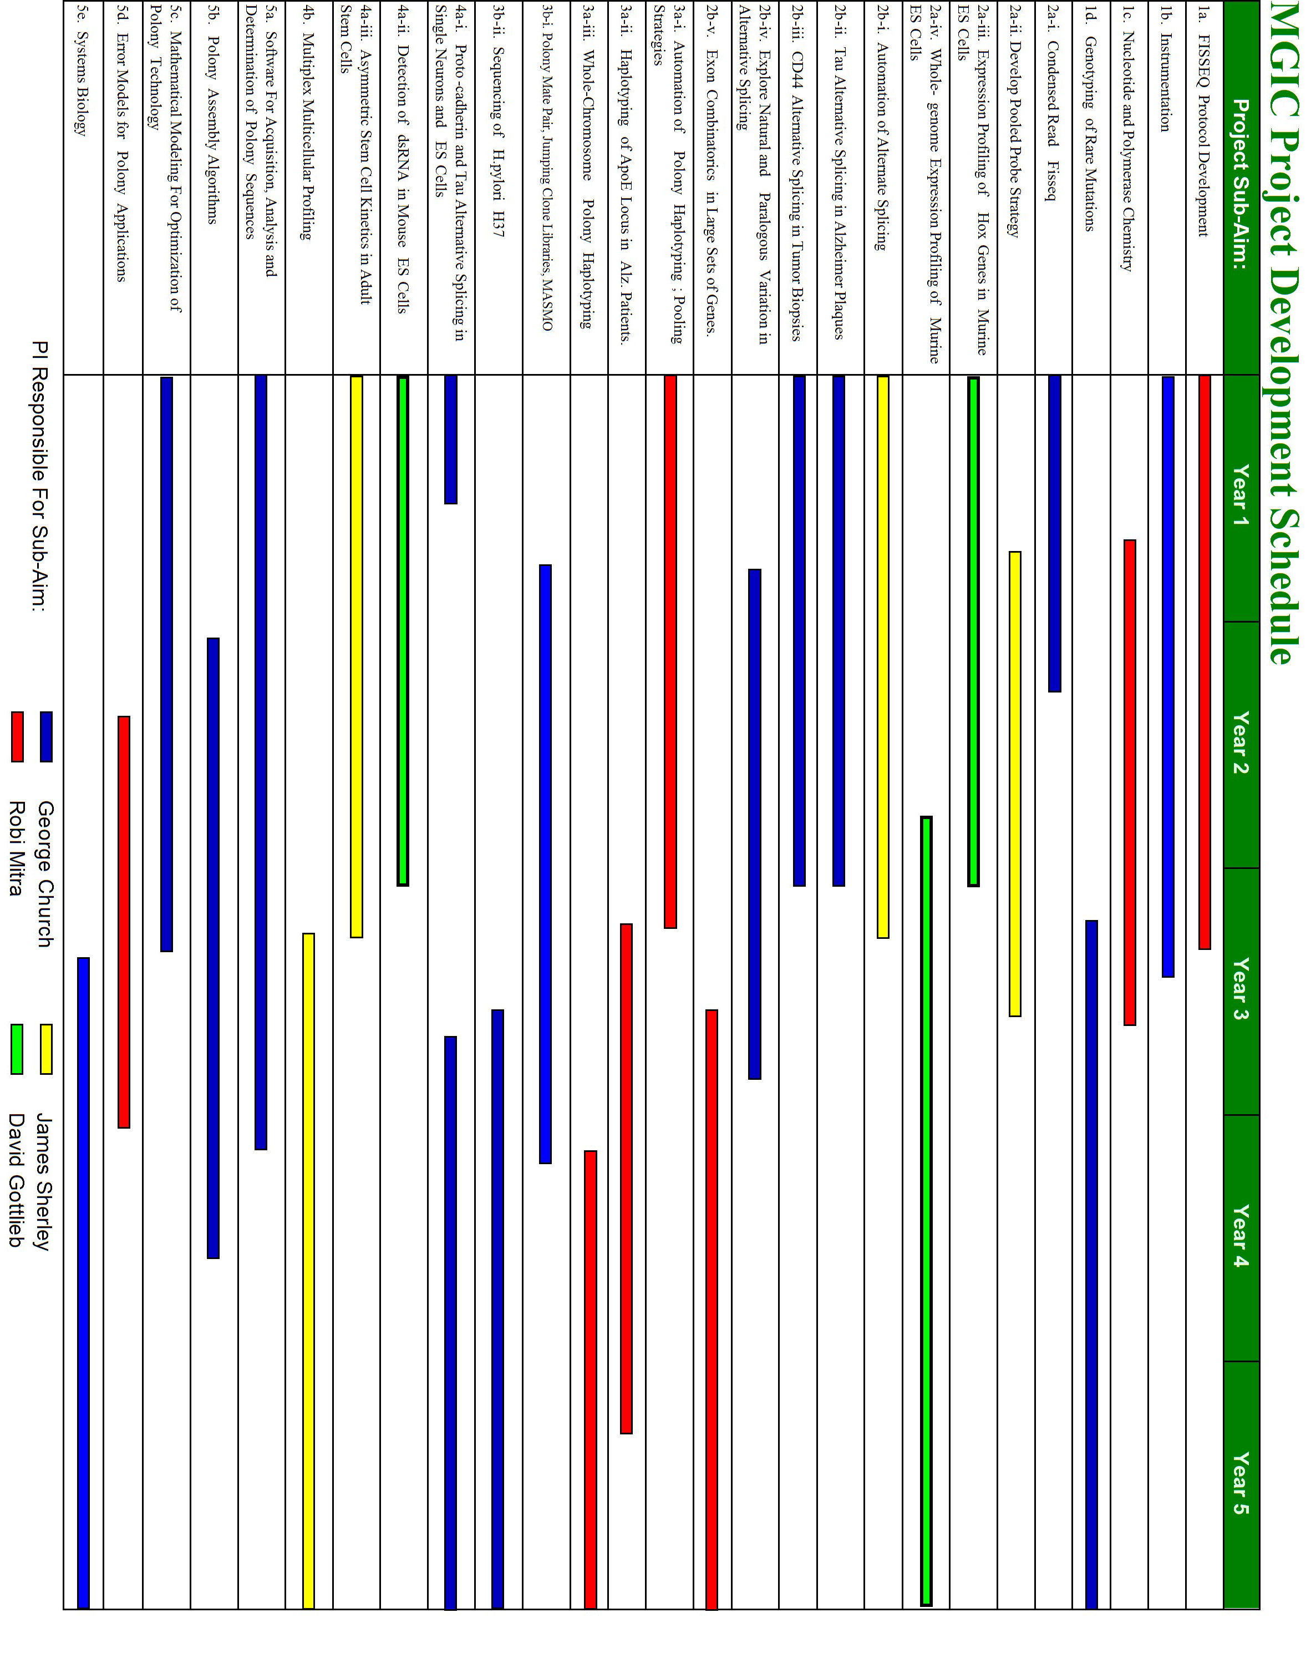

MGIC Team Organization | (Collaborating labs in parens) (See also Budget justification)
Project Sub-Aim | Team Members
1a. FISSEQ Protocol Development | Mitra, Church, Hotfelder, Shendure, Porreca, Loyal, Williams (Venter)
1b. Instrumentation | Church, Porreca, Shendure, Horn, Peterson (Mardis)
1c. Nucleotide and Polymerase Chemistry | Mitra, Church, Hotfelder, Loyal, Shendure  (Ellenberger,Kwiatkowski, Pirrung, Olejnik, Nelson, Quake)
1d. Genotyping of Rare Mutations | Church, Porreca, Shendure, Horn (Hunter, Lander)
2a-i. Condensed Read Fisseq | Church, Dudley, Grad
2a-ii. Develop Pooled Probe Strategy | Sherley, Church, Dudley (Genex)
2a-iii. Expression Profiling of Hox Genes in Murine ES Cells | Gottlieb, Mikkilineni, Adams
2a-iv. Whole-genome Expression Profiling of Murine ES Cells | Gottlieb, Dudley, Adams
2b-i. Automation of Alternate Splicing | Sherley, Derti, Grad, Lansita
2b-ii. Tau Alternative Splicing in Alzheimer Plaques | Church, Derti, Zhu (Hyman)
2b-iii. CD44 Alternative Splicing in Tumor Biopsies | Church, Derti, Butz, Mikkilineni (Edwards, Vogelstein, Meyerson)
2b-iv. Explore Natural and Paralogous Variation in  RNA-levels & Alternative Splicing | Church, Grad, Zhu (Maniatis, Vogelstein, Wu)
2b-v. Exon Combinatorics in Large Sets of Genes. | Mitra, Zhu, Hotfelder, Loyal
3a-i. Automation of Polony Haplotyping; Pooling Strategies | Mitra, Chang, Peterson (Hunter, Lander)
3a-ii. Haplotyping of ApoE Locus in Alz. Patients. | Mitra, Chang, Peterson (Hyman)
3a-iii. Whole-Chromosome Polony Haplotyping | Mitra, Church, Williams, Chang, Peterson
3b-i. Polony Mate Pair, Jumping Clone Libraries, MASMO | Church, Steffen, Varma (Lander)
3b-ii. Sequencing of H.pylori H37 | Church, Steffen, Varma (Mardis, Meyerson)
4a-i. Proto-cadherin and Tau Alternative Splicing in Single ES Cells | Church, Zhu, Varma (Maniatis)
4a-ii. Detection of dsRNA in Mouse ES Cells | Gottlieb, Zhu,Badarinarayana, Ndassa, Adams (Ruvkun)
4a-iii. Asymmetric Stem Cell Kinetics in Adult Stem Cells | Sherley,Badarinarayana, Ndassa, Lansita (Melton)
4b. Multiplex Multicellular Profiling | Sherley, Badarinarayana, Ndassa, Lansita (Wu)
5a. Software For Acquisition, Analysis and Determination of Polony Sequences | Church, Aach, Mitra, Tam, Rindone
5b. Polony Assembly Algorithms | Church, Aach, Shendure, Lee, Petti, Zhu (Lander)
5c. Mathematical Modeling For Optimization of Polony Technology | Church, Aach, Mitra, D’hasseleer
5d. Error Models for Polony Applications | Mitra, Aach, Tam, Viktup, Petti (Wong)
5e. Systems Biology | Church, Aach, Tam, Mitra, Rindone, D’hasseleer, Viktup, Zhu (Edwards)

Training Plan [to top] [timeline]

A. Overview

B. Training Programs of the MGIC

C. Action Plan For Communities Underrepresented in the Genomic Sciences

A. Overview. Our training plan has two goals. First, we wish to build a set of center-based training programs for students and faculty focused on instruction in genomics, bioinformatics, and technology development. Second, we wish to pro-actively participate in efforts to increase the presence and training of underrepresented minorities, women, and persons of disability in the sciences. To the utmost extent possible, we will integrate pursuit of these goals by actively recruiting individuals from underrepresented communities directly into the MGIC (rather than supporting activities external to the Center). We will devote ~10% of our budget specifically to pursuing these commitments. The structure of our proposed center will be very compatible with a wide variety of training and recruitment strategies, which are described below.

B. MGIC Training Program. The MGIC will play an active role in educational activities in both the Boston and St. Louis areas. In addition to lecture-style, bench-side, and lab-meeting training strategies, our proposed center will meld genomic, computational and technology-development oriented studies with traditional biological sciences by conducting a center-specific course, sponsoring a center-based seminar series, and supporting, in Years 2 and beyond, "bridging" research positions that will permit trainees to work closely with more than one key investigator of the center. This multi-pronged approach should provide our trainees with a base of knowledge broad enough to prepare them for leadership in the genomic, computational, and biological sciences. Wherever appropriate, we will encourage discussions of the ethical, legal, and social implications (ELSI) of genome science. To help guide us in this regard, we have succeeded in recruiting Dr. Lisa Lehmann to our Advisory Board. We have discussed with Troy Duster of NYU Sociology department and UC Berkeley American Cultures program on the issues in our ELSI section. We would like to incorporate discussion of the role of commercialization in ELSI and other aspects of our projects. For this we consult Juan Enriquez (Director, Life Sciences Project at Harvard Business School) and author of "As the future catches you. How Genomics...". Another local expert with whom we could consult is Evelyn Fox Keller ( author of "The Century of the Gene"). Also our participation in the "Boston University Pardee Center for the Study of the Longer Range Future" will help us recruit experts. We hope that individuals like these will not only help us work through the ELSI issue well in advance of need, but also help attract students from a greater diversity of fields and cultures than even our very "interdisciplinary" center does now.

Internet-based distance teaching and traditional classroom instruction: We, our colleagues, and laboratory members also enjoy being involved in formal classroom instruction both on their own campuses as well as elsewhere, either in person or through Internet-based distance learning options. For example, George Church directs and is the sole instructor of the main course on genomics and computational biology at HMS, Harvard College, Harvard Extension School, and MIT, and also has participated in team-taught courses, including MIT, HSPH, JFK School of Government, Harvard Business School, and Boston University College of Engineering. His primary course is also accessible through the Internet and, in this way, he reaches students internationally (http://www.courses.fas.harvard.edu/~bphys101/). This year it is also available under the MIT OpenCourseWare (http://ocw.mit.edu/index.html).

In-house courses: Without doubt, there are gaps between genome scientists, bioinformaticians, technology developers, and more traditional biologists. The largest gaps likely lie between the first three groups and the last. Not only are their approaches to biological problems frequently very different; even when there is intellectual agreement, they are often unable to converse productively due, simply, to unfamiliar vocabularies. As a center, we will address this issue head-on. In both Boston and St. Louis, we will sponsor in-house courses, where members of our center will conduct in-depth mini-courses in their own fields, including lectures and bench-side experiences. This effort will cross train our laboratory members and, importantly, teach each member how best to present their work to scientists outside of their own specialty. A priority will be placed on using technology to overcome geographical boundaries to training (e.g. OpenCourseWare, video-conferencing, etc.). We anticipate that the course will entail an even dose of math, computation, technology, biology, and medicine, as well as discussions in the area of bioethics. Additionally, we will host focused seminars specifically focused on hands-on training in polony-related protocols. Those mini-courses that prove successful may then be opened to the general community. To support our in-house course, our budget includes a request funds to purchase teaching tools and reference books.

Seminar series: We will sponsor a seminar series that brings an international panel of researchers to our campuses. Such a series will be critical for the growth of our trainees; by exposing them to new ideas and providing opportunities for them to forge personal connections and collaborations with the speakers, we will be augmenting the intellectual and international arena in which our trainees will establish their own research programs. Furthermore, such opportunities to solicit outside assessments of the proposed center's progress will not only benefit our growth, but increase the rate at which our technological innovations can be introduced to the community at large. Seminars will be alternately held in the Boston and St. Louis areas. We will implement video-conferencing systems such that Center members in the non-hosting city can view and participate in any given seminar. To help offset the costs of our seminar series, our budget includes a request for funds to bring in speakers from beyond our local areas. We anticipate that seminars will be held approximately every month (i.e. alternating between Boston and St. Louis). To ensure continuing ELSI dialogue, selection of invited speakers for three of the twelve seminars held each year will be ELSI-driven.

Bridging research positions for postdoctoral fellows and senior researchers, including sabbatical professors: An important goal of the center is to produce researchers who will go on to bridge the gap between the genomic, computational, technological and biological sciences. To this end, we propose to establish in Years 2 and beyond, research positions that will allow trainees, to be called MGIC-CEGS Fellows, to move freely from one laboratory to another as their experimental programs might best be served. This position would be most appropriate for postdoctoral fellows, although we would also consider more senior researchers, including visiting and sabbatical professors. In the case of postdoctoral fellows, we would assign each to a key investigator so that he/she will have a home base and a dedicated mentor. While we do not believe this program should be implemented during Year 1, when our laboratories will still be establishing experimental, training, and organizational protocols, we feel confident that bridging research fellowships could be advantageously supported by Year 2. Therefore, funds are requested in Years 2 and later for two MGIC-CEGS Fellowships.

C. Minority Action Plan For Communities Underrepresented in Genomics. We fully recognize the need for a pro-active stance in addressing the under-representation on our campuses of individuals of minority status, women, and persons with disabilities. The Church Lab will build on its existing experiences to assume a lead role in organizing and executing on this action plan. Dr. Church serves on an Advisory Committee (on genomics and bioinformatics) for the Society for Advancement of Chicanos and Native Americans in Science (SACNAS). The annual meeting attracts over 350 student poster and oral presentations with published abstracts. Aimee Dudley, a senior post-doctoral fellow in the Church Lab, spearheaded an educational initiative that, each year, involves 12 to 18 eighth-grade minority students from Boston public schools in an introductory laboratory course in microbiology. The program incorporates one-one-one mentoring by pairing each student with a Harvard medical or graduate student. To facilitate adoption of the program by other institutions, Aimee Dudley and David Cardozo have written a description of the program which has been accepted for publication in American Biology Teacher. Also, the Church Lab is already participating in NCI CURE (Continuing Umbrella of Research Experience), a program designed to increase the number of underrepresented minorities engaged in biomedical cancer research.

Building upon existing infrastructures associated with Harvard Medical School, MIT, and Washington University, and guided by our personal experiences, we will tailor specific strategies to the MGIC. Just as a scientific community thrives best when there is diversity in its research approaches, so will it thrive better when there is diversity among its members. Therefore, we aim to rectify the situation by intensifying our competition for the interest of members of minority communities. Our goal is to recruit individuals that might not normally consider our areas of endeavor and, in this way, broaden the intellectual strength of genomic science. Below, we outline five avenues (C1-5) that we think would work well with the goals and structure of our proposed center. We have sought to emphasize initiatives that invite students to directly participate within and directly contribute to the MGIC in close contact with faculty.

C1. Summer Undergraduate Experiences. Summer Honors Undergraduate Research Program (SHURP), partially funded by the NIH and NSF, was initiated in 1991 to encourage minority college students to consider research careers in the biomedical sciences. It has grown from 5 members in 1991 to 23-25 each year in recent years, and now totals 226 former participants. Ninety-seven percent of the SHURP alumni who have finished college, have graduated from, entered, or are planning to enter Ph.D., M.D./Ph.D. or M.D. programs, including 27 at Harvard, and 62 in Ph.D. or M.D./Ph.D. programs nationwide. Student exit evaluations from the 1991 - 2000 participants indicate that respondents were usually positive about their research experiences and would recommend the program to their fellow students and to faculty advisors at their home institutions. This is reflected by the number of applications to SHURP increasing from 7 in 1991 to over 300/year in recent years. The Four Directions Summer Research Program (FDSRP) has been similarly successful. It was initiated by Native American medical students at Harvard in 1994 with the research and financial support of DMS. It received over 100 applications for 2000, and in 2001, the total number of participants reached 55. Dr. Jocelyn Spragg, our proposed Minority Initiatives Director (see below), has been heavily involved in these programs.

We firmly believe that the impact of an undergraduate research experience can be a turning point for convincing young investigators that research is a very rewarding and feasible career choice. Accordingly, we will work with the existing programs (such as SHURP and FDSRP) at Harvard, MIT, and Washington University, to recruit undergraduate students of underrepresented minority groups. Beginning immediately, we will recruit and provide funding for one underrepresented minority undergraduate student per summer per investigator (exception = two students in Church Lab)

$4000/summer stipend x 5 students = $20,000/year.

Milestones: For each year, successful recruitment of 5 undergraduates to 4 laboratories.

C2. Collaborative Research Efforts. Occasionally, SHURP students and their research faculty explore ways of continuing the summer research project through collaborations with faculty on the student’s home campus, but these potential collaborations are limited by lack of funds. An excellent example of a promising research project in need of further support is that of Mr. Xavier Rios, an outstanding SHURP 2002 student from the Mayaguez campus of the University of Puerto Rico. He is attempting to develop his genomics project into an inter-institutional collaboration that would not only further his research efforts but has every potential of developing genomics research capacity on the Mayaguez campus. This project has the enthusiastic endorsement of faculty at both campuses, including that of Dr. Church, who is in weekly email contact with Mr. Rios during the school year. The fact that a considerable portion of the work would be in silico heightens the likelihood of a successful collaboration. Funds are requested to support the research efforts of Mr. Rios at the University of Puerto Rico Mayaguez campus in collaboration with Dr. Church.

We feel that one-on-one mentoring relationships are critical to long-term retention and progress of any student within a given field of science. The scarcity of genomic scientists on many campuses limits the opportunities for this to happen. We therefore additionally request funds for one undergraduate or graduate student to be paired with each of the four MGIC investigators in a manner similar to that of Mr. Rios. Students to be paired with and mentored by other investigators will be recruited via summer undergraduate experiences (C1) or connections to specific universities such the Mayaguez campus of University of Puerto Rico.

We plan to recruit at several meetings including Center pamphlets with both senior and peer representatives of the MGIC. The meetings include: Two of the largest annual meetings which include over 300 under-represented minority postdocs, graduate, medical, college students happen to occur in our area and are hence more likely to attract students to our MGIC. These are the New England Science Symposium In March and the Biomedical Sciences Careers student conference also in March. As part of Dr. Church's involvement in SACNAS (Society for Advancement of Chicanos and Native Americans in Science), he will attend the annual meeting. In addition we will participate in the MITE²S (Minority Introduction to Engineering, Entrepreneurship, and Science) and Whitehead Genome Center Diversity Initiative. We will strive for other geographically dispersed recruiting.

Travel at $2,000/trip x 4 trips/year x 4 students = $32,000/year; supplies at $12,000/year x 4 students = $48,000/year; Total = $80,000/year.

Milestones: For Year 1, successful recruitment of individuals to scientific mentoring relationships with the three investigators other than Dr. Church (who will continue with Mr. Rios). For Year 2 and beyond, successful retention of involvement with students. New students will be recruited for this initiative if an opening becomes available (e.g. if a student withdraws from participation due to graduation, etc.)

C3. Post College Opportunities. Every year, a few summer program alumni of Harvard Medical School plan to spend one or two years doing research after graduating from college and before applying to graduate school. Some are in programs at the NIH or in NIH-funded extramural post-baccalaureate programs. Several have returned to Harvard to work in their SHURP labs or other research labs. We would be eager to provide continued assistance, advising and mentoring to such alumni as they make the transition to graduate school. Funds are therefore sought to allow six such students (or other students who have participated in similar summer programs), should they choose to work at our proposed center, to take advanced science courses at Harvard Medical School, Washington University, and/or MIT without having to pay tuition. We anticipate that the free tuition will be a means of recruiting students to participate in post-baccalaureate programs that will encourage application to graduate school. Funds are also requested to pay for participation in Princeton Review GRE preparation courses.

Course costs at $3,200/course x 2 course/year x 6 positions = $38,400/year; GRE costs at $1000/year x 6 = $6,000/year; Total = $44,400/year.

Milestones: For Year 1, successful recruitment of 6 recent graduates to 4 laboratories. Students will given the option of remaining for 1 or 2 years. Spots will be filled by further recruitment as they become available.

C4. Mini-sabbaticals. We have been working with Dr. Gary Gibbons, Director of the Cardiovascular Research Institute at the Morehouse School of Medicine to establish a collaborative effort with their genome science research program. The focus of the Morehouse program is relevant to work being done in the laboratory of Dr. Church and includes microarray analyses of vascular and neural tissues, the generation of SAGE libraries with a focus on animal models of cardiovascular tissues and correlates of human specimens, and studies to link functional genomic studies in cell culture and animal models to human disease pathogenesis. At present, Drs. Gibbons and Church are considering a) one or more seminars to be presented at the Morehouse School of Medicine by Dr. Church and others from our proposed center, b) arranging teleconference links for seminars on both campuses, and c) mini-sabbaticals that will allow researchers to move between campuses. Furthermore, Dr. Church has agreed to act as an external advisor/consultant for the anticipated Bioinformatics Center at the Morehouse School of Medicine.

Funds are requested for one-month sabbaticals that would bring faculty and other researchers from minority serving institutions to the MGIC, or allow our researchers to spend time on minority-serving campuses. These sabbaticals could be used to help a new faculty member write a grant application in the area of genome science, foster a collaborative study that might further the career or a young investigator, or train new researchers. These sabbaticals could also focus on refining and developing science teaching curricula or lab modules in research areas relevant to our proposed center. Funds are therefore requested for one month for two faculty and, in addition, for a modest salary for one of these faculty who may be on a nine-month salary and would therefore require salary support to participate.

Sabbatical costs at $5,000/sabbatical x 2/year = $10,000/year; salary for one at $5,000/year; Total = $15,000/year.

Milestones: In each year, successful recruitment of 2 faculty to fill sabbatical positions.

C5. Assignment of Personnel Devoted to Minority Initiatives.

We have determined that in order for the initiatives described above to be realistically accomplished, we will need the guidance and assistance of additional personnel. In particular, although the principal investigators are very committed to the program, they do not, on their own, have the expertise, knowledge base, or time to efficiently achieve the goals for increasing minority presence on our campuses. Furthermore, while all universities participating in the MGIC currently provide salary and office support for programs ongoing on all campuses, we believe that it would be optimal if the goals specific to our proposed center could be under the direction of personnel dedicated to the Center with significant time commitments to minority initiatives. We therefore propose both “Director of Minority Initiatives” and “Coordinator of Minority Initiatives” positions.

Milestones: In Year 1, successful recruitment and hiring of a qualified individual to fill the position of “Coordinator of Minority Initiatives”. It is critical that we fill this position quickly to expedite progress on other initiatives.

Director of Minority Initiatives. Dr. Jocelyn Spragg, Ph.D., Ed.M. promotes women and individuals of minority status in the sciences as Faculty Director of Minority Programs and Special Academic Resources at HMS. She is director of the Division of Medical Sciences Summer Honors Undergraduate Research Program and the Four Directions Summer Research Program for Native Americans, co-chair of the Minority Recruitment Committee, advisor of the Minority Biomedical Scientists of Harvard, member of the NIH Research Centers in Minority Institutions study section, and past member of the NIH Bridges to the Baccalaureate review panel. Her research interests as an HMS faculty member produced over 50 publications in the fields of immunology, biochemistry, and related areas." She co-chairs, with Prof. Harold Amos, the Minority Recruitment Committee, assists admissions committees in the evaluation of minority applicants, participates in workshops for minority students on other campuses, directs the DMS-sponsored Summer Honors Undergraduate Research Program (SHURP) for minority college students, and serves as the faculty administrative director of the Four Directions Summer Research Program (FDSRP) for Native American college students. Dr. Spragg is also a member of Leadership Alliance, a consortium of 29 schools whose goal is to develop outstanding minority leaders and role models in education, business, and the private sector. She serves as co-chair of its post-doctoral fellows committee and is an author of its publication, “Tips on Preparing for and Applying to Graduate School”. We have asked Dr. Jocelyn Spragg to be our Director of Minority Initiatives. She will contribute expertise to all aspects of the minority proposal, provide training, and oversee all the activities. She will also maintain and develop contacts with faculty on minority-serving campuses and represent our initiatives at conferences and campuses throughout the nation. Dr. Spragg is uniquely qualified for this role.

Funds requested: 15% effort = ~$12,000/year plus fringe at 19.6%.

Coordinator of Minority Initiatives. In addition to Dr. Spragg, we feel that successful execution of we would like to bring on an individual with a background in the biological sciences and familiarity with academic environments. This individual would be in frequent communication with the principal investigators of the proposed center, students, alumni of our programs, as well as researchers and administrators on other campuses. He or she would assist with the selection of students and faculty for participation in our initiatives, track the participants, and maintain and update alumni records. In addition, he or she would also administer the financial aspects of our initiatives, respond to telephone, email, and mail contacts regarding our program, update our web site information as required, and coordinate our efforts to publicize activities and openings for research and training positions. This individual will report jointly to Dr. George Church and Dr. Jocelyn Spragg.

Funds requested for 50% effort: $20,000/year plus fringe at 25%.

Summary of Funds Requested for Minority Initiatives

Summer Undergraduate Experiences = $4000 / stipend x 5 students / year = $20,000
Collaborative Research Experiences = $20000 / student (travel + supplies) x 4 students = $80,000
Post College Opportunities = $7400 / student (courses + GRE) x 6 students = $44,400
Mini Sabbaticals = $5000 x 2 / year (+ $5000 / year salary for one) = $15,000
Director of Minority Initiatives = $12000 / year (15% effort) plus fringe at 19.6% = $14,352
Coordinator of Minority Initiatives = $20000 / year (50% effort) plus fringe at 25% = $25,000

Total = $198,752.

Data & Materials Dissemination Plan [to top] [timeline]

Open Source Biology. Our programs and data will be distributed from the MGIC website (http://arep.med.harvard.edu/Polonator). The programs will be generally available as documented source code with a Harvard and/or Washington University copyright, distributed freely to academics, and with a Harvard and/or Washington University license for commercial use. Our strains will be distributed by mail as we have done in hundreds of instances already. Invented chemicals, constructs, and instruments will be submitted for patenting within one month of discovery and published without delay. As part of the DARPA BioComp/ BioSPICE project, we continue to champion concepts that we helped establish for the genome sequencing community and which concerns rapid data deposition and technology transfer. We are helping to establish an "Open Source Biology" (OSB), which will determine procedures and technologies to aid the distribution of complex reagents more effectively. An example would be the compressed sequence tags (CSTs) described in Aim 2a. These are analogous to the Sequence Tagged Sites (STS) and Expressed Sequence Tags (EST) of the Human Genome Project and could be distributed electronically and/or commercially. The related goal of OSB is to prevent exclusive licenses from potentially interfering with technology transfer. In this regard, we will try to move our technology either into the public domain or non-exclusive licensing mechanisms well before they would be normally publishable. Just as genomics has made laudable the publication of loads of "hypothesis neutral" or "negative" results by way of comprehensiveness and data mining/post-experiment hypotheses, so, too, do we hope OSB will encourage a similar process for technology development and transfer. George Church has been on the Harvard-wide Copyright and Patent Committee (CPC) for years, a recipient of numerous successful patents, and is in constant contact with the HMS Office of Technology Licensing (OTL). The above plan, while aggressive on the sharing end of the spectrum, as far as we know, is fully consistent with the spirit of the HMS-OTL, Washington University OTM, MIT-TLO, NHGRI, and Bayh-Dole missions.

Software and protocol sharing. Our current policy for software sharing is closest to ISCB Level 2: "Source code is available for research use to educational institutions, non-profit research institutes, government research laboratories, and individuals, without the right to redistribute". Examples of software that we have shared at Level 2 are available on Church lab web pages (http://arep.med.harvard.edu). Although not requested in this update, we note that in addition to software, the principal investigators of the proposed center will make many other resources available with a similar level of access. Such resources will include cell lines, DNAs, experimental protocols, data sets and models. Indeed, we are members of research consortia (e.g. DARPA BioSPICE and DOE-GtL) that are actively promoting ways to make these other types of resources more 'shareable'.

Timing of deliverables: Each of the milestones in the timeline has an associated deliverable within one month of the scheduled date. The mechanism of distribution will be posted on our web page at the time on the timeline. If our schedule advances or recedes relative to this proposal (which will also be posted online), then an explanation will be posted at the scheduled time or before.

Related CEGS application. One of the PIs for this grant submitted last year a CEGS proposal (1 P50 HG002801-01). The current proposal is considerably different, but retains a focused subset of the polony work and a tighter biological focus on stem cell differentiation. Here is background information on that application:

Original submission June 2002
Critique of that June '02 Proposal (roster).
Our Apr '03 Letter of intent and response to the critique.
Feedback from NHGRI about our Apr '03 letter.

Acknowledgements
This grant proposal would not have been possible without the enthusiastic support of the people listed in the staff and collaborators list. In particular, John Aach and Jay Shendure wrote large segments of this proposal and Cindy Vallaro worked hard on the budget and administrative components. We also owe a great debt to coauthors of last year's version, Jennie Lee, Cynthia Morton, Joel Voldman, Ting Wu, and Jocelyn Spragg. In particular, the latter two contributed portions of the Management and Training retained in this proposal..

