MGIC-CEGS Proposal Update (September 16, 2003)

[Church, Gottlieb, Mitra, Sherley]

Since submission of our proposal on June 1, 2003, we have made progress on several Aims and have laid the groundwork for more extensive collaboration between sites. Additionally, four manuscripts mentioned or provided as pre-prints in the proposal have now been published, and two new manuscripts have been submitted. Updates are described by Aim.

Aim 1: Polonies and In Situ Sequencing

(i) Our manuscript on FISSEQ [Mit03B] has now been published. (ii) ‘Wrap around’ extension results from intramolecular priming of the free 3’ ends of the tethered strands in a polony, and is particularly an issue in sequencing long templates. We have performed experiments and analysis aimed at identifying and limiting the amount of ‘wrap-around’ extension that takes place during polony sequencing. Several methods (e.g. restriction digestion to reduce length of amplified templates; extension with ddNTPs to “cap” free 3’ ends) have been shown to significantly reduce the magnitude of the problem. (iii) We have further developed the prototype automated dipping station described in Figure 1-3 of our proposal. Detailed drawings for the manufacture of parts have been made, which allow immediate, low-cost production of the machine in a form suitable for an end-user of the technology.

In another development (iv), we have developed a set of sequencing-by-synthesis protocols for populations of “clonal” beads, each bearing thousands to millions of copies of the same sequences. Analogous to a polony, all molecules on the same bead are amplicons of the same single molecule, but molecules on distinct beads are amplicons of different single molecules. Populations of clonal beads can be generated by a number of published methods [Dre03][Bre00]. The strategy is conceptually and philosophically identical to that of FISSEQ / polonies, but brings us past several key challenges, most

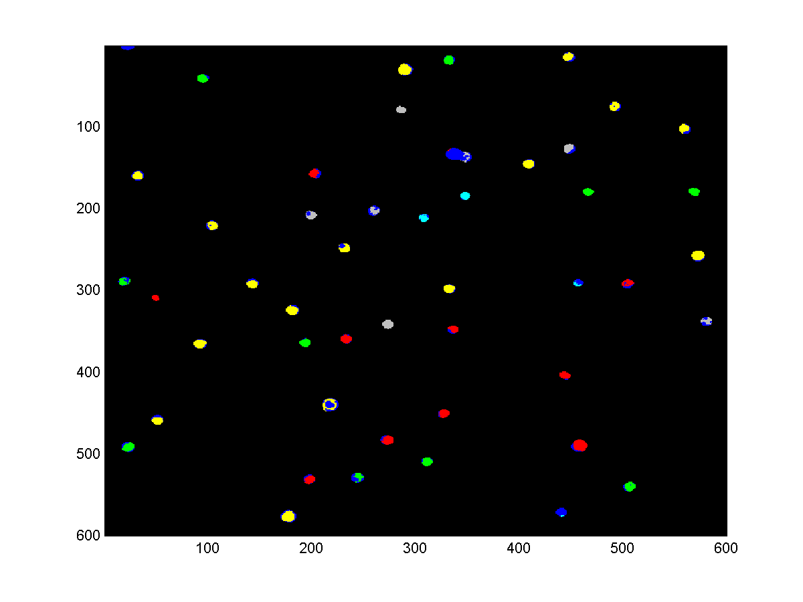
Figure S1. Parallel sequencing on oligonucleotides coupled to 8.8 micron beads. A population of beads, each bearing one of five 80-mer oligonucleotides was immobilized in acrylamide and subjected to multiple rounds of FISSEQ sequencing [Mit03B] until five to eight base-pair reads were obtained. This post-processing image shows a region of the slide, with pseudocolors representing individual sequences (with dark blue representing “noise signatures”, as in [Mit03B]). A 600x600 pixel region is shown here, where the resolution is approximately 0.5 microns per pixel in each dimension. Images were captured on an inverted epifluorescence microscope. importantly that of reducing polony size to single micron scale. We are also planning to apply this approach to multiplex exon-typing (Aim 2). The fusion of bead and polony sequencing protocols represents a technology ‘branch point’ (see proposal section 8b) that trades off increased sequencing throughput against molecular location information that is retained by ordinary gel-based polonies. This is a very rewarding effort including work from the Mitra, Church, Edwards and Vogelstein groups. Some preliminary results are described below.

In Figure S1, we summarize the results of an experiment in which 5 to 8 base-pair reads were obtained on oligonucleotides coupled via biotin to streptavidin-coated superparamagnetic beads (8.8 micron in
diameter). The beads are immobilized in acrylamide, and the protocol is derived from that described in [Mit03B] with minor modifications. However, these beads are ~100 times smaller than the polonies sequenced in [Mit03B], and therefore 10,000 times more features can be sequenced on a single slide. Had we been imaging a full slide in this experiment, we would have obtained independent sequencing reads from ~1 million beads.

Towards further miniaturization, we have also performed preliminary experiments generating short sequencing reads (4 base-pairs per template) on 1 micron beads (Figure S2). The result brings us closer to our goal of “one sequence-read per pixel”, as each bead is only represented by ~1 to 4 active pixels. At this demonstrated bead size and density, we can obtain sequencing reads from over 30 million independent beads per slide.

Our final goals involve hundreds of millions of independent sequencing reads per slide. This can be implemented as 1 micron beads packed at high densities. We have begun experimenting with self-organizing monolayers (SOM) of superparamagenetic beads, and have made some progress (Figure S3). We are currently working on integrating our SOM protocols with bead immobilization and FISSEQ protocols, as well as extending our average read-length to 30 bases. Obtaining 30 base-pair reads from a slide perfectly coated with a monolayer of 1 micron beads would yield ~56 billion bases of sequence per slide.

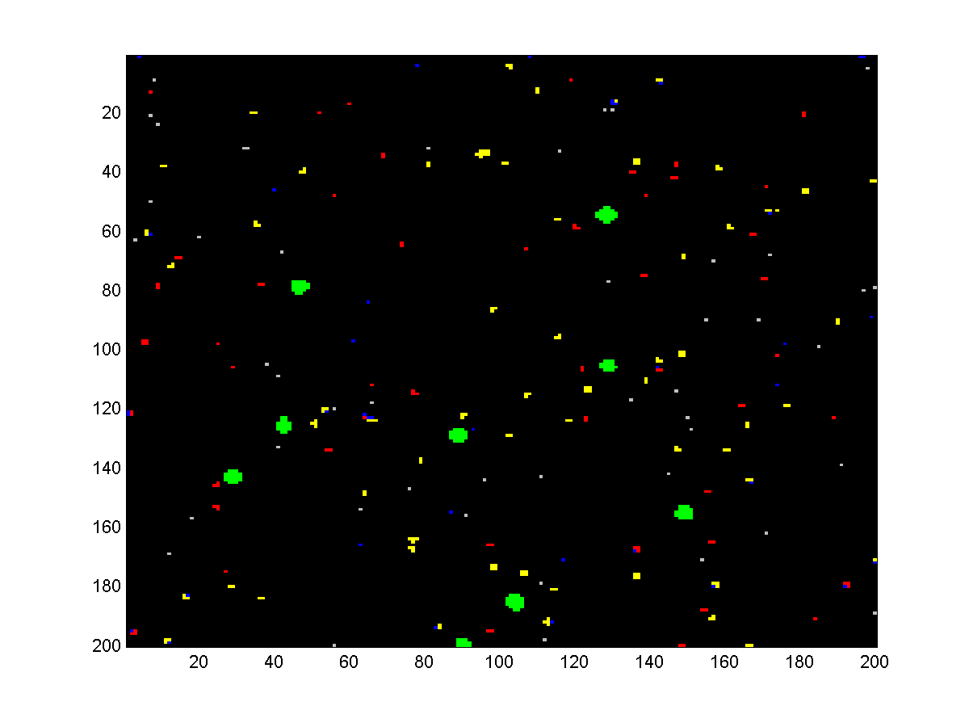
Figure S2. Parallel sequencing on oligonucleotides coupled to 1 micron beads. A population of 1 micron beads, each bearing one of three 80-mer oligonucleotides was immobilized in acrylamide and subjected to multiple rounds of FISSEQ sequencing [Mit03B] until four base-pair reads were obtained. Larger beads (2.8 micron) were mixed in to serve as “guide posts” for image alignment. Correct signatures are pseudocolored red, white, yellow; noise signatures are pseudocolored dark blue; and “guide post” beads are pseudocolored green. A 200x200 pixel region is shown here, where the resolution is approximately 0.5 microns per pixel in each dimension. Images were captured on an inverted epifluorescence microscope.
(a) (b)
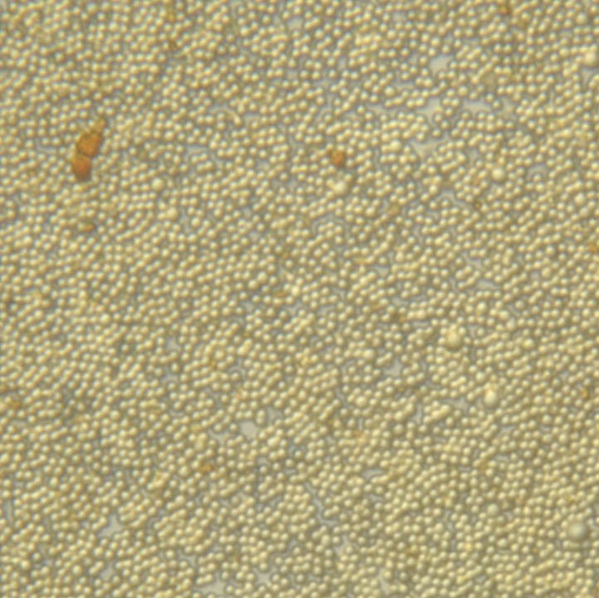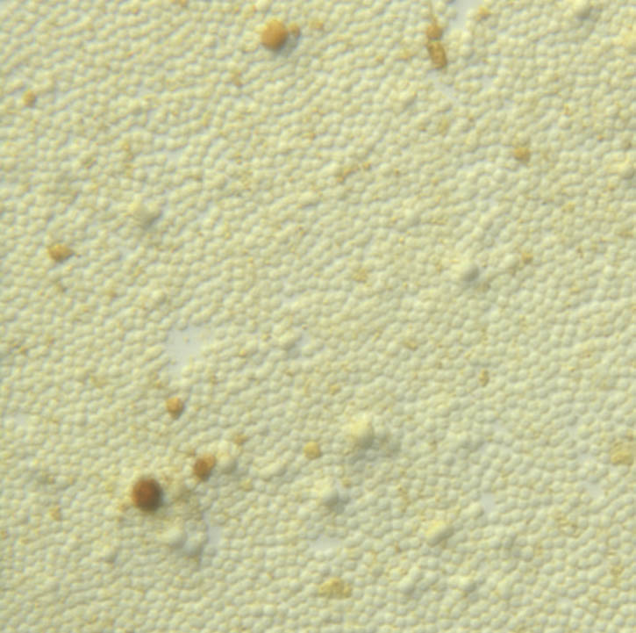

Figure S3. Monolayers of paramagnetic polystyrene microspheres (1 micron diameter) were prepared by convective self-assembly. The protocol used was similar to that described in [Den92]. The monolayers can be loosely packed (a) or more tightly packed (b) by varying the amount of detergent added. Multilayers (Edwards group, confocal data not shown) have also been constructed using transverse magnetic fields.

Aim 2: Quantitating RNA molecules and exon typing.

(i) Our manuscript on alternative splicing [Zhu03] was recently published in Science, and a new manuscript [Mik03] on digital RNA expression quantitation (representing collaboration among the Harvard, Wash.U, and U.Delaware labs) is in review.

(ii) We have developed polony assays to digitally quantify the expression of the Oct3 and Nanog genes in mouse embryonic stem (ES) cells. One of the central issues in the ES cell field is the mechanisms that keep these cells totipotent. Part of the answer involves the transcription factors Oct3 and Nanog. Both are highly expressed in ES cells but not in differentiated cells. Previous work in the Gottlieb laboratory established the expression pattern of Oct3 and Nanog in a culture system where ES cells differentiate into neural cells of the ventral part of the developing CNS. Expression was determined by conventional RT-PCR and by real time PCR. As expected, undifferentiated ES cells express both genes. The differentiated ventral CNS cells do not express either gene. Thus we have established a culture model in which Oct3 and Nanog expression is switched off. We are using polonies to answer the next level of questions. First we will determine if all ES cells express Oct3 and Nanog. This is an important issue since there are many suggestions that ES cells are actually a heterogeneous population of cells. We also want to find out how many mRNA molecules there are per cell. Finally, we would like to profile individual cells as the population differentiates.

In Figure S4, we show preliminary results of digital expression analysis of Oct3 and Nanog. Undifferentiated ES cells were grown by standard methods and total RNA prepared from approximately 5X10⁶ cells. cDNA was synthesized by standard methods. cDNA was amplified by the standard polony protocol and polonies were visualized by SybrGreen staining. Polonies for both Oct3 and Nanog were amplified. Having established that we have a working system, we are proceeding to

(a) (b)
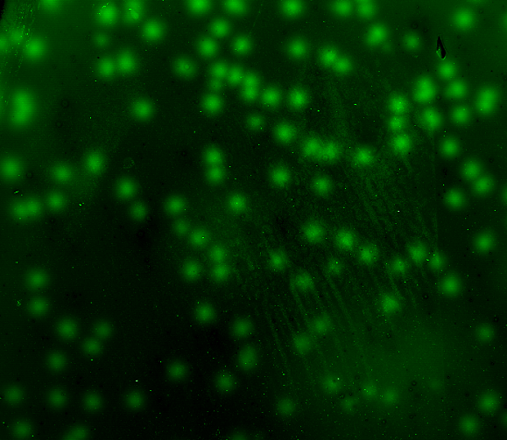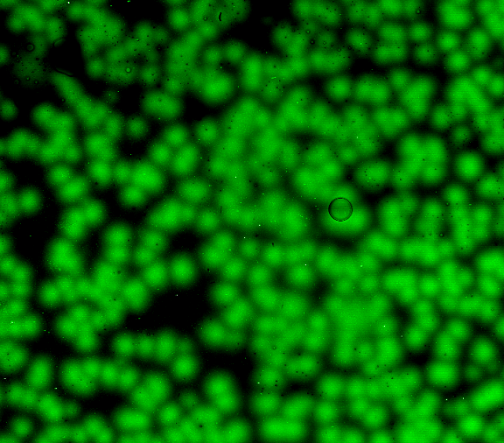

Figure S4. Digital expression analysis of (a) Nanog and (b) Oct3. See text for details.

quantify the number of polonies per cell. We are also proceeding to adapt the system to the single cell level of analysis (Aim 4).

(iii) Additionally, we note that, in support of the stem cell focus of this Aim, the Church group (HMS) has expanded its work with stem cells. While previous work (before our June 1 proposal) focused on the culturing and RNA expression analysis of murine ES cells, we have also performed mass-spectrometric proteomic analyses of these lines on our own and also in collaboration with Doug Melton’s group.

Aim 3: Long sequence connectivity and haplotyping

The Church Lab has arranged for an FTE (Kun Zhang) to work on “whole genome amplification”, one potential route to the long range sequencing goals for this Aim.
He is pursuing both the ligation-mediated PCR and the phi29 approaches.

Aim 4: Single Cells and In Situ profiling

The Sherley group (MIT) has now published a manuscript that greatly enables our studies of adult stem cells [Lee03] (this was included on our original proposal CDROM as “submitted”). The Edwards group has applied polonies to point mutant loss-of-heterozygosity (LOH) in human pancreatic tumors [But03] (this was not included on the CDROM, but is now published).

Aim 5: Computational methods and systems biology

(i) Aaron Lee has made considerable progress on computational support for image analysis and protocol automation, in particular, converting the slow MATLAB code to speedy C. (ii) A manuscript on mathematical models of polony growth and interaction has been submitted [Aach03], and preliminary

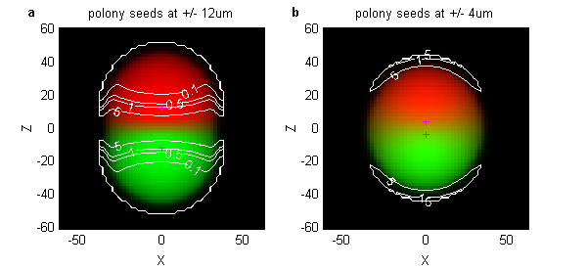
Figure S5. Computational simulation and analysis of polony ‘exclusion’. Polonies were simulated in three dimensions using algorithms and standard parameters described in [Aac03], and the results rendered as false color images comparable to scanned images of actual polonies. Shown are simulated polonies resulting from individual template seed molecules at (a) +/- 12 and (b) +/- 4 on the Z-axis (indicated by magenta ‘+’ signs), where one amplicon is colored red and the other green, and intensities are proportional to the amount of product in each scanned pixel. Units are μm. The ability to sequence each polony without error requires that regions of the scanned polonies be free of contamination from the neighboring polony. Contours show borders of regions of 5, 1, .5, and .1 % contamination, for regions containing > .005 of the maximum amount of product. The simulated +/- 12 polonies in (a) exhibit good exclusion in which large regions of each polony have < .1% contamination. The +/- 4 polonies exhibit substantial contamination throughout the entire image.

work has been done using the models to develop measures of polony ‘exclusion’ that may then be optimized (see figure S5).

MGIC-CEGS References (Publications & Submissions)

[Aac03] Aach JA, Church GM. (2003) Mathematical models of diffusion-constrained polymerase chain reactions: basis of high-throughput nucleic acid assays and simple self-organizing systems. Submitted to J Theor. Biol.

[Lee03] Lee HS, Crane GG, Merok JR, Tunstead JR, Hatch NL, Panchalingam K, Powers MJ, Griffith LG, Sherley JL. (2003) Clonal expansion of adult rat hepatic stem cell lines by suppression of asymmetric cell kinetics (SACK). Biotechnol Bioeng. 83(7):760-71

[Mer03] Merritt J, DiTonno JR, Mitra RD, Church GM, Edwards JS. (2003) Parallel competition analysis of Saccharomyces cerevisiae strains differing by a single base using polymerase colonies. Nucleic Acids Res. 31(15):e84

[Mik03] Mikkilineni V, Mitra RD, Merritt J, DiTonno JR, Lemieux B, Church GM, Ogunnaike B, Edwards JS. (2003) Digital analysis of gene expression for quantitative monitoring of gene expression. In review at Biotechnology and Bioengineering.

[Mit03B] Mitra RD, Shendure J, Olejnik J, Edyta-Krzymanska-Olejnik, Church GM. (2003) Fluorescent in situ sequencing on polymerase colonies. Anal Biochem. 320(1):55-65

[Zhu03] Zhu J, Shendure J, Mitra RD, Church GM. (2003) Single molecule profiling of alternative pre -mRNA splicing. Science 301(5634):836-8.

Additional Cited References

[But03] Butz J, Wickstrom E, Edwards J. BMC Biotechnol. 2003 Jul 23;3(1):11. Characterization of mutations and loss of heterozygosity of p53 and K-ras2 in pancreatic cancer cell lines by immobilized polymerase chain reaction.

[Den92] Denkov, N.D., Velev, O.D., Kralchevsky, P.A., Ivanov, I.B., Yoshimura, H., Nagayama, K. (1992) Mechanism of Formation of Two-Dimensional Crystals from Latex Particles on Substrates. Langmuir 8:3183-90

[Dre03] Dressman D, Yan H, Traverso G, Kinzler KW, Vogelstein B. (2003) Transforming single DNA molecules into fluorescent magnetic particles for detection and enumeration of genetic variations. Proc Natl Acad Sci U S A. 100(15):8817-22.

[Bre00] Brenner S, Johnson M, Bridgham J, Golda G, Lloyd DH, Johnson D, Luo S, McCurdy S, Foy M, Ewan M, Roth R, George D, Eletr S, Albrecht G, Vermaas E, Williams SR, Moon K, Burcham T, Pallas M, DuBridge RB, Kirchner J, Fearon K, Mao J, Corcoran K. (2000) Gene expression analysis by massively parallel signature sequencing (MPSS) on microbead arrays. Nat Biotechnol. 18(6):630-4.

