Executive Summary

Polony Sequencing will potentially reduce the cost of DNA sequencing by five orders of magnitude, such that 1 megabase of DNA can be sequenced for about eight cents. We have accomplished several technical milestones towards this goal, including the sequencing of a small number of bases using our technology. Much of the progress made to date has been achieved with modest resources (2 FTEs), but we are rapidly expanding (currently 7 FTE's and 4 commercial contractors/partners). We are asking for a 5.7 million dollar commitment from DARPA, which will drastically reduce the time needed to bring a polony sequencing product to market. In this white paper, we present an overview of the technology, a cost analysis of polony sequencing, seven technical and business milestones, and a description of how polony sequencing will meet DARPA's goal of rapidly sequencing a 10,000 base pair DNA molecule. Because we use "off the shelf" equipment, we believe that, with DARPA funding, we will deliver a product in 2 years.

Technology Overview of Polony Sequencing

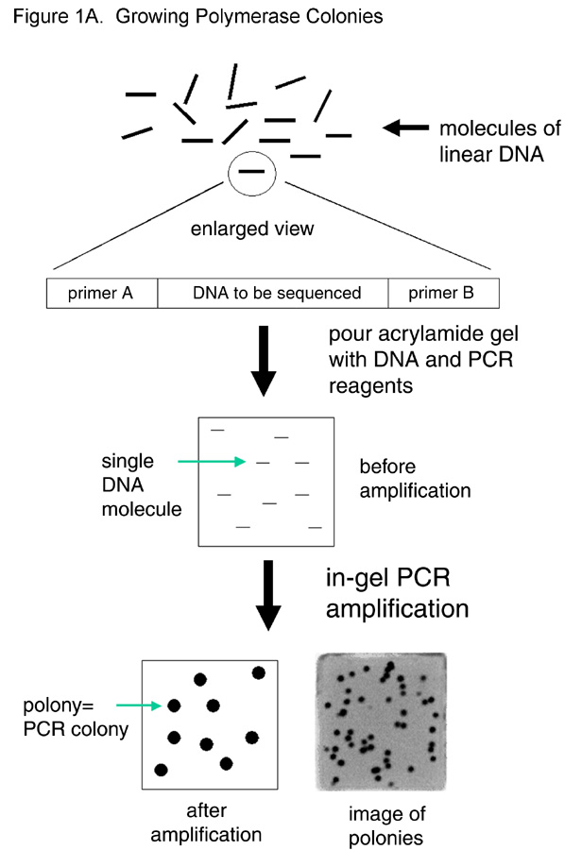
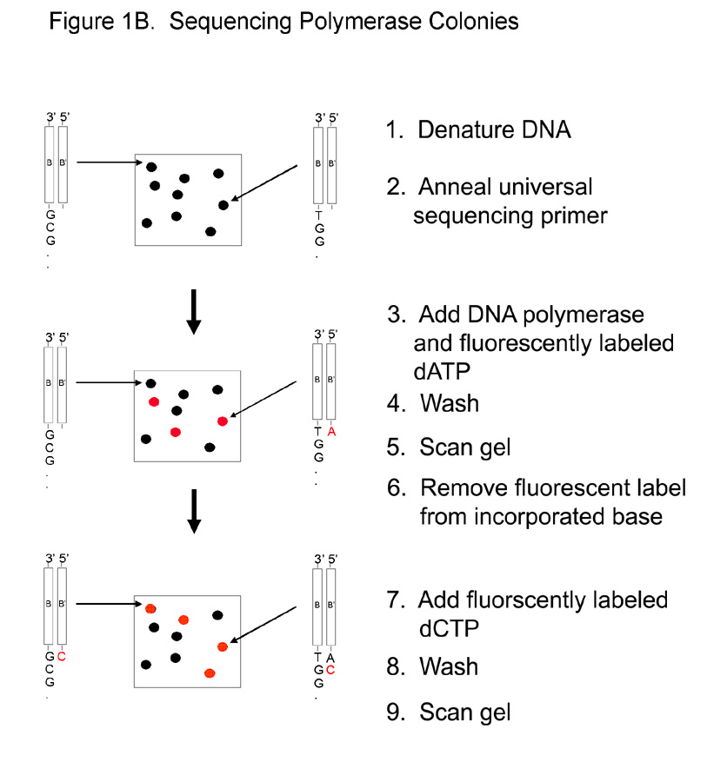
To form polymerase colonies, millions of individual DNA molecules are amplified by the polymerase chain reaction (PCR) in an acrylamide gel attached to the surface of a glass microscope slide (figure 1A). Because the acrylamide restricts the diffusion of the DNA, each single molecule included in the reaction produces a colony of DNA, which we have termed polonies (for polymerase colonies). We have amplified 18 million informative polonies on a single microscope slide, and have developed a chemistry such that one strand of every DNA molecule within each polony is covalently attached to the acrylamide matrix. This feature allows us to perform sequential single base extensions with fluorescent deoxynucleotides to obtain the sequence of each polony in parallel (figure 1B).

Figure 1. A) Polonies are amplified by diluting a library of DNA molecules with universal priming sites into a PCR mixture that contains acrylamide monomer. This mixture is used to pour a thin (5 - 50 micron) acrylamide gel on the surface of a microscope slide. We then perform PCR, resulting in the growth of polymerase colonies or polonies. B) One DNA strand of each polony is covalently attached to the acrylamide, allowing sequential single base extensions with fluorescent nucleotides. In this fashion, the sequence of every polony on the slide is determined in parallel.

Experimental Progress

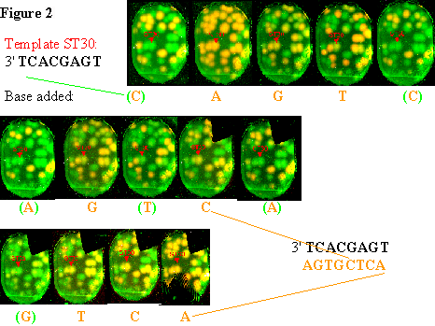We have demonstrated the amplification of polonies and investigated the parameters that affect their growth and size (Mitra and Church, Nucleic Acids Res 27(24); e34 pp 1-6). Recently, we have focused our efforts on developing a sequencing protocol for polonies. We have designed, synthesized, and tested a novel fluorescent nucleotide with a cleaveable crosslinker, and we have demonstrated eight base pair sequencing reads on amplified polonies (figure 2). The reaction ended after the gel detached from the slide, but the sequencing chemistry performed well up to that point. We have quantified the specificity and extension efficiency of our sequencing protocol and predict 200 base pair reads should be possible without making significant changes to the chemistry.

Cost analysis
Raw data rate: 25 pixels/bp, 1Mpixel per 6sec/CPU = 24 CPU days.
Amortization: 5 years, 80% duty cycle, 12.5 minutes/cycle = $3433 per 6.9x10¹⁰ bp
Overhead: $200 /sq ft/yr * 60 sq.ft (600 cu.ft) = $42
Reagents: At 20 microliters/cycle 200 bases/slide = $979
Library Preparation: (includes DNA preparation) $28
Electricity: 2 kwatts 24hr*17days* 0.13$/kwatt-hr = $104
Labor for repair: 10% of instrument cost = $343
Labor for operation: Slide PCR, slide dips, scans, etc. = $499
Total: $5428 per Diploid Genome (11x or >99.99 coverage) or 7.9 cents per Megabase

Milestones
Milestone #1: Collect sequence on small polonies (5 - 20 microns).
Time: 4 FTE's x 0.75 years
Cost: $0.5 million
We can produce over 18,000,000 informative polonies (5 micron diameter) on a single microscope slide by using long PCR products (roughly 2kb). However, these long DNA molecules have proven more difficult to sequence because the single stranded DNA folds into a stable secondary structure in the acrylamide pore. We plan to solve this problem by using cleaveable crosslinker or performing the sequencing reaction at higher temperatures. Alternately, we will use short DNA templates, but use means such as "drag tags" or bridge PCR to reduce the size of the resulting polonies.

Milestone #2: Improve Gel Stability
Time: 4 FTE x 1 year
Cost: $0.75 million
Currently, gel tearing and detachment limits the length of our sequencing reactions. In order to sell this technology as a product, it must be robust and current gel strength requires delicate handling. We plan to investigate alternate attachment chemistries, alternate matrices, and thinner gels (which decreases susceptibility to tearing). Our goal is to have a gel that will stay intact through at least 100 base additions.

Milestone #3: Software
Time: 8 FTE x 1year
Cost: $2 million
We plan to have a robust software system that can quickly identify polonies from the scanned images and call the sequences. This system must be user friendly and intuitive. In addition to polony identification and base calling, this software package must address informatics issues such as sequence assembly, and finding the acquired sequences in databases of known or conserved sequences (e.g. Genbank).

Milestone #4: Equipment
Time: 2 FTE x 1year
Cost: $1 million
We are committed to using off the shelf equipment for our fluidics and scanning devices, so this problem is largely an integration issue. We plan on partnering with manufacturers of microarray scanners to develop a robust instrument that provides that resolution required (1 micron).

Milestone #5: Expand to 4 color chemistry
Time: 6FTE x 6months (through contracts with NEN, Jena)
Cost: $0.4 million
Performing 4 color sequencing will reduce the cycle time of the wash steps by a factor of 4 and the imaging time by a factor of 2 -4. We plan on investigating new fluors to find the appropriate dye/nucleotide combinations that will enable four color sequencing. This will largely be achieved through contractors.

Milestone #6: Base calling accuracy
Time 6 FTE x 2 years
Cost: $1million
We plan on assessing and improving the base calling accuracy of our sequencing technology. To do so, we will acquire > 100,000 bases of sequence from known templates and assess the accuracy of our technology. Then, we will develop computational methods that will predict the effect of sequence contexts on the quantum yields of the fluorophores to improve the measured accuracy.

How Will This Technology Help DARPA Achieve Its Goals?

Currently, we are targeting a throughput of roughly 360 million base pairs/day/machine. We estimate the maximum read length on any given polony will be 200 base pairs. To sequence and assemble a 10,000mer with greater than 99.99% probability of closure, we will need to sequence 1.8e5 bases (Roach, Genome Research 5:464-472, 1995). Therefore, one machine could, in principle, sequence 2000 10,000-mers in a day. Repetitive sequences greater than 200 bases would be handled by a mated pair strategy where two sequences are read from a fixed distance apart. Alternately, amplifying multiple polonies from a single extended molecule could also be used to give ordering information.

